|  |  |
| --- | --- |
| CRM (Customer Relationship Management) - 6degreesIT  Business Information Systems 2 | Luca Gerin  Politecnico di Milano |

Summary

1. Web Information Systems 3

E-Commerce 3

Recommendation systems 5

Supply chain management – SCM 6

2. Social Media 8

Crowdsourcing and Co-creation 9

Communication and Marketing on social media 10

Manage the online reputation of a brand – Social CRM 11

Social media and the *Metaverse* 12

3. KPMG – Consulting for ERPs 13

From Legacy systems to ERP systems 13

How ERP systems are made (levels, environment) 14

The introduction of an ERP system in the company 15

SAP: sample of ERP system 16

ERP Projects 17

Recommended Approach 20

4. KPMG – Engagement Review Form 21

The culture of feedback in KPMG 21

5. The IT Strategy consultant 22

ICT Assessment Methodological Framework 24

Case Studies 27

6. Elasticity 31

7. Work Force Management 32

Case study: OTIS elevators 34

8. Predictive maintenance 35

9. Knowledge Management 38

Knowledge Management Systems 40

Case study: Law Firm 41

10. Projects management 42

10. SCRUM 46

Roles 46

Events 47

Artefacts 49

11. Big Data Analytics 50

Artificial Intelligence 50

How big is Big Data? 53

Challenges of Big Data projects 55

Solutions for Big Data projects 58

Case study of Big Data projects: targeting 61

12. The widening digital divide 64

Adaptive workforce 65

Modern delivery 65

Data as an asset 66

Customer trust 66

Dynamic investment 66

13. Micro-services 67

Web application and architectures 67

Micro-services paradigm 71

14. Intelligent Automation 72

Intelligent customer interactions 74

Scale now – Embedding intelligent automation across the enterprise 76

# 1. Web Information Systems

A **WIS** – **Web Information System** is a system that uses internet or an IP-based private VPN to implement the communication between machines and provides functionalities that are accessed through a browser. This is a very broad definition including both sites and portals, as well as traditional information systems (core ERPs) redesigned to provide their functionalities through the Internet with a browser-based interface

Information systems can be redesigned to be web based. This has advantages among which:

* Functionalities can be accessed from every device via browser (more compatibility with hardware)
* Interfaces are simpler
* Improved responsiveness
* No need for installation (this can be problematic), as access happens through browser
* No need for updating on every device, but the update is performed only once on the server side, where the logic is
* WIS are easily comparable with each other’s, so there are recognisable quality standards

All functionalities of the information system are available through the browser, and so also the functionalities of the intranet.

The Internet is a network that has brought connectivity to individuals, and, thanks to this fact, companies are connected with their retail customers. This has a lot of advantages. However, the idea that a quality product will sell more thanks to the internet is not always true. The web is strong especially for mass market, not for high quality, which alone is insufficient to achieve great competitiveness. Moreover, geographic distribution of customers and the subsequential difference in their culture causes the differentiation of quality standards used to make comparisons.

The web is a window on a company’s processes (and their performance).

The quality of Web sites and portals cannot be high if companies have not completed the integration of their information processes (common unified data, consistent omni-channel processes).

The Web is the enabling technology of customer relationship management (CRM) and allows the omni-channel integration of service distribution.

As omni-channel integration is deployed, the Web becomes the single access point for both customers and internal users.

It’s important to notice that the service provider has to pay for the website and has to perform additional work (for example to implement online packaging and shipping), so there are more expenses, and the provider makes less money.

## E-Commerce

**eCommerce** is the activity of buying or selling of products (goods or services) on online services. Most of the times, eCommerce services are on the Web.

It I possible to distinguish between:

* eCommerce: in B2C scenario, referring to retail customers.
* eBusiness: in B2B scenario.
* eGovernment: in G2C scenario, referring to services offered by public institutions to citizens.

At the beginning, eCommerce sites were often implemented by separate teams, often involved in rebranding initiatives. The objective was to reduce the back-office work, so eCommerce was seen as an investment to gain more money. But the Web turned out to be a distribution channel, a production technology, and a source of external information; therefore, it involves revolutionary change. Ecommerce is an opportunity, but it comes with the need to manage the whole process behind it in order to remain competitive in it.

The design of eCommerce sites involves a variety of competences (typically, IT + design + product innovation + marketing), while the management of eCommerce sites involves brand new competences, in particular editors creating and updating content. For the website to be successful, a lot of work has to be devoted to the content and messages should come directly from the company, so editors have to be internal people. These are also entry barriers of e-commerce, and larger corporations have an advantage against smaller ones.

Some examples of eCommerce are: eFashion, fashion eCommerce, digital fashion (is it possible to recreate or extend the experience of costumers in the shop?), eGrocery, eTourism/eTravel, eBanking, eTrading, eLearning, MOOCs, eBooks, eTicketing, video/music streaming, eGaming.

The sites of the companies are in a way information services: 90% of visits to a company site are aimed at getting information. There is the presentation of the company, information about products and contacts.

There are some issues regarding the organizational structure of a company portal and eCommerce: a design and navigation structure must be defined; it must be filled with the right information which has to be retrieved and then constantly updated in a coherent way. There are 3 main solutions:

* Federation: one central site with general information and services and multiple local sites serving different organizational units that are locally managed (e.g. university/departments) by a limited number of editors. Information is centralized. This is the cheaper solution for which quality is also generally lower with few exceptions.
* Editorial committee: it should be created at the beginning of the WIS project, and it becomes a permanent organizational unit
* Help desk: the call center and the Web should be tightly integrated

To evaluate an eCommerce site from the perspective of users, *quality criteria* are defined:

* **Content** – It represents the quality of the information and services provided by the site. It depends on:
  + Completeness
  + Dependability, i.e. user ability of assessing the correctness of information (for example via calling the call center)
* **Structure** – It describes the quality of the structure of content and depends on:
  + Centralized vs. federated, if federated different organizational units provide diverse information with no standard (quality is lower, but it is cheaper)
  + Understandability, i.e. users’ ability to build a conceptual model of the site that supports easy retrieval of information and easy interpretation/use.
* **Presentation** – It describes the quality of the Web interface and depends on:
  + Graphics, i.e. appeal and visualization tools.
  + Coherence of graphic style
  + Page layout, i.e. position of information and links
* **Navigation**:
  + paths
  + intuitiveness
  + reference points (e.g. «home» or «back»)
  + Interaction (amount of cross-links)

**Search engines** are where eCommerce services are found by the customers. A lot of pages are not showed by the web engines, and some have more visibility than others. The order in which sites di appear is relevant, as results are ranked, for example the first page shown by a search engine is really important. Search engines are a business: a company like google sells visibility, offers the ranking in exchange for money (google adwords).

**Marketplaces** are where the products and services are sold to the customers. Companies should share order management and delivery processes, as they have costs that can be expensive for a company alone, so better to share them or make an external company do what is needed for more companies together. Marketplaces can be shared by different companies, this facilitates comparisons between products and customers will be happier with more choice, but it is a risk for sellers as also in marketplaces there are issue regarding visibility of the products.

The price for products and services can or cannot be fixed. It usually remains more ore less the same, but in some cases, it depends on demand, not on rationality and we can talk about **dynamic pricing**. Auctions are a specific form of negotiation in which there is dynamic pricing. There are 3 types of auctions:

* Ascending (or English) auction: Ascending (or English) auction. The vendor sets a minimum price. The product is sold to the last highest offer (with timeout).
* Descending (or Dutch) auction: The vendor sets a maximum price that is decreased by a fixed amount at regular time intervals down to a minimum price. The product is sold to the first client offering to buy at the current price.
* Vickrey auction: all customers make an undisclosed offer within a given time frame. The product is sold to the second highest offer. Often used in B2B scenarios.

The first layer of a WIS is the one presenting the offer to the customers, while there is a second one that performs a set of **advanced functionalities** to customers. These functionalities are usually the mirror of the back-end of the company:

* Product configuration: to understand the customer’s needs, an online analysis of the requirements.
* Pricing: after the product configuration, the price can change accordingly.
* Online orders: with a legal value, the customer accept and agreement with the seller.
* Payment: with different modalities, as not all customers trust websites
  + Credit based (credit cards)
  + Debit based (Paypal)
  + Token based (Bitcoins)
* Order status: companies provide info about the steps accomplished by the company before delivery.
* Transaction log: to provide information about the order to customers.
* Online services: to make possible to the customer for example to modify or delete an order.
* Post-sale services: with the aim to increase the loyalty of the customers, an example is order replacement.
* Customer profiling: in order to understand preferences of the customers and create customized offers.

## Recommendation systems

A **recommendation system**, or a recommender system, is a subclass of information filtering system that seeks to predict the ratings and the preferences of users regarding the items sold.

Such a system may work as a B2B2C service: business providing services to other businesses by exploiting a free service provided to costumers (for ex. google sells data to other Businesses).

There are three main approaches:

* Collaborative Filtering: Collaborative filtering is based on the assumption that people who agreed in the past will agree in the future, and that they will like similar kinds of items as they liked in the past. The system generates recommendations using only information about rating profiles for different users or items. By locating peer users/items with a rating history similar to the current user or item, they generate recommendations using this neighborhood.
  + - Recommendations are based on each customer’s past purchasing behaviour
    - Recommendations are based on past purchasing behaviour of customer segments (that is subsets of customers similar by either static characteristics from catalog information, such as age, location, etc., or dynamic behavioural characteristics)

The aim of these systems is to perform targeting: an accurate choice of the customers to whom push certain items.  
Collaborative filtering approaches often suffer from three problems:

* Cold start: For a new user or item, there isn't enough data to make accurate recommendations. Note: one commonly implemented solution to this problem is the *Multi-armed bandit* algorithm.
* Scalability: There are millions of users and products in many of the environments in which these systems make recommendations. Thus, a large amount of computation power is often necessary to calculate recommendations.
* Sparsity: The number of items sold on major e-commerce sites is extremely large. The most active users will only have rated a small subset of the overall database. Thus, even the most popular items have very few ratings.
  + Content based: Content-based filtering methods are based on a description of the item and a profile of the user's preferences. These methods are best suited to situations where there is known data on an item, but not on the user.
    - Recommendations are based on the similarity of products or product categories, with the objective of up-selling: trying to sell to customers more expensive products.
    - Recommendations are based on the complementarity of products or product categories, with the objective of cross-selling: trying to sell more, to remind the client what he needs or tempt him with correlated products.
  + Hybrid: a combination of collaborative filtering and content based

Recommendation strategies should be consistent with business objectives: increasing sales for low-turnover or high-stock products, promote new products, prevent churn, and so on. The key concept is that recommendation system should make the company make more money, and this is not always true.

A new fast-growing trend in which recommendation systems are widely used is eFashion. Instant fashion: buy things at low prices and use them for few times.

Web shop visitors often abandon the site when an item is out of stock, not in their size or it is not exactly what they were looking for. So **similar product** recommendations come in handy: through computer vision it is possible to automatically suggest similar items when a customer is looking at a specific garment or accessory, reducing the chances of abandonment.

Retailers’ goal has become to personalize merchandising, depending on their customers’ taste. This is the main reason why AI-powered **recommendation engines** are quickly gaining ground in the eCommerce field. They provide personalized product recommendations based on user behavioral data and customers segmentation and are often presented in the form of “You may also like”.

**Chatbots** or **virtual assistants** are virtual machines that recommend garments and accessories that best suit a specific customer via chat as if they were actual shopping assistants working around-the-clock. These services are fed with data and learn from each customer interaction.

**Visual search** aims at enabling consumers to take a picture of a product in order to search for it online. With the use of computer vision and image recognition, visual search solutions match the image uploaded by the consumer and with the retailer’s closest image in their catalog.

In the fashion industry, **virtual personal stylists** are deployed. In fact, the same piece of clothing usually fits certain body types differently, and this is the main reason why consumers find it hard to be confident that the apparel they buy online will suit them, causing a drop of sales. Some companies like are starting to use algorithms that learn what suits each person best according to their body type in order to convince customers to buy helping to solve the doubts.

## Supply chain management – SCM

Software supporting SCM coordinate and integrate all activities along a value chain involving multiple companies, in a B2B scenario, from the downstream company that receives orders to the upstream suppliers working on base resources and materials. The fundamental benefits are cost reductions, service level improvement, flexibility.

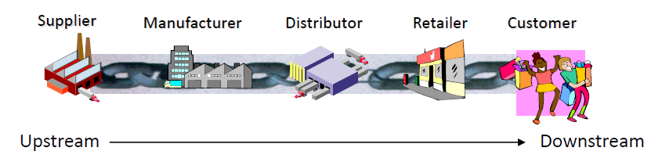

All companies along the chain need to cooperate for different reasons and the chain then acts in the more similar way possible to a single company. A company can cover more than one place in the supply chain, having multiple functions and/or operating in different markets.

One of the benefits of SCM is that all the companies in the supply chain can share the same information. ERPs sharing the same information is easier when the level of standardization is high inside the industry.

Web is utilized to improve experience with other businesses such as suppliers, so to offer them services and the side effect is to attract them instead of needing to searching for businesses to cooperate with. This is extremely useful as companies want to have a supply base that they can use to adjust to market demand. So one of the main goals is to adapt supply to demand in an easier and effective way. When a company has the capability to adapt supply to demand, it can provide to the market the right product, at the right price, with the right intermediary, in the right quantity, to the right costumers, at the right time, all of the above resulting in higher profits. Downstream companies are the ones nearer to costumers and so to demand, and aside from being the first to adapt, are also the ones creating new needs for the market through marketing.

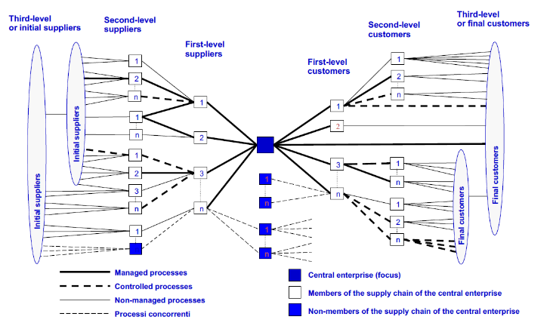SCM allows to create a map of relations between the companies, and to automatically rank suppliers according to some parameters given to the system.

SCM is a continuous learning process focused on a company, typically most focused on the leading company, which is the one operating downstream. The leading company is the one who can impose a standard on suppliers. There are 4 main phases:

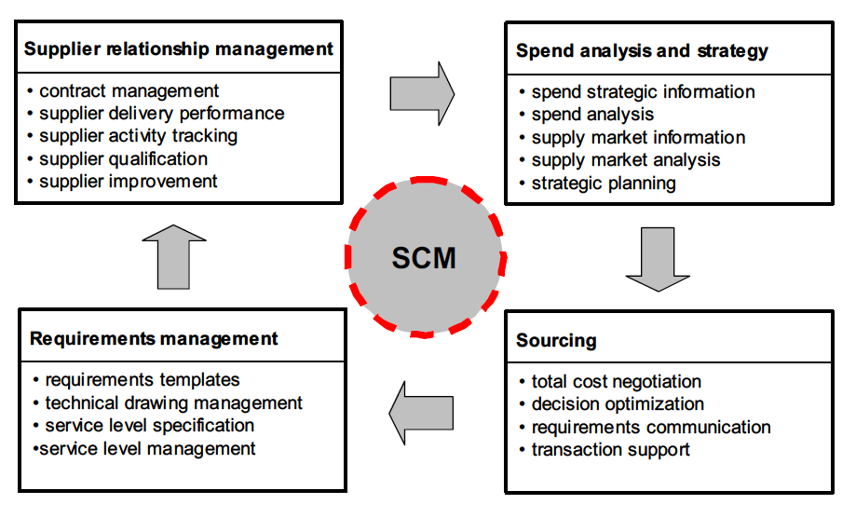

1. Spend analysis and strategy: in this phase what the company needs must be understood. Starting from a spend analysis, in which all purchases and expenses are analyzed. The analysis comprehends the study of the suppliers, so to understand the convenience of them and to see If there are new suppliers not involved but that might be of interest to involve. So a selection of suppliers happens with as output a ranking of them. The objective is to increase the weight of better suppliers. Based on this information, a strategy is defined for the company. Along the process, also analysis on particular items and suppliers for those items are made.
2. Sourcing: consists of different phases starting from the negotiation with suppliers. After that, decision optimization happens, which consists in implementing a system to optimize daily decisions with static or dynamic approaches but always in a consistent way with the strategy. Requirements are communicated to chosen suppliers. At the end, during transaction support, the integration with suppliers happen and the collaboration starts.
3. Requirements management: during the collaboration, suppliers need to have enough information about the company in order to optimize their production according to the company needs. This way, they can plan in a synchronous way. Also the Research and development of both the supplier and the company must be aligned in order to support continuous innovation.
4. Supplier relationship management: during this phase, supplier’s activities are monitored. Company has to make sure the supplier is growing with the company itself. During supplier’s selection, standards are imposed so that suppliers have to qualify to become the company’s partners adapting to the standard and to the company’s needs. Also a training program can be set to let suppliers grow with the company after the selection.

# 2. Social Media

Social media are Web 2.0 sites, i.e. sites that support any form of sharing of user generated content by leveraging the social relationships among individuals. They represent an innovation that has impact on both organizations and businesses, for which they have a value.

Social aspects are used as a leverage to attract users to share content. The extent to which social media leverage social relationships can vary from pure sharing of interests (e.g. YouTube channel) to a form of interaction among actual friends (e.g. Facebook). End users share content for a return: it might be entertainment, gaining a position in a certain field recognized by people, social motives, for fun, for prestige tied to the number of followers, etc. Social media are designed to make sure the return is clearly visible.

Companies owning social media make money by selling ads and selling information about the users to third parties. The more a social media is utilized, the more information is collected and the better for the company.

There is contamination between real-life social relationships and the networks of relationships on social media:

* Social media create new social relationships.
* Social media change existing relationships, it is a communication channel and so has also effects on the way people communicate on it.
* Social media change the time frame of social relations; an example could be keeping track of past work relationships with LinkedIn connections or adding a person as a friend after meeting him so to extend the relationship
* social media reduce the barriers of knowledge sharing (e.g. Slide share) and, thus, reduce the clout of knowledge holders. In fact, knowledge is easily accessible and it is difficult to protect the ownership of knowledge, so people tend to be less protective about their contents.

Overall, social media make social relationships easier, reduce the importance of knowledge holders and increase the importance of content.

Since clout on social media depends very much on content, social media tend to care about the quality of content and invest in keeping it clean and dependable (e.g. Wikipedia). In general, if something is on social media, we take it as «true». Normally, the source is not considered enough to guarantee that content is true, but people trust social media content thanks to the «wisdom of the crowds»: if something is not true, somebody would know it and tell the community.

*Historical case:*

The classic wisdom-of-the-crowds finding involves point estimation of a continuous quantity. At a 1906 country fair in Plymouth, eight hundred people participated in a contest to estimate the weight of a slaughtered and dressed ox. Statistician Francis Galton observed that the mean of all eight hundred guesses, at 1197 pounds, was closer than any of the individual guesses to the true weight of 1198 pounds. This has contributed to the insight in cognitive science that a crowd’s individual judgments can be modeled as a probability distribution of responses with the mean centered near the true mean of the quantity to be estimated.

The **wisdom of the crowd** refers to the process of taking into account the collective opinion of a group of individuals rather than a single expert to answer a question. This phenomenon can easily lead to its misuse.

There are 4 main classes of social media:

* Content sharing (videos(e.g. Youtube, Vimeo), pictures (e.g. Flickr), music (e.g. Napster) , knowledge (e.g. GoogleDocs, OS), experience (e.g. Yelp, or any feedback system))
* Social networks (e.g. Facebook, Orkut …)
* Forums (moderated interactions, netiquette, evolution of bulletin boards and newsgroups, e.g. 4chan.org)
* Blogs (personal blogs, corporate blogs, news blogs, political blogs, prison blogs …). Platforms: blogspot, wordpress. Note that nowadays blogs are usually linked to social media.

## Crowdsourcing and Co-creation

The wisdom of the crowds is the basis for crowdsourcing and what makes it so powerful. **Crowdsourcing** is the act of sourcing tasks traditionally performed by specific individuals to a group of people or community (crowd) through an open call. Crowdsourcing is a distributed problem-solving and production model. It is a paradigm in which tasks, previously executed by professionals, are sourced from a community of non-experts.

A famous example of crowdsourcing is *Waze*. The app was made competitive because they created a map cooperatively, they track users and know about traffic in real time. However, people cooperate and put effort if they receive something back. Waze gives to users the opportunity to grow and gain points in the platform so to create an online and recognizable personality for people and so to give them satisfaction in contributing.

Another example is *Nike*, which collects data from thousands of customers' finger taps on their smartphone displays and use it to collectively dictate what merchandise should be stocked in a new concept store in LA. In this way, they hope to bridge the virtual and physical world.

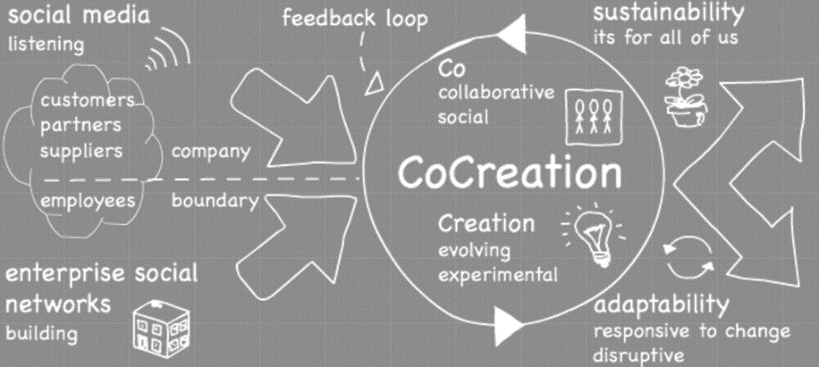A specific goal of crowdsourcing can be **co-creation**, which is a way in which companies can use crowdsourcing. Co-creation is a product/service innovation paradigm based on the cooperation between a supplier and the potential customers of the new product/service. Companies co-design products and services not only via their hierarchical functions and consulting experts, but also thanks to the cooperation with customers.

Cooperation can be:

* Direct, i.e. customer participation in the innovation process is deliberate (aware) and active.
* Indirect: innovation occurs by taking advantage of the suggestions, comments, and opinions that customers provide in a variety of ways (call center, corporate site, social media…) without making them explicitly part of the innovation process (and related decision-making tasks).

It’s usually not advisable to have a direct cooperation, instead of an indirect one, for many reasons. It’s not to be taken for granted that customers are willing to take part and so to put the necessary effort into the co-creation. They could be put in a rewarding environment but in some cases it might not be enough, while in others the initiative can work well. If the company has a negative reputation, involving customers in direct cooperation can lead to bad results. If the cooperation is indirect, customers that are not aware they are participating express opinions freely and are then more useful for innovation.

Companies should do the so-called “**listening**” initiative to understand the general opinion of customers on the company. This is important in both types of co-creation, direct and indirect. In fact, on social media, customers spontaneously provide suggestions, comments, and opinions, that are more easily sincere than in the outer world. Listening can provide indications on all the inputs provided by customers that can be useful for product/service innovation. When co-creation is aimed at design, it can focus on «influencers».

Usually, indirect co-creation represents the first step (according the «listen first» principle). A broad-range listening, outside of one’s own community can help identify a few indirect co-creation initiatives useful to set clear goals for direct co-creation.

A fundamental risk of co-creation initiatives is to assume that customers will be happy to cooperate and will contribute to the initiative just because they are provided a chance to do so. This is generally not true. So, contribution should be encouraged and coordinated with a careful design of co-creation initiatives. When designing a co-creation initiative, a checklist can be followed, containing the main design variables that should be taken into account:

* Participation mechanism: how and where a customer can participate? what are the customers going to do and contribute to?
* Technology platform: to lead on
* Roles and tasks of community members: participant, coordinator, etc.
* Types of users in the community: with different aims
* Incentive systems and rewards: for taking a role, for participating, etc.
* Quality control mechanisms: the initiative shouldn’t degenerate in low quality suggestions

## Communication and Marketing on social media

Marketing is defined as «market orientation». It involves sensing market requirements to respond with organizational flexibility. Traditionally, the first step of marketing was to make an organization’s products and services known to the market, as a necessary action to stimulate feedback. Unfortunately, this communication has been found to be very effective also to drive the market especially through broadcasting. As a consequence, traditional marketing is often equated to advertising and there is always the idea that you can both sense and drive the market.

On social media, communication goes both ways between the customers and the company. The company sends a message, for example with advertising, but nowadays the customer has a way to reply.

In the past, the communication happened only in one direction, from the company to customers via advertisement. This kind of communication is the broadcast: in **broadcasting**, one broadcaster makes a content simultaneously available to many listeners (the audience). Customers could not reply and so the message sent by the company had to be qualitatively high but not necessarily true. An add on television had to be nice to watch and nicely packaged.

On the contrary with respect to broadcasting, in **communication** all players are both broadcaster and auditors at different points in time. Communication involves the ability to «listen». In communication processes, each one of us expects to be listened to at some point in time.

Suspension of conscience: on broadcasting people are passive, they see the ads but they do not interact, so only the content holder is relevant in this case and the focus is on it instead on being on the message passed through the ad. The conscience is this way suspended, as people care only about the form of the ad. If it is untrue it does not matter, the customer thinks he can most of the times distinguish it.

In social media the audience is not passive as in broadcasting, they are engaged in conversations on social media, the conscience remains active. Content plays a more important role on social media where it is more important than content holders. Companies need to say things that is credible by the mass, if something is credible people will share and appreciate the message, while if it is untrue than people will respond and give public negative feedback that other customers can see. The way the content is conveyed should be designed and the content itself should be true in order for a message to be effective.

The same message that may be effective on a broadcasting channel, like television, is most of the times not effective on a communication channel such as social media. The message should be conceived in a totally different way, in order to be convincing enough for people who receive the message to share the content spontaneously. It’s possible to say that, on social media, marketing is «viral»: it takes advantage of the ability of all users to become broadcaster. However, people are free to choose whether to broadcast or not at all, so strategies need to be implemented. This is a very profitable and efficient way of doing marketing, because a message delivered by a person sharing it, rather than from the company itself, is more powerful. However, saying something negative has a higher impact than saying something positive, so it’s crucial to be careful to be shared for good things and not for bad ones.

What can also be done is to use the concept of influencers: people with a lot of followers that are opinion leaders in a certain field. They can be sponsors of a company for a price that incentives them to go on delivering advantages to the company. It’s however important that they are chosen wisely, handpicked. An influencer sponsoring a company has to be credible and do something that represents his character. If an influencer adapts to the company needs, it won’t work at all or at least not as good as if the company chooses and influencer that fits the company message.

Some findings about social media marketing:

* On average, negative tweets seem to be more retweeted than positive ones. However, social networks have a general positive bias.
* However, the dynamics (i.e. speed) of retweeting seem to be independent of the sentiment carried by tweets
* The volatility of tweets is a critical variable, as 80% of retweeting occurs within the first half an hour from posting.
* Having more followers increases the probability of being retweeted, especially for negative opinions. However, about 40% of retweeting is performed by non-followers.

## Manage the online reputation of a brand – Social CRM

The process of managing the online reputation of a brand is the following:

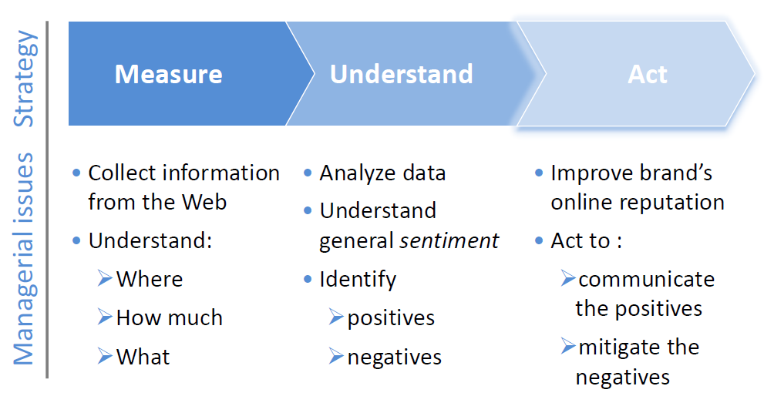

At first, some measurements happen. How much and where people talk about the brand? What are the most popular topics of discussion? Info is gathered in form of semi-structured information. Then the data need to be analyzed to identify the weaknesses and the strengths of the brand. The need is to understand the general sentiment about a certain topic. At last, the manager should act, meaning communicating the positives and mitigate the negatives, for example communicating an improvement of a negative issue. Mitigating the negatives cannot be done through communication only.

The tools to utilize for this purpose is **social CRM**. Social CRM is a set of functionalities meant to manage the presence of the company online, by integrating the social media into the CRM platform.

Social CRM usually starts in one of the following ways:

* Hosting and supporting a branded or private-label community and providing the surrounding functions
* Monitoring, listening-to and surveying private-label or independent social networks
* Facilitating the sharing of common B2B or B2C contacts through the use of an internal community
* Community product reviews to facilitate the online sales process

Must be noticed that to have a complete view a private-label community is never enough, as it is necessary to listen to all kinds of customers.

Typical Social CRM user functionalities are: discussion forums, message boards, comments, polls and voting, surveys, reviews, ratings, chat, blogs, wikis, bookmaking, tagging, search. Inside a private-label network, a company can insert automatically these functionalities and customize them as whished.

On the other hand, typical administrative functionalities are: moderation, reputation management, dashboards, reports, events management, privacy management, video management, outbound campaign functionalities. These are all meant to facilitate the activity of social media handlers.

Social CRM performs listening through surveys, direct interaction, manual monitoring (e.g. fan pages). It is to be combined with Listening, which should be broader and include posting from non-members of private-label networks (e.g. non-fan), it should help understand a brand’s competitive position, strengths and weaknesses compared to other brands. The disadvantage of listening is that it is technically challenging, as it involves the semantic understanding of natural language.

From 2014, traditional software vendors have started to integrate social media intelligence.

Social CRM relies on a listening platform, that in most cases is its own platform, but might be a different one. It’s important to know the sources exploited by the CRM, as it’s practically impossible to include all of them. Most platforms state that they crawl «the Web» or «all the Web», but it can’t be true.

Some platforms will also provide indicators of the precision of assumptions made, for example on identification of the brand or categorization. Precision is typically not assessed or assessed on a single type of analysis. It’s to be taken into account that assumptions could be used pipelined (so for example 3 assumptions of precision 80%, which is ok for a general purpose, will have a pipelined precision of 0,8x0,8x0,8 which is low).

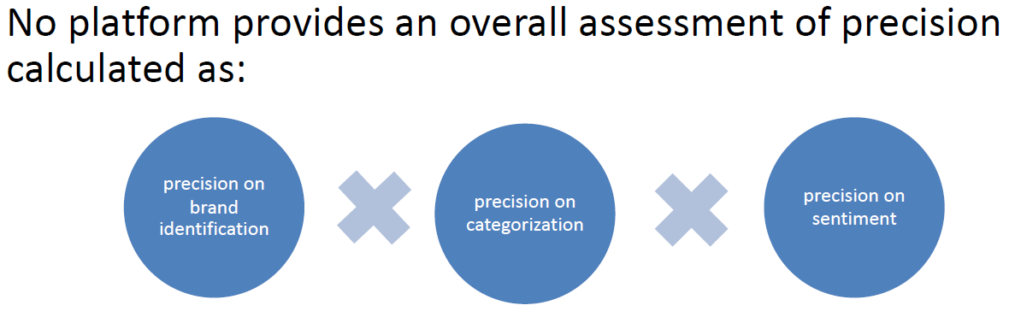

Another issue to take into account when choosing a listening platform is whether it is real-time or not. 75% of top platforms (Forrester sample) state that their service is real time, but real time is not defined as an absolute metric, but is intended to be «quasi» real time (below 1 hour). But real time is not guaranteed for all sources. Also, platforms do not specify whether real time applies to all data or only a subset.

Some popular additional functionalities might be analysis on geo-localization, or benchmarking services based on the analysis of leading companies within selected industries.

50% of top platforms (Forrester sample) state that they provide vertical solutions in multiple industries, but some solutions are vertical and industry specific. This allows to embed the domain-specific knowledge in their analysis and as an effect increase precision. Only 3 platforms specify the industries for which they provide vertical solutions (Nielsen, Attensity, Jdpower, so they are all specialized in market analysis). None of them provides benchmarks on the amount of domain knowledge that they embed.

## Come entrare nel Metaverso con Oculus Quest 2 - IT AtsitSocial media and the *Metaverse*

In 2021, Facebook company announced to change name into “Meta”. According to Zuckerberg, the mission and the philosophy of the company was going to remain the same.  
The big innovation that came along is the so-called ***metaverse***, for which the key words are connecting with people, and it is meant to be a fully customizable experience for the customer, with a continuous development of new features.

An issue is the one concerning privacy and safety of users, which is said to be completely taken care of with efficient solutions. The *metaverse* would also redefine how people spend money, as for example you do not need to buy a tv but just the model of it.

People can have their own home space in the digital world, called “Horizon Home”, and it is going to be customizable. Spaces are in general customizable and are where avatars belonging to different people can meet. This other space is called “Horizon world”. People can meet in the metaverse also for work reasons, and work needs to be possible. Some solutions and tools for work’s reasons are proposed, a lot of attention is devoted to this theme, especially in regards to the communication and interaction part of work.

According to the plan, the tools in the metaverse won’t substitute present tools, but existing developers and customer’s applications will be integrated. The “Presence platform” is which is a broad range of machine perception and AI capabilities that empower developers to build mixed reality experiences on the platform. An example of functionality is the one regarding the utilization of hand interaction with the app.

Quest is the Virtual reality tool to enter the metaverse. Another high end product is in project and it’s called “Cambria”, and it should embed the most modern technology available. A functionality of Cambria is the reproduction of facial expression and eye movement of the person wearing it on the avatar, to facilitate interaction inside virtual reality. Another one is the reproduction of the real physical world inside the headset, in order to make possible some activities like fitness.

Also augmented reality is involved, and “Nazare glasses” are the project of augmented reality glasses.

# 3. KPMG – Consulting for ERPs

## From Legacy systems to ERP systems

A **legacy system** is a system that is created as successive layers of autonomous applications, each of which covers the IT needs of different organizational units. Every application of a legacy system has its own Database (which can or cannot be a relational Database), so there is no data integration between applications that communicate to each other through interfaces. Their development is expensive, as they are developed in a "custom" way, they are built through an extensive use of software programming activities. Despite their development, they are technologically underdeveloped, as they do not embed the state of the art technology, and therefore based on Mainframe or Host technologies and characterized by character-based interface. Legacy systems are software usually developed in-house which allow the registration of all the operational activities of the corporate functions.

On the other side, there is the **ERP** paradigm. ERPs were born as an extension of MRP (Material Requirement Planning) and MRP II (Manufacturing Requirement Planning). MRP Systems were born to rationalize the use of materials in factories and were transformed first into MRP II which were able to control the entire production activity, and finally into ERP with the addition of administrative, management and financial functions.

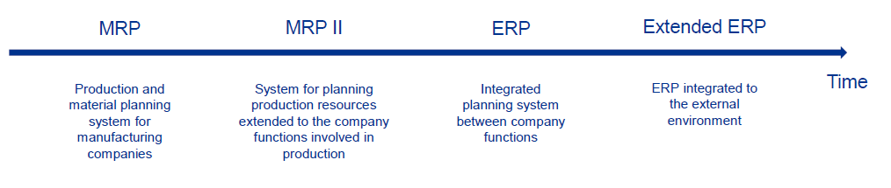

To make a comparison between legacy systems and ERPs:

|  |  |
| --- | --- |
| Legacy system | ERP |
| Closed systems.  Ex-post records of information about past actions.  Use of non-shared repositories, duplication of activities.  Heterogeneity of operating methods across business functions.     * Ex-post information recording on past actions. * Development of programs for individual functions. * Programs developed in-house. * Use of non-shared repositories, duplication of activities. * Heterogeneity of operating methods across business functions. * The activities carried out in one functional area do not affect other functions. | Internal integration.  Systems that can perform simulations and make proposals on future actions.  Sharing the same archives and information.  Sharing of the same operational logic among the various company functions.     * Systems that perform simulations and make proposals on future actions. * Development of programs for processes shared between multiple functions. * External supplier packages. * Sharing of the same operational logic across business functions. * Open systems that allow integration with external applications. * Close interconnection of activities carried out in the various functional areas. |

## How ERP systems are made (levels, environment)

The main features of ERP systems are:

* They cover the main business processes (logistics, accounting, production, human resources) through a set of application elements called "modules" or "granules";
* Since in ERPs there is a single Database, they guarantee the uniqueness of the data and therefore the univocity of business information, thanks to the fact that transactions update online the data managed by all business functions, and there is no redundancy of information;
* They are produced by the major software houses that develop them according to the requirements of pilot customers and update them continuously according to technological, regulatory or best practice evolutions;
* Controlled data management and uniqueness imply that data cannot be modified directly but through "transfers";
* They are characterized by relational DB;
* They are characterized by a Client/Server architecture;
* Although they do not cover all Core Business processes, vertical solutions by industry are available for the main ERPs;
* They bring into the company a set of processes referred to best practices, without having to "reinvent the wheel".

Here is the logical architecture of an ERP system:

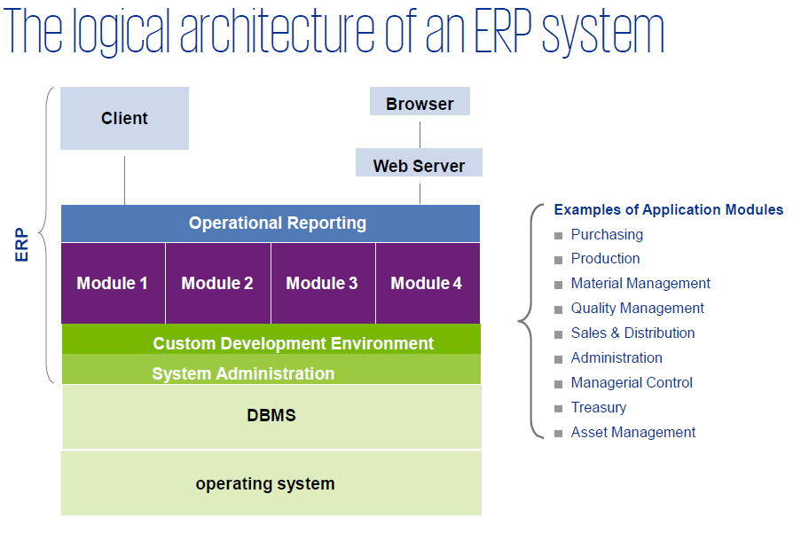

There are 3 main steps in the history of ERP systems:

1. Enterprise Information Systems (EIS): these are the first business information systems to be created and they aim at managing individual business functions like general accounting and warehousing.
2. Material Requirement Planning (MRP 1 and MRP 2): applications devoted to production process planning, done by taking into account different elements in an integrated way. MRP2 aim at the optimization of the entire plant production system by supporting new ways of planning and control.
3. Enterprise Resource Planning (ERP): expansion of MRP 2 to cover more functional areas, till the full range of activities within any company.

Nowadays, ERP is expanded by the Extended ERP which includes the Customer Relationship Management (CRM), the Supply Chain Management (SRM), and functionalities for the advanced management of planning and scheduling processes.  
The new ERP platforms are developed consistent with current paradigms regarding:

* Cloud Computing
* Remote usability Mobility
* Leveraging the processing capabilities of large volumes of data Analytics (Process Mining)
* Extension of the Internet to the world of concrete objects and places (IOT Internet of Things)

The main evolutionary line of the ERP systems is that one to open itself towards the outside supporting models of company "extended" or virtual. The key words to explain the main evolutionary line of ERP systems are: Accessibility, Collaboration, Synchronization.

Key players in the ERP technology are Oracle and SAP, followed by Microsoft and others.

## The introduction of an ERP system in the company

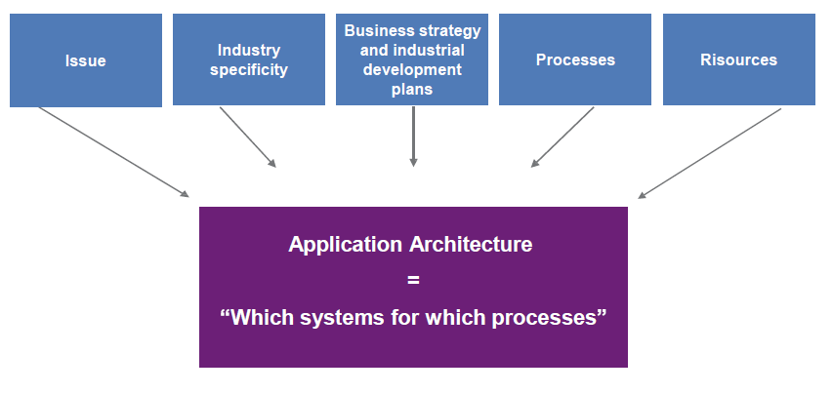Choosing or implementing an ERP has some issues and there are some recommended steps.

The choice of an ERP should be framed within a broader definition of the application architecture that requires an articulated assessment of both the current technological and organizational situation and the business strategies and critical success factors of the company. Processes, resources, business strategy and development plan of the company, the specificity of the industry need to be considered. Implementing an ERP is not only an IT project but one that embraces processes, human resources, and IT.

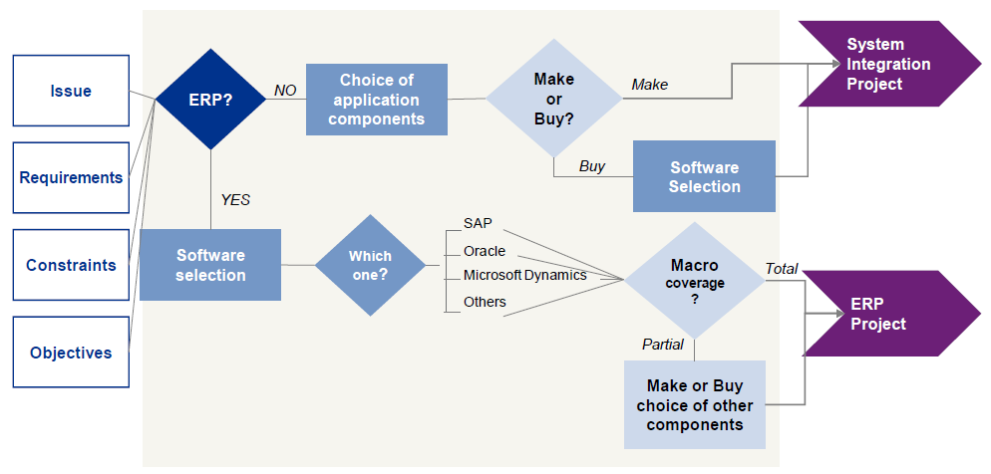

The software selection can have two kinds of foundations:

* Industry based
  + Strategic criteria
  + CEO perspective
  + Based on analysis of suitable solutions from industry leaders
* Requirement based
  + Specific criteria
  + Based on the choice of the ERP that best covers the specific requirements

If the processes of a company are standardized, it is easier to find a ERP that fits the requirements.

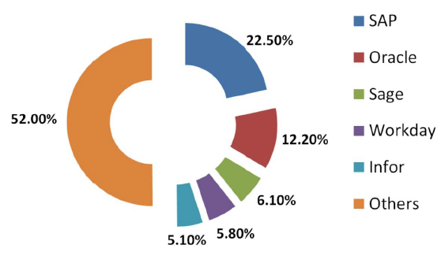

## SAP: sample of ERP system

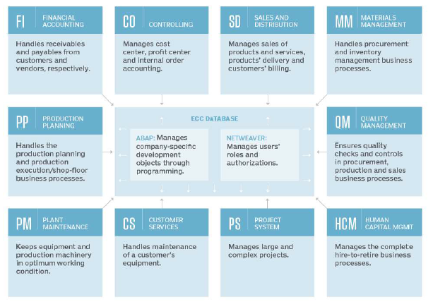SAP is a popular ERP software that now covers most of the company functional areas (about 1200 processes), is structured with Modules having a single Database with the most used DBMS, uses the most widespread hardware platforms, and is based on hierarchical Client/Server technology on 3 levels. SAP system is currently structured by processes and scenarios. Among insiders, the module concept remains absolutely central.

During a process, more modules are called into action and they need to cooperate in order to perform the required process. All these modules are inside SAP ERP.

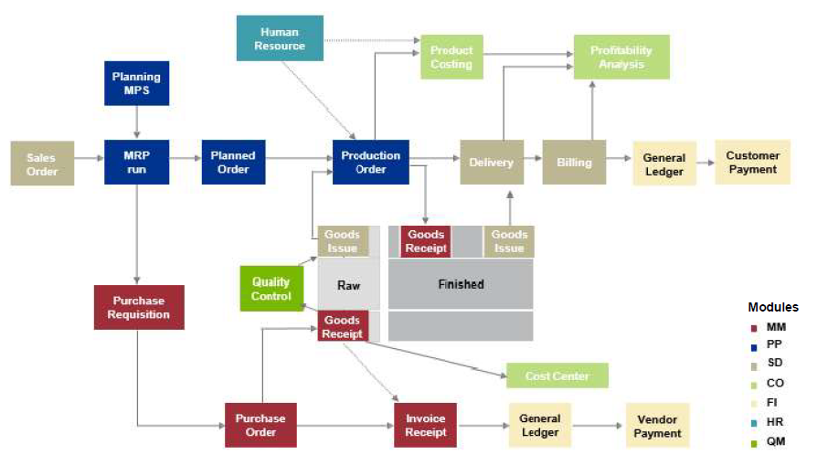

Main areas of SAP modules are:

* Financial
* Controlling
* Asset Management
* Sales and Distribution
* Material Management
* Production Planning
* Plant maintenance
* Basis component
* Human resources
* Project system

All the modules are integrated and attention is also devoted to the user interface of those modules.

## ERP Projects

The ERP project is one of the primary agents of business change and a unique opportunity for companies to renew their organizational and cultural system. The impact of ERP projects that are most significant for the company are those on human resources, on their ways of working. The business impacts of the ERP project must be addressed and managed with great care both to achieve the project objectives and to contain the project risk.

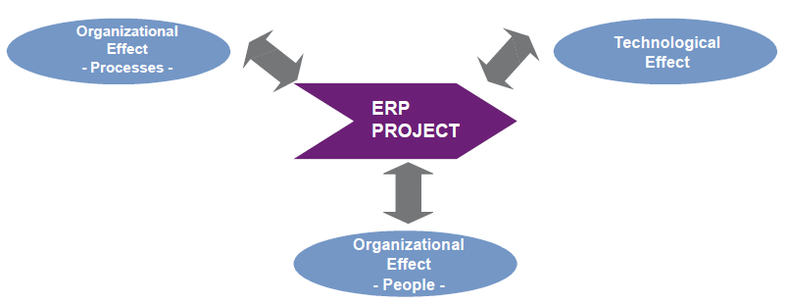

KPMG conducted a survey of 252 companies. The main reasons for the lack of success of information systems are as follows:

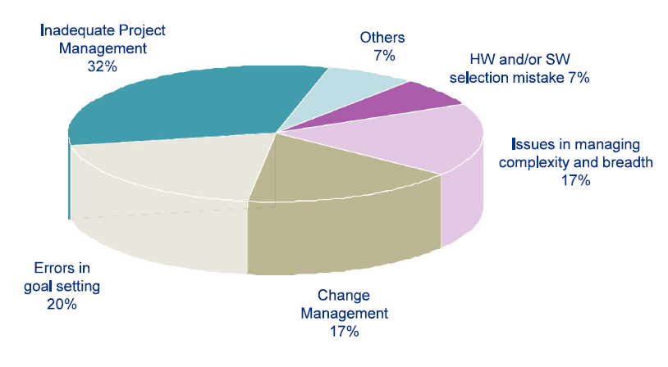This shows that in an ERP project the initial setting of goals is crucial for the success of the project.

The methodology for an ERP project is the following: (the flow from left to right)

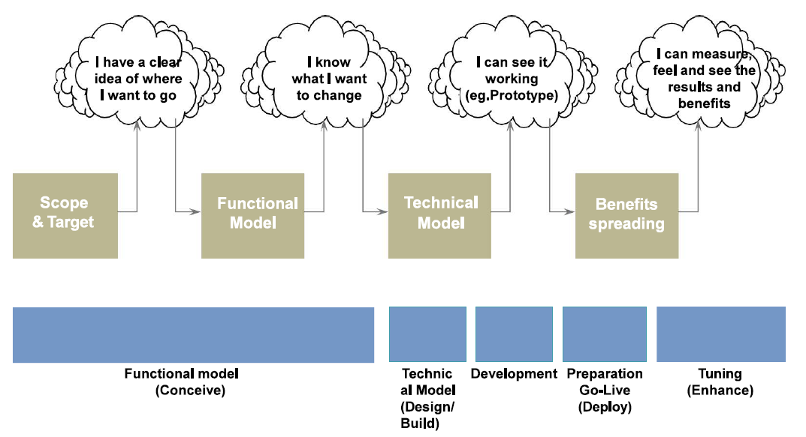

All these steps are covered by a specific methodology. Each consulting company has its own methodology developed and tested on the field.

The methodology of KPMG is divided in 5 main steps:

* Conceive
  + Define an Alignment between processes and systems
  + Identify the processes as is and to be
  + Definition of the conceptual model of the processes and the systems (Blueprint)
  + Functional Process Model
  + Application Architecture Definition and Gap
  + Migration Strategy
  + Detailed Plan
* Design/Build
  + Build and setup the ERP system
  + Technical model definition and prototyping
  + Prototype
  + Functional and technical analysis
  + Interfaces
  + Migration tools map
* Develop
  + Implementation and testing of the system in all its components
  + Configuration
  + Programs, interfaces
  + Data traces
  + Test cases
* Deploy
  + Preparing and populating the production system
  + Uploaded data
  + Production system ready
  + User profiles
  + Contingency procedures
* Evaluate/Support

Let’s look at some steps more in detail.

During conceive phase, the process representation happens. Alignment between processes and systems requires a clear representation of *As Is* and *To Be* processes, as the new trending model of business processes initiates the requirements definition and management process that is the backbone of a BPR or ERP project. There are many ways to represent the processes of the trending model, the choice of which depends on the context, the client, the time availability and the objectives. For ERP projects, the procedure (or circulation) diagrams represent the most suitable solutions (on the columns the organizational units, on the rows the process steps).

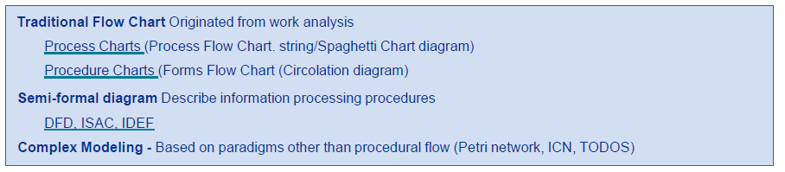

In recent years, international process mapping standards based on the concept of Business Process Markup Language (BPML), such as BPMN, have become widespread and can be transformed into workflow models for modern Business Process Management systems.

During the design phase there is a requirements chain for requirements to be expressed and followed. The step from the design of the process to the realization of the system is much delicate one since the model to tend of process must transform itself in specific requirements. Every step of deepening in the analysis of the requirements demands the consistency to the previous step. Every step of deepening in the analysis of the requirements demands, subsequently to the implementation a verification through a specific test. The Design and Build phase is characterized by the development and from the deepening of the requirements to the design of detail of the solution.

Business Objectives <--> Functional Requirements <--> Technical Requirements <--> Implementation

Then a prototype is produced as output. It has three functions: to allow functional requirements to be highlighted by having users see a concrete example, to allow to support with concrete examples the choice between different implementation and configuration options, to allow to highlight the process scenarios as a difference from the base scenario. The prototype is always prepared on the base case and then expanded to other scenarios in subsequent prototypes.

In the design, the right trade-off between custom features and standard package utilization needs to be found. Frequently, most of the requirements can be covered by the packaged solutions, assuming the company chooses the right solution and approach. The effort in ERP projects is to trace the identified solution back to standard solutions; gaps unfortunately exist and need to be identified, documented and managed. Often, gaps are filled with some customization.

The build phase is characterized by intensive testing. The realization of the information system is realized in the extension of the prototype scope to all identified scenarios (configuration of all system parameters) and in the completion of custom developments, interfaces and data loading programs. During the Develop phase all the prerequisites for the Go Live of the system have to be effectively created such as: clear organizational procedures, process and system training, user profiling. In the next phase there are the key elements: testing and data migration.

From the implementation, at first technical requirements are tested. From them, functional requirements are tested and going up again from functional requirements it is possible to test the fulfillment of business objectives.

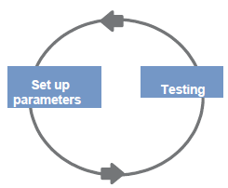The Test can be read as an evolution of the prototype cycles, the tests however have an official and contractual value from the point of view of KPMG.

Type of Test:

* Necessary
* Unit Testing: testing of individual modules is done by the core team
* System Testing: Connection between the different modules within the ERP test
* Integration Testing: Entire process with integrated testing between interfaced components test
* Data Load/Conversion tests: Quality of the loaded data, normally it is inserted inside an integration test
* Optional
* User Acceptance Testing: user validation
* Parallel Running: extensive testing to verify the process and develop user readiness
* Model Office: test oriented to the verification of the workload on the specific organizational unit

During the testing period, system changes are very dangerous which could impact on other business processes or areas. It is therefore necessary to test all potentially impacted areas. Therefore: changes during testing could cause many problems, the system should be kept as stable as possible, its needed to delay minor changes to later moments.

## Recommended Approach

KPMG has developed a recommended approach based on 4 steps:

1. Create a transformation vision
2. Define the transformation
3. Define a design and an integrated roadmap (in terms of implementation, streams of the project)
4. Communicate and mobile people, share the project with all the department involved

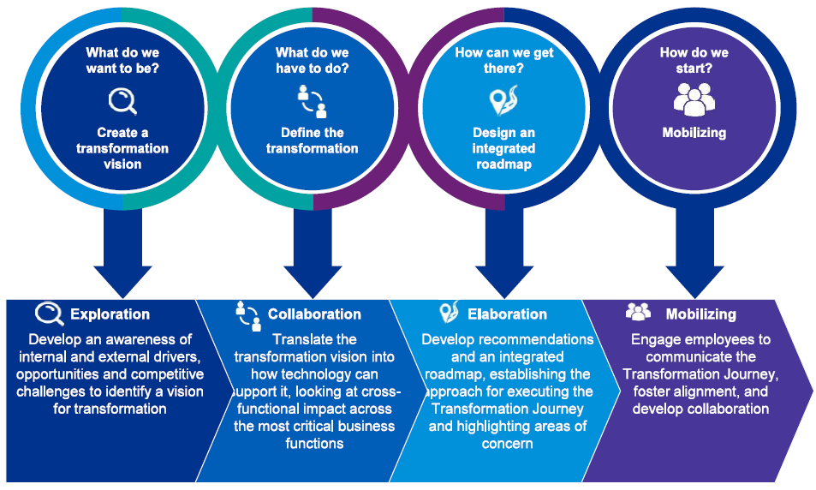

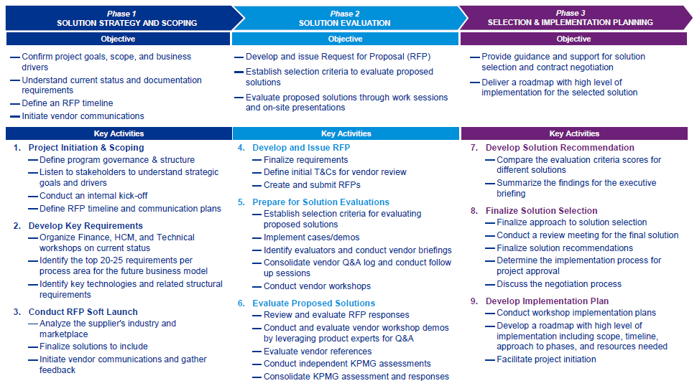

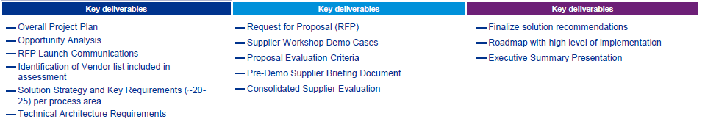

# 4. KPMG – Engagement Review Form

## The culture of feedback in KPMG

Inside KPMG company, a vibrant feedback culture is being created, where giving and receiving feedback is the norm. Feedback is asked regularly to a broad range of colleagues, in order to support the development of employees, make possible to learn and adapt and constantly look for ways to experiment, innovate and grow. Also self-evaluation and assessment has the same weight and contributes to the same objectives.

There are two types of feedback: informal and formal. With **informal feedback**, the subject of it can choose how to use the observations that are made at no precise moment, in real-time. **Formal feedback** has a precise moment dedicated and is part of the performance management process. Self-assessment, receive feedback, give feedback, ask specific questions in a transparent way to the performance manager or to colleague in order to work on some issues or objectives. It’s important that the evaluation is given before receiving to read an evaluation from others, to guarantee transparency.

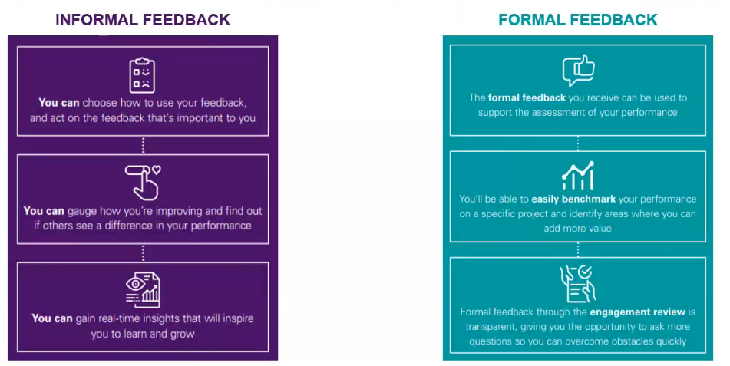

**Engagement Review Forms** (ERFs) are a tool for gathering formal feedback on engagements, it’s the template used for formal feedback. ERFs allow appraises to adopt a growth mind-set and be ready to act on developmental feedback. They help the employees to drive performance and client results, by ensuring fair and rich feedback is provided promptly by Engagement Managers after any given engagement/project life-cycle, and support Performance Managers to receive data which helps them to assess and differentiate performance fairly at key performance development milestones.

ERFs align with KPMG’s values of *Everyone a Leader Framework*, that articulates what high performance looks like at KPMG and outlines the critical competencies all the employees need to demonstrate in order to drive enhanced performance individually and collectively. An employee does not need to be in a senior role in order to be a leader and gain trust of his colleagues; this leads to high performance individually and as a team. Every team member can make a difference and needs to be involved as much as possible so to make his voice relevant. There are 3 pillars of Everyone is a Leader Framework: Inspire Trust, Deliver Impact, Seek Growth.

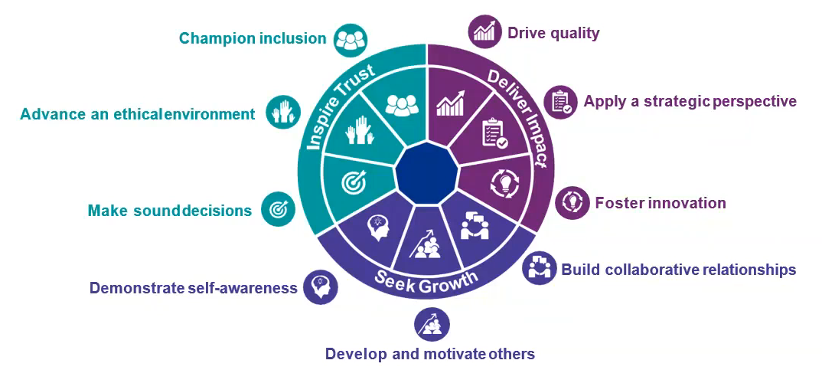

# 5. The IT Strategy consultant

Being an **IT Strategy consultant** is about understanding the business. Then a consultant needs to know about technology, about information strategy and everything that is related to IT, but the most important thing is to understand the business. Technology per se is useless, it needs to be connected to business to make it powerful.

Nolan, Norton Italia is the ICT Strategy company of the KPMG Network in Italy. It is a point of reference for organizations wishing to strategically exploit the transformation process connected to technological innovation. The company helps organizations to understand the strategic role of ICT for their competitive positioning, a distinguishing feature in the current framework of digital transformation. Its approach recognizes ICT as one of the factors that most influence the transformation of the economy and which has allowed to oversee all the technological eras up to today's Digital Transformation.

In the theory of "Information Systems Development Stages", it was recognized that the ICT is one of the factors that most influence the transformation of the current economy, as it pervades all sectors of activity, involves human resources, organization and management, which constitute all the essential paradigms of competition. Therefore, ICT has a strategic role in determining the competitive positioning of companies and as a consequence comes the necessity for consulting, to help improve the companies’ abilities in the following:

* Business linkage: develop the connection between business and organizational strategies and information systems
* define of the *application and technological architectures* facilitating and supporting the evolution of the organizational and business model
* assist the company in managing transformation programs and complex ICT projects, managing the problems of cultural and organizational change urged by the information technology
* develop internal expertise to face the increasingly fierce and changing competition
* Market Vision: support the assessment of supplies from a benchmarking perspective with respect to market values

It is possible to distinguish between some models that represents the evolution stages of IT inside companies. Old models can still be found in a lot of companies.

* **IT Silos**: in the 90’s, IT is considered a mere technical support for operations. Application is developed on a specific type of hardware, often with a mainframe. Silos is a model that is present in hierarchical-functional organizations with highly specialized IT technicians for it, but it is also an organizational structure for the people used to work: also people are silos, as they have one area of expertise and know well the applications they use, but they are highly specialized and without a global vision on business. This technology-oriented model is often still present in insurance companies.
* **IT Demand**: between 2000 and 2012, IT works as a bridge between business and technology. It’s when business people and IT people start listening to each other, in order to develop something that is useful for the business strategy. So, demand-supply models are enacted to support business-IT interaction and IT becomes a driver of the business strategy. In these years, it also started to grow the development of outsourcing models.
* **Digital Ecosystems**: from 2010, Highly integrated (Business - IT Operations) and flexible team networks appear and the challenges shift from the “Traditional” world to the “Digital” one. IT impacts on services and business models, for both big and new companies. New companies, in particular, are advantaged by the fact that new technologies enable new market entrants to launch new products and services quickly. Also, a multi-sourcing ecosystem of partners is now utilized by companies.

The IT function faces the challenges of the Digital Transformation as a strategic and integrated part of the business.

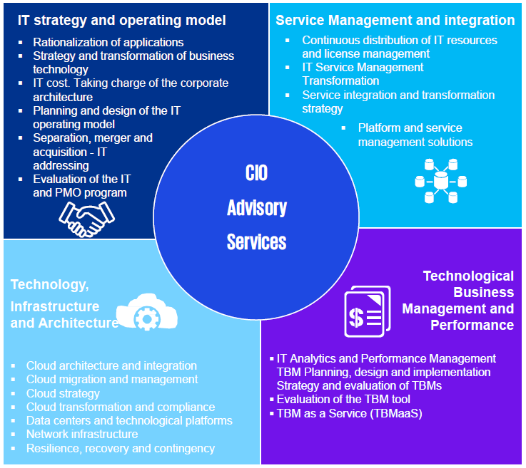KPMG's CIO Advisory has the aim to help CIOs, technology leaders and business executives leverage technology disruptions and more effectively manage technology assets to achieve agile and better business performance and improve strategic position, through technology investments finalized to continuous innovation and business growth.

There are 4 kinds of services provided:

* IT strategy and operating model
* Service management and integration
* Technology, infrastructure and architecture
* 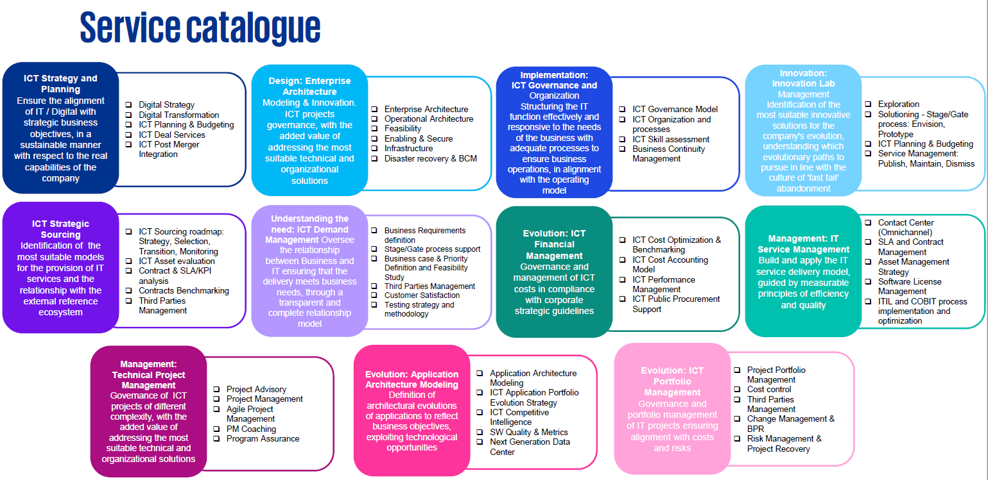Technological business management and performance

## ICT Assessment Methodological Framework

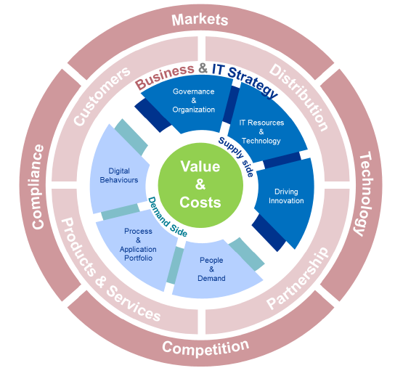The first thing to do in consulting is understanding the business that is going to receive interventions. The assessment phase tells the consultant about the resources and needs of the company, it allows to analyze all aspects of ICT, is useful for the “scanning" of the Company's information systems in order to suggest possible evolutionary guidelines and / or priority interventions.

Performing an IT assessment means to go through more areas of investigation.

The first area of investigation is **Business & IT Strategy** area. It must be understood whether the transformation is driven by the business and what is that the IT systems are not able to provide. This first analysis is performed by speaking with the business area of a company, so competence in economic is required. Different markets and companies have usually different challenges and different budgets for technology. In terms of percentage on the revenue, banks are the ones to spend more on technology as they have to fulfill regulations, this leads to increased needs.

|  |  |
| --- | --- |
| Business & IT Strategy |  |
| *Scope of analysis*   * Overall Business Strategy * Identification of current and future needs and "gaps" by Area / BU with respect to strategic developments * Identification of scenarios and "common practices" in specific business contexts * Identification of elements of strong discontinuity | *Goals*   * Identification of "do wells" and ICT implications * Check of the drivers to be implemented and of the main critical issues * Highlight opportunities for technological innovation and the impact of their adoption * Check the consistency between business strategy and ICT strategy |

A second area of interest for the assessment is **Governance & Organization** within the IT department. The analysis is about how the IT department is organized from different points of view. IT departments nowadays are a mixture of internal and external resources: there are internal people who run the day-by-day administration of the department and, to have more flexibility, there are external people devoted to new investments and projects, often with a long time relationship with the company. External providers may represent a risk, as they might have an advantage over the client as the client has no longer the knowledge and is “locked-in” and cannot change provider in an easy way.

|  |  |
| --- | --- |
| Governance & Organization |  |
| *Scope of analysis*   * Organization charts / Roles / Responsibilities / Activities / Policy * Staff size Skills / Skills / Certifications * Management methods applied to the main ICT processes * Relationship with "local" ICT structures * Internal / external resources, service procurement and control models | *Goals*   * Check of the sustainability of the Business and IT4IT requests * Check of organizational consistency with the characteristics of the services provided and the managed systems * Check of potential risks associated with "make / buy" policies * Evaluation of the control on external providers |

**IT Resources & Technology** is the area of analysis about the technical part. It’s an investigation about the kind of resources and technology in use, performed by experts in the particular systems and networks involved. It’s also about *shadow IT*: any piece of technology inside the organization that is not managed by the IT department.

|  |  |
| --- | --- |
| IT Resources & Technology |  |
| *Scope of analysis*   * Architectures (physical and logical) * Inventory by technological area: Systems (Mainframe, Open, centralized), Network: WAN / LAN / TLC, Storage, End User Computing, Virtualization, Cloud, Shadow IT. | *Goals*   * Identification of the technologies in use, obsolescence and heterogeneity * Check of the historical evolution of the ICT context * Analysis of the delivery model * Highlight consistency between solutions and service levels * Analysis of architectures scalability and flexibility |

The analysis then shifts to the area of **Driving Innovation** to understand if the company is ready for innovation and how much innovation the company is able to take. Proposing innovation is not only about offering new technology or new ways of doing things but also about understanding people and whether they are ready for the innovation. Retraining programs comes into scene here.

|  |  |
| --- | --- |
| Driving Innovation |  |
| *Scope of analysis*   * Innovation ability: Enterprise cloud (architectures, applications, scalability), Enterprise mobility and BYOD, Virtual Desktop, New generation data centers, Big Data management, Internet of Things, Unified Communications & Collaboration. * Innovation efficiency, effectiveness and barriers to entry. | *Goals*   * Identification of areas of potential technological innovation according to an "end to end" approach * Analysis of the impacts deriving from the use of current architectures / applications * Market analysis, selecting possible partners and defining contractual models (services and pricing) * Response to business requirements and regulatory constraints (e.g. privacy and security) |

Of big importance is understanding **People & Demand**, how the relationships work at operational level. Part of this is to measure user satisfaction.

|  |  |
| --- | --- |
| People & Demand |  |
| *Scope of analysis*   * User community (end users, Key User / Process Owner, top Management) * Demand Management processes * ICT user satisfaction and measurement process | *Goals*   * Analysis of the demand management process to ensure consistency with business requests * Identification of the perception of ICT within the Company * Consistency check in relations between ICT and users * Level check of objective satisfaction (e.g., by Customer Survey) and perceived satisfaction |

**Processes & Application Portfolio** is about the software. Companies have infrastructure and application portfolio that suits and support the business processes. This area is not a cross-market one, as it needs to satisfy the industry needs.

|  |  |
| --- | --- |
| Processes & Application Portfolio |  |
| *Scope of analysis*   * Front, middle and back end application architecture * Inventory: * Technology platforms, programming languages, databases, etc. * Information flows (internal and external interfaces) * Process coverage * Functional quality / technical quality * Project portfolio * Technical documentation | *Goals*   * Identification of the current and expected levels of compliance of the applications with the Business needs * Analysis of the qualitative "health" level of the application portfolio * Highlight key decisions to be addressed regarding applications evolution and maintenance |

Another area is **Digital Behaviors**. Internal users have also expectations about how technology should work, and this might affect their performances. Big Data is also something to be understood and to be decided how to use.

|  |  |
| --- | --- |
| Digital Behaviors |  |
| *Scope of analysis*   * Collection of business and user requirements * “Social tools “analysis * Corporate portal * Campaign management * Community collaboration * Human resources monitoring * CRM * Presence and use of Omni channel mechanisms * E-Commerce | *Goals*   * Definition of a Social Enterprise strategy * Scouting of market tools (listening, analytics, ...) and definition of KPIs * "Big Data" Adoptions Possible * Alignment of ICT and Marketing & Communication * Definition of a plan for change |

**Value & Costs** consists in understanding how IT costs work and evaluate the convenience of something, it’s value, compared to its cost. Cost accounting frameworks and methodologies are to be understood by the CFO. There are different kinds of analysis of costs that are possible, in order to deduce from the figures how the company works and the costs trends. Benchmarking is about comparing a company expenses with the expenses of competitors and peers.

|  |  |
| --- | --- |
| Value & Costs |  |
| *Scope of analysis*   * ICT spending reporting and control model * Annual view of ICT costs:   + By service (Server, EUC, ...)   + By activity ("running", projects, evolutionary maintenance)   + By nature of expenditure (labor costs, consultancy, SW license fees, ...) * Historical trend * Outsourcing contracts, main clauses and monitoring tools | *Goals*   * Consistency check for:   + Cost levels compared to the size and the business context   + Investment levels and development plans compared to business evolution and evolutionary strategies * Positioning of ICT costs with respect to the market indicators of the main Market analysts and / or based on information available in the KPMG Network |

**Compliance** analysis aims at analyzing the regulations of the market in which the company operates. This requires people with expertise in legal stuff to cooperate with consultants.

|  |  |
| --- | --- |
| Compliance |  |
| *Scope of analysis*   * The goal is to evaluate and analyses the system compliance with sector regulations (e.g. banking or insurance specific) and with cross sector regulations (such as GDPR), such as:   + User and profiling management process   + Guidelines (e.g., by e mail, internet and use of assigned ICT assets) | *Goals*   * Check of potential critical compliance issues, with the aim of protecting the organization from civil and criminal sanctions * Identification of improvement points and appropriately addressing the evolution areas, according to the principles and requirements in the relevant domain |

**Cyber Security** is a more technical part about prevention and is definitely an issue for consultants. Security assessments on the company are performed by security experts in order to improve the situation.

|  |  |
| --- | --- |
| Cyber Security |  |
| *Scope of analysis*   * Cyber Risk Identification * Assessment of the maturity level of the controls implemented by the organization Leadership and Governance   + Human factors   + Information Risk Management (Data & IP Protection)   + Business Continuity   + Operations & Technology (e.g. physical, logical, network security) | *Goals*   * Identification of all factors (Business, technological, organizational) that may affect the organization's Cyber Risk Profile * Identification of the "quick wins" allowing the control of the main identified Cyber Risks (technical, organizational and process) |

The assessment outputs of the previous areas enable the identification of evolutive guidelines, in compliance with the corporate objectives.

The main aspects to be addressed will be:

* Effectiveness improvement areas and operational efficiency ("quick wins" vs. structural interventions)
* ICT organization
* Optimization of the services portfolio
* ICT architectures
* ICT delivery model
* IT risk management and Privacy compliance

## Case Studies

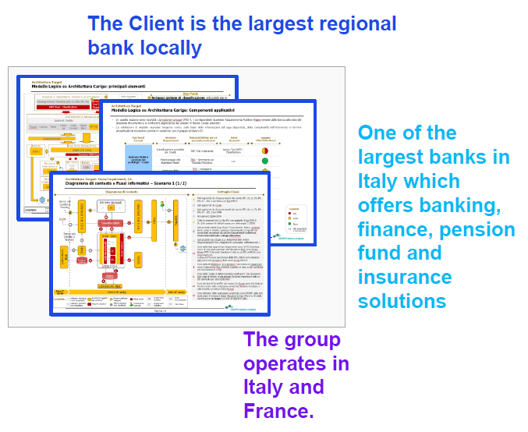**Retail banking- IT Strategy - IFRS9 IT Target Architecture**

Context and Project Objective

The Bank was facing challenges from the new IFRS9 accounting rules and needed to assess architectural impacts on the information system. Information system was mainly based on both internally developed applications and software packages from external providers, with different technologies being used.

Goals:

* Identify impacts in terms of existing systems to be evolved and new applications to be developed/acquired understanding how to connect them with the existing system.
* Design of the target IT architecture

Our solution and Results

Our engagement, in collaboration with a larger KPMG engagement, required strong and frequent liaising with the business analysis in order to provide consistent support to the Client. From an IT perspective the engagement concerned with an ICT assessment, a gap analysis, a support for the IT function in understanding the business requirements and selecting the main new software solutions, and the design of the target IT architecture applying NNI standard methodology and tools.

Results:

* We provided useful insights into the main impacts associated with the new accounting requirements
* We provided the client with support in vendor selection
* We provided a clear, immediate and comprehensive snapshots of the target areas of impacts, to allow the client start building their detailed implementation plan

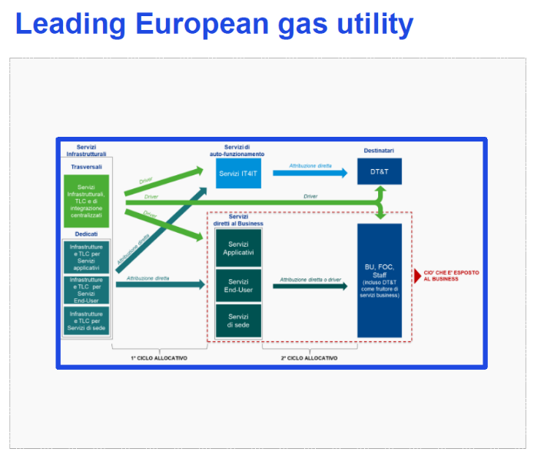**Gas utility- ICT Assessment**

Context and Project Objective

The Client is Europe’s leading gas utility.

Goals:

* Revise IT cost allocation to:
* Get an IT cost allocation model coherent with real usage of IT
* Empower end user when asking for IT projects
* Improve IT cost transparency

Our solution and Results

Support to gather IT information to provide a full scope IT DD report

Results:

* Presented an IT Service Portfolio as most comprehensible as possible to end users
* Enabled an internal IT efficiency approach
* Facilitated the request of IT services by end users by enabling tracking and reconciliation mechanisms

**Renewable energy - Operating Model Revision**

Context and Project Objective

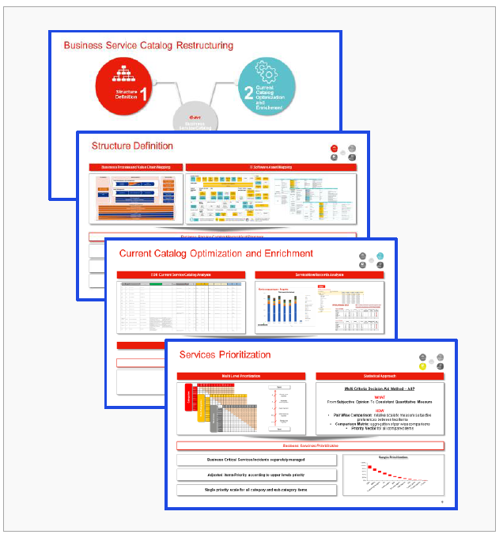The Client is a European company operating in the renewable energy sector that is carrying out a service management project concerning the restructuring of the catalogue of business service.

Goals:

* Structure definition.
* Current catalog optimization and enrichment.
* Services prioritization.
* Vendors capacity matching.

Our solution and Results

Approach:

Through workshops with the CIO, IT Operation, the main Eon suppliers and the various business areas that uses the services, NNI analyzed the Business service catalog and designed a new catalog structure aligned with the various business areas’ needs. Following the structuring of the catalog, NNI supported IT Operation in the rationalization and enrichment of the catalog service items and guided users in the prioritization of services through statistical tools (AHP) and dedicated workshops.

Results:

* Business Service Catalog Hierarchical Structure.
* Services and ITEM Restructuring.
* Business Services Prioritization.
* Services Demand Matching.

**Optical market - Procurement & system revision**

Context and Project Objective

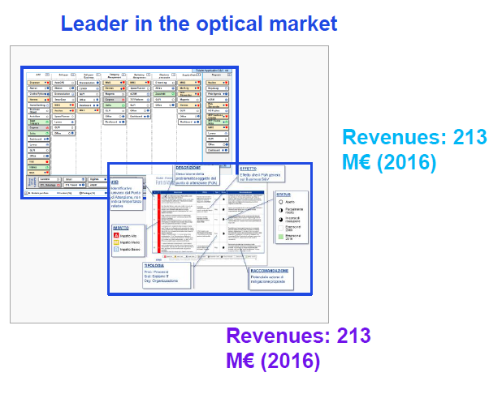The client is an Italian chain leader in the optical market with more than 424 point of sales (direct and franchising). Since KPMG 2009 support heavy business chances have been made:

Logistic to point of sales directly managed

Rationalization of external providers and franchising

Spaccio Occhiali no more in the Company

Goals

* Alignment of all Business processes to current situation
* Alignment of all IT assets to current situation (IT spending not included)

Our solution and Results

Due Diligence and issues collection activities have been conducted through interviews to the IT referents and the suppliers.

Results:

* Respect of methodology
* All round analysis of target Company's IT structure
* Chance for the Client to clearly expose to the Management the main issues regarding the IT transition project

**Italian Municipal Administration – IT STRATEGY TRIBUTES**

Context and Project Objective

The variability in the regulatory context and the increasing tax burden, which threats both the economical balance and the municipality ability to deliver services, create the need, for the municipalities themselves, to review their organization and governance model and to obtain an integrated governance concerning the revenue management. In this context the team has conducted the survey on the municipality's revenue management.

Goals:

* Revenue management model diagnosis and assessment of the supporting Informative system
* Strategic lab aimed to identify the priority action scopes, defining the improvement path and identify the intervention actions needed

Our solution and Results

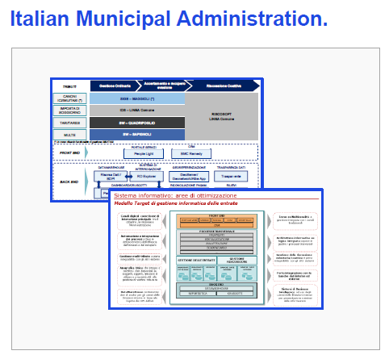Two phases methodological approach: the first one consists of the survey (revenue diagnostic) regarding the municipality's revenue management aimed at confronting data with other comparable realities (by dimensions and complexity). The survey was focused on three main scopes: management models, service models and economical/management and IT performances. The second phase consisted of a training on the job activity, motivated by the direct correlation between lab activities used as an instrument to spread the new operating modes to the impacted staff members.

Results:

* Services management model assessment regarding the tributes delivered to the consumers, focused on the actual Informative system and identification of the main scope of intervention
* IT Target Model definition to manage tributes and identification of the performance improvement actions.

**Regional Health System - ICT Assessment**

Context and Project Objective

The Client has requested an update of the ICT Assessment of the administrative accounting and healthcare systems in use by the Regional Health system Entities (18 local entities).

Goals:

* Photograph the IT ecosystems of local hospitals;
* Highlight possible inefficiencies of SSR Entities and supporting the path towards improving the data quality envisaged by the Region;
* Identification of potential future scenarios in line with the Lazio Region's vision regarding the establishment of a Centralized Accounting System;

Our solution and Results

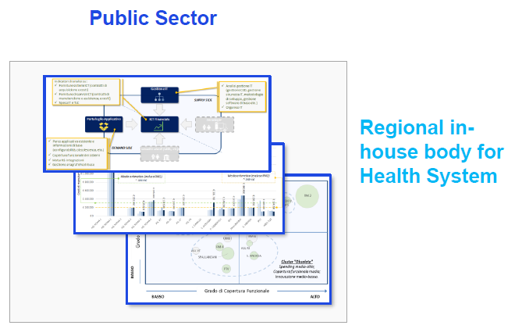NNI supplied support in implementing a due diligence of the administrative accounting and healthcare systems based on the NNI methodological framework of IT Assessment that analyses the IT situation through demand and supply factors of IT services.

Results:

* Application portfolio analysis: register information, functional system coverage, maturity integration, obsolescence index, etc
* Contractual analysis: identification of suppliers, economic and timing details of supply contracts and ICT spending trends;
* Benchmark with other regional centralized systems: application perimeter, architecture, system management, functional requirements and modules.

# 6. Elasticity

The **price elasticity of demand** ($E$) indicates the expected percentage change in demand for a given product/service (or quantity sold, $Q$) compared to a percentage change in the price ($P$) of the same product (or other products, cross elasticity):

$$E=\frac{{∆Q}/Q}{{∆P}/P}$$

Elasticity changes or does not change as price changes depending on the mathematical form of the elasticity curve.

As can be seen from the figure, the elasticity curve typically follows a power law:

$$Q=kP^{-h}$$

In the case of the power law, elasticity is constant and equal to $-h$.

Demonstration:

$$E=\frac{∆Q}{∆P}\frac{P}{Q}=-khP^{-h-1}\frac{P}{Q}=-khP^{-h-1}\frac{P}{kP^{-h}}=-h$$

Elasticity does not depend on price, but is an intrinsic characteristic of the product.

It is possible to select products that follow a power law and assign to them a fixed coefficient of elasticity.

How to use the elasticity coefficient? It is possible to rank the products by decreasing elasticity: the products with greater elasticity are those for which the effect of price changes is most easily measured. Discounts applied should be consistent with actual elasticity.

If elasticity is constant (i.e. for products following a power law), by increasing price: the quantity sold decreases and the unit margin increases; vice versa if price is decreased.

The **Cumulative Margin** ($CM$) can be defined as:

$$CM=Q*(P-C)$$

Where $C$ is the unit cost and $(P-C)$ represents the unit margin.

|  |  |
| --- | --- |
|  | For example, in the graph the optimum price that maximizes the cumulative margin is 4,90€. |

Unlike the unit margin, the cumulative margin can increase as price decreases up to a maximum and then decrease, so there is an optimal price for which the cumulative margin is maximum.



If elasticity h is> 1, revenue always decreases as price increases.

$$R=QP=kP^{-h+1}$$

Therefore, highly elastic products are those for which a price increase always has a negative effect on revenue, but not necessarily on cumulative margin.

**How to calculate elasticity from data?**

We have P-Q pairs that we can plot in the log(P)-log(Q) plane

In the log-log plane a power law becomes a straight line

We can use linear interpolation

Elasticity is the slope of the interpolating line

In fact: $Q=kP^{-h}$ so $\log\left(kP^{-h}\right)=\log\left(k\right)-h\log\left(P\right)$ so the slope is $-h$

# 7. Work Force Management

**Work Force Management** (WFM) is part of the extended ERP, which is concerned with the information and processes that are not only inside the company but also regard the interaction of the company with the external environment. Work Force Management has to do with the client and the relationship between the company and him, ruled by a transaction model. Every type of transaction has 4 phases, the last of which is the post-settlement one; WFM has to do specifically with this phase of post-sale activities. In particular, it has a lot to do with manufacturing companies, where installation of sold physical goods and their maintenance are an issue. For instance, the company might provide a maintenance service which involves sending out employees specialized on premise of the client. A **work force** is a team of employees with technical skills who are in charge of maintenance or installation processes, who manage the technical issues of customer upon the customer’s request. Such activity has a wide range of costs, from the cost of transportation (reach the customer) to the costs of the team itself. In maintenance activities, the level of service can be of high value, because the issue can be about something critical, like if a hospital needs something. Response time is an example of something that is included in the service level. Moreover, the level of service impacts on the image of a company, as having a bad service means lowering the customers’ loyalty, so maintenance service has a competitive value.

There are two types of maintenance:

* *Routine maintenance*: it is scheduled by the company and represents a profitable service.
* *Emergency maintenance*: it is asynchronous and must be scheduled, executed, and billed according to the characteristics of each individual maintenance request.

Both types of maintenance typically involve a physical maintenance activity on the product/plant at the customer’s site, but one kind is more challenging than the other. Routine maintenance can be planned and therefore it can be optimized, and is usually profitable (particularly, the sale of spare parts). On the contrary, emergency maintenance is asynchronous, and is not predictable so it is harder to respond to emergency requests. It is non profitable at all. Emergency maintenance is also often more important, cannot be refused or delayed. As a consequence, increasing the customer loyalty depends more on the emergency maintenance than on the routine one, which has a smaller impact on it. Then, routine maintenance is more exposed to local competition, as smaller providers can usually provide lower prices to customers, and this has an impact on the company image, as the company has higher costs due to the emergency routine that the company only con perform.

The reasons why maintenance is costly are various:

* Customers (and the workforce) are physically distributed over a (possibly) large geographical region.
* Visits are costly.
* Maintenance activities can involve different skills. The optimization of teams, schedule, and visits is not an easy task.
* A maintenance request is often generic and multiple visits are needed to specify customers’ needs. Moreover, more than often, requests are answered by level 1 call centers who do not have the skills to do more than set up an appointment.
* Spare parts may or may not be available, especially for emergency maintenance.
* SLA can be tight. If human life is involved, companies must oversize their workforce (e.g. elevators).

Maintenance is a service, and has an impact on customer loyalty. It becomes profitable if we account for the positive impact on customer loyalty (reduction of customer turnover). However, Customer loyalty is not easy to achieve, and is tied to emergency maintenance more than it is to routine maintenance. Also, customers may decide not to buy an ordinary maintenance service, but need an emergency maintenance service anyway.

The reasons for the existence of non-proprietary maintenance services are:

* The sale of spare parts can be used as an economic lever. If price is high, non-original spare parts are available on the market.
* The physical distribution of customers gives an edge to local maintenance services.
* In general, smaller companies are more flexible and can accommodate maintenance with greater efficiency.

To some extent, maintenance can be outsourced by the company, by partnering with non-proprietary maintenance services. However, outsourcing maintenance can be risky. First of all, non-effective maintenance has a negative impact on the company’s brand equity. Customers are more attract to buying products for which the company guarantees the maintenance. Then, there might be legal issues/liability for inefficient emergency management. At last, there can be no cross-selling with outsourcing.

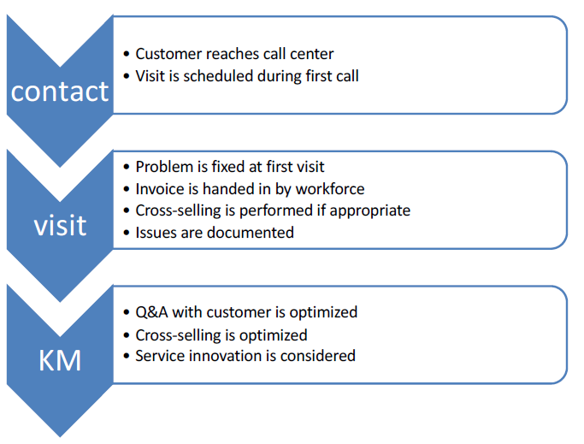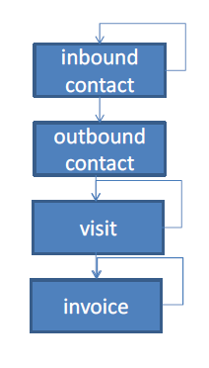Let’s analyze a bad maintenance process. The customer has an issue and makes a call to the call center of the manufacturer, so there is an inbound call from the customer. The responder knows nothing about the manufacturing and the calling customer, and there cannot be intelligent Q&A in the first call. The responder cannot immediately help the customer, as the call center is not integrated with the company Information System, so there is no info about products, customers, maybe there is not even a shared agenda. So the call center makes a later outbound call to the customer in order to set an appointment, giving a timeframe to wait. Multiple calls are exchanged before the visit, in which the work force doesn’t know anything about the customer needs, and frequently needs to reschedule a second visit, as they have to fetch the spare parts needed, or the team skills are not adequate to the customer problem that they only just identified. There might be issues regarding internal coordination with workforce team members and their skills and it is needed to monitor the entire process, including invoices at the end. Invoice is often done after the maintenance has happened as the team is not able to do it before, so there might be discussions with the customer. With this bad managed process, the opportunity to do cross selling is missed, for example a new insurance cannot be sold.

The ideal maintenance process is way different. The customer calls a call canter which has an intelligent Q&A, so the problem can be immediately understood and a team with the right skills and equipped with the right spare parts is set up right away or at least with a precise and known timing depending on availability of people and parts. Also, there is no need for other calls to schedule the appointment, as the call center has a shared agenda with the maintenance service. During the first visit, the issue is solved and there should be less problems with invoicing, as customers can have a direct and immediate perception of costs, they are aware of how they are spending their money. Also cross-selling is easier and scheduled, because of the invoice mechanism and the integrated offer. The work force has usually a technical background, but now needs to have also an administrative one. Knowledge management performs the diagnostic of interventions in order to reach service improvement and innovation.

The Key actions to get to the ideal process are the followings:

* Implement a KM process:
  + Ask questions during first contact to describe the nature of the maintenance issue
  + Involve workforce in KM process
  + Create editors of new knowledge on maintenance processes provided by workforce
  + Cluster maintenance issues and relate to skills of workforce
* Implement embedded technologies to help prevent emergency maintenance through targeted routine maintenance
* Redesign maintenance process by considering truck as a warehouse of spare parts replenished with JIT logic
* Generate invoices automatically

## Case study: OTIS elevators

OTIS is a global leading company in its sector, it has not outsourced maintenance, as it has been always perceived as key to the brand. For this company, maintenance is challenging, since safety is involved. The life of the product is particularly long and demand is a steady variable. The strategy of OTIS is to sell the maintenance contract together with the product to get as many subscriptions as possible before competitors come in.

They experienced a decrease in market share (maintenance market), which was faster in urban areas where smaller competitors provided maintenance services at a lower price. Urban areas are the most profitable areas for maintenance services and decreasing price would significantly reduce profitability. OTIS applied higher prices also due to high internal costs, therefore lowering prices to a competitive level would make OTIS maintenance processes non profitable.

The solution to these issues came from Knowledge management process. They implemented KM and redesigned their maintenance processes with the goal of cost reduction, but they continued to sell their service as leading service as opposed to low cost solutions. Thanks to this, they managed to implement embedded technologies and reduce the need of emergency maintenance by over 30%. This was done thanks to the cooperation between work force and research, finding routine processes to improve the products resistance and reliability. As a consequence, they were able to leverage their position as large global company to provide a highly responsive call center service (OTISLINE communication service). In fact, with mobile devices, the workforce has real time access to technical and administrative information.

“the right maintenance at the right time extends the life of the equipment and protects the owner’s investment”

Otis developed the REM (Remote Elevator Monitoring) system to optimize elevator performance and minimize elevator downtime. It is a sophisticated interconnected system of sensors, monitors, circuits, hardware and software to collect, record, analyze and communicate data about elevator operations 24/7. If the REM system detects a problem, it analyzes and diagnoses the cause and location, then makes the service call and helps an Otis mechanic identify the component causing the problem. Elevators are often back in service before owners or tenants even know there is a problem. It’s no more the customer to call for maintenance, but the maintenance service to call the customer and tell him that maintenance is needed or there might be a problem soon. Emergency maintenance becomes routine.

It all it looks as a high-quality service that aims at customer loyalty. They have reduced internal costs by improving coordination.

# 8. Predictive maintenance

Modern technical environments require a high degree of reliability both in machinery and in equipment. Technological progress has, on the one hand, increased this efficiency but on the other hand, it has changed the way in which this equipment and these machines have traditionally been maintained. In industry 4.0, the optimization of maintenance processes is important because of the financial situation. This includes the profits made by the production company and differs from traditional maintenance, by shifting towards new trends such as predictive maintenance; as such, it is crucial for the development of the company.

The vision for future production includes modular and efficient production systems and presents scenarios in which products follow their own production process. The aim is to raise awareness of the production of individual products in a single batch size while maintaining the economic conditions for mass production. A company providing these conditions becomes a user and part of the system “**Industry 4.0**”. In the area of Industry 4.0, the production system of a company would consist of an information system and numerically controlled machines, which would operate autonomously and show elements of artificial intelligence. Industry 4.0 is not intended to create factories where people are re-placed by robots, as people are invariably the most important asset; thanks to the new solutions, they will receive much more support than was the case previously. The industry 4.0 environment has identified and specialized advantages: flexibility, low production costs, high availability, cost effectiveness, increased transparency, resource saving. The main elements that are closely related to the idea of Industry 4.0 include the Industrial Internet of Things, Cloud-Based Manufacturing, Smart Factories, Cyber-Physical Systems and Social Product Development – SPD.

In summary, the term “Industry 4.0” describes various changes in the production systems, most often in IT. These changes not only have technological implications but also organizational implications. As a result, a change from a product function to a service function is expected, even in traditional industries. Secondly, in addition to the adaptation of enterprises to new conditions, new types of enterprises can be expected to take on new, specific roles in the production process or value creation networks.

According to the requirements of Industry 4.0, modern technical environments demand an elevated degree of reliability, both in plant and in equipment. Technological advances, on one hand, have increased this reliability; on the other hand, however, more traditional methods of plant and equipment maintenance are changing. Information and communication technology continuously modify conventional practices, such as the manual inspection of plant and the retention of information on paper, and progress, ever increasingly, towards computer-aided maintenance.

**Maintenance** consists of the combination of all technical, administrative and managerial actions during the life cycle of an item or asset, intended to retain it in, or restore it to, a state in which it can perform the required function. An item may assume a variety of states; the two main types being defined as the ‘up’ or the ‘down’ state.

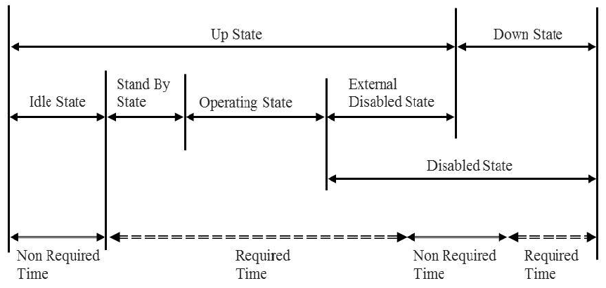

Maintenance is segmented into four main tasks:

* Inspection: measures are taken to assess and detect the actual state of an item, including investigations to discover the cause of attrition and to derive necessary consequences for future operations.
* Service: every action that serves as sustainment of the target state, respectively, in order to delay the degradation of items.
* Repair: the steps to restore an item back to its functional and original shape
* Improvement: the enacting of technical and administrative measures to enhance the functional reliability of an item without altering the required features

Typically, maintenance was seen just like an expense due to the failure of plant and equipment. In reality, maintenance is a cross-company business process, which assumes an active part in the value-chain. Although traditional maintenance in and of itself does not add value, as a support process, it offers enormous value-adding contributions:

* preservation of asset value
* reduction of expenditure by optimizing maintenance strategies
* enhancement of the temporal and functional utilization rate, as well as a decrease in depreciation
* prevention of breakdowns and faults that would impact upon the plant, the environment and safety

Also, maintenance can avoid future costlier maintenance.

Maintenance plays a key role in providing profitability and a reliable production process. The higher the intensity of investment in production facilities, the more does this impact upon well-organized maintenance management, as efficient maintenance can influence big part of the production costs.

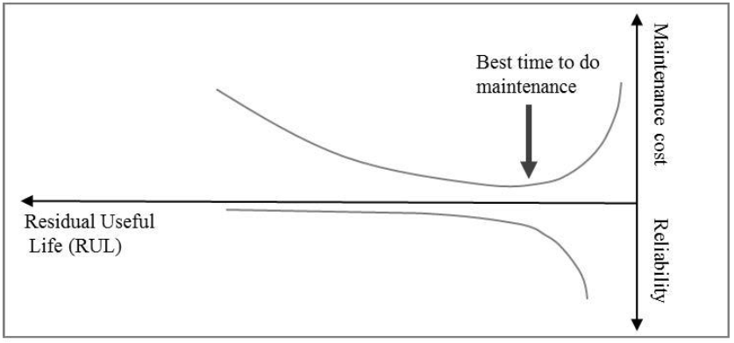Companies have a maintenance strategy, which is a management method in order to achieve maintenance objectives. Such a policy determines the maintenance that needs to be undertaken, the item on which it is to be carried out, the frequency at which it needs to be done and at what point in time it must be done. In order to avoid to reach bad reliability that will impact on production and cause loss of money, and also to find a right balance of maintenance expenses so not to waste too much money in it, the right strategy must be found.

When the time for a system to fail approaches zero, the reliability of the system decreases, as also do the maintenance costs. As soon as the time to fail actually equals zero, the system will go into the ‘down’ state and maintenance costs will rise enormously, due to high consequential costs. The choice of an appropriate maintenance program has a decisive influence on the frequency of “down” states and the many undesirable consequences of such interruptions.

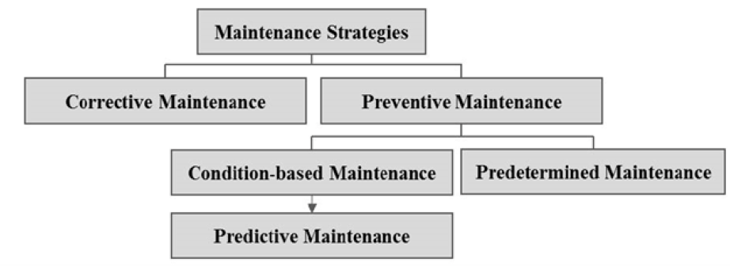Besides economic aspects, legal, safety and technical requirements have to be considered, as well as when to select the right strategy.

Maintenance strategies, in general, may be categorized into two main types, namely, corrective and preventive maintenance. The latter can, additionally, be subdivided into a predetermined, condition-based and predictive strategy.

**Predictive maintenance**, so-called, is an enhancement of the condition-based strategy. It ex-tends automated condition monitoring by a computerized evaluation of the input data and allows intelligent prognostics to detect precursors of failure and to predict how much time remains before the likely occurrence of a failure. While condition-based maintenance simply describes the current state of health, a predictive policy can also estimate prospective condition-changes. Predictive maintenance is a policy which undertakes maintenance before product failures happen, by assessing the condition of the product, including operating environments and predicting the risk of product failure in real-time, based on the product data gathered.

The forecasting of the degradation of an item is based on the assumption that most abnormalities do not occur instantaneously and usually there is a steady evolution from normality to abnormality. Even if no direct evidence of the degradation of an item is available, predictive maintenance tools exploit variables in the processes and logistics gathered during operation. Degradation is monitored by observing continuously, the workload of an item and consequently, detecting deviations from the average performance.

Predictive maintenance brings major advantages: it can produce information about the severity or cause of the fault that is going to happen and the root cause of the issue with the time frame in which it is likely to emerge.

Predictive maintenance allows service and repair measures to be undertaken at exactly the right time, just as an item is about to fail. In so doing, predictive maintenance attempts to maximize the item’s current usefulness as well as its residual usefulness. At the same time, it significantly improves the scheduling of maintenance. Furthermore, sophisticated software uses analytical modelling techniques and offers diagnostic insight, prioritizing issues according to severity and suggesting measures that may be adopted.

Despite these benefits, predictive maintenance has limitations, primarily because investment costs are usually high. In order to implement predictive maintenance, the installation of high-quality monitoring equipment and the deployment of databases and large-scale, data processing systems are prerequisite. In addition - and in order to be successfully used – not only is an investment in hardware required, but also, an investment is required in data science and/or physical expertise, in order to develop models, algorithms and decision-making strategies based on the data collected. Finally, the technologies and technical methods for the predictive approach are still in their infancy.

The following table shows a comparison of different maintenance strategies.

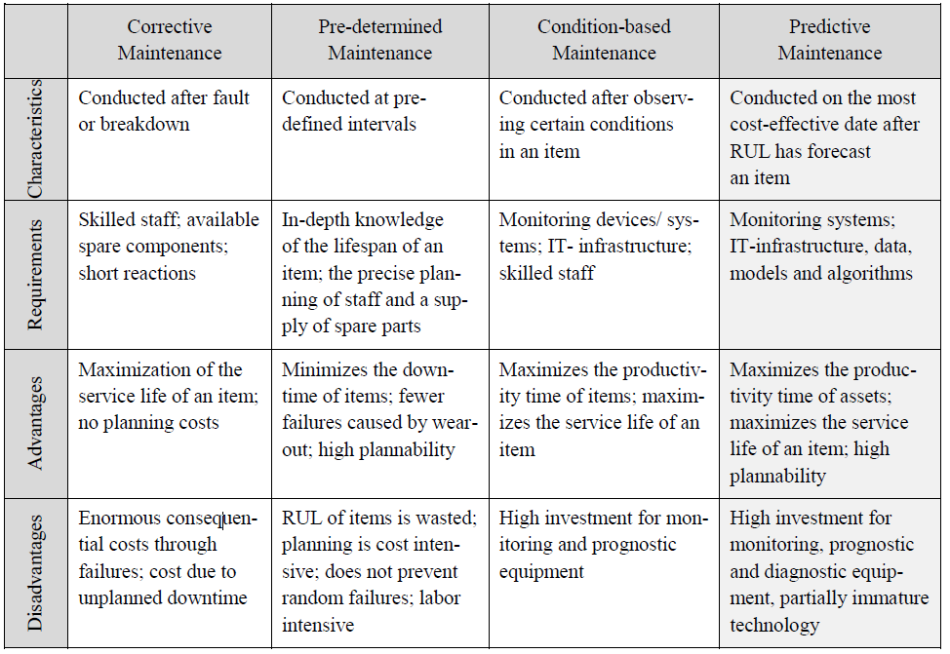

# 9. Knowledge Management

**Knowledge management** has to do with the management of knowledge inside organizations. There is a vast literature on the definition of knowledge, which is very vast. It can be defined as a state of mind or belief that increases an entity’s capacity, an object to be stored and manipulated, a process involving applying expertise, a capability itself, or a transformation resulting from data to information to knowledge (Data -> Information -> Knowledge), which is useful to solve some kind of problem.

Service companies collect information and use this resource to improve their processes and for future gains; this allows them to remain in tight contact with the market and easily follow and adapt to its trajectory.

Limiting the definition to the application of knowledge, some factors are generally agreed. First thing, knowledge is related to information and comes from data, but is not restricted to them. To have knowledge, a company needs to possess information but also to be able to transform it in something useful. Then, knowledge is tied to change, in order to find creative solutions to problems, so to contextualize the knowledge and so general advice, expertise, best practices in a given situation. The found solution cannot only be theoretical but is also strictly tied to action (making choices, learning about the environment, innovating, …).

Knowledge can be classified in order to better understand how it can be applied. Knowledge can be:

* *Internal*: resides within the firm boundaries
* *External*: resides outside the firm boundaries, organizations take specific actions to get this knowledge, like hiring a consultant or directly buy the information

Another distinction for knowledge is between:

* *Personal* (individual): resides within the mind and the action of individuals
* *Organizational* (collective): specific of the organization and its culture, and internalized by its employees, it’s not just the sum of the individual knowledge inside the company but is also about how to put it together

The last distinction is between the two kinds of knowledge:

* *Tacit*: knowledge that cannot be codified and which resides in the expertise/competences of people and groups of people, it’s hard to make explicit by its nature
* 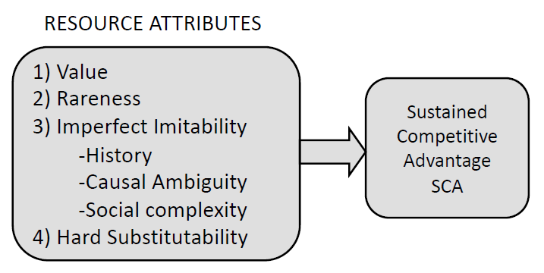*Explicit*: knowledge that can be codified in some sort of artifact (sw program, rules, document, …), companies aim at making explicit as much tacit knowledge as possible

Knowledge is in general important for the company because it is a source of sustaining competitive advantage. The **Resource-Based View** of the firm (RBV) is a literature that view an organization as a mere set of resources, and is concerned with providing a description and framework to categorize resources and understand which ones are key to the company success, as they have the potential to become a source of sustained competitive advantage, and so have high value and which ones are less important.

The objective is the evaluation of the company and its resources through a ranking of them, based on some feature and attributes: in general, a resource has value if it is rare, not easy to obtain or to replace. Most of the knowledge owned by a firm clearly shows the potential to adhere to the principles of the RBV theory in order to become a source of SCA: Value, rareness, low imitability, low substitutability.

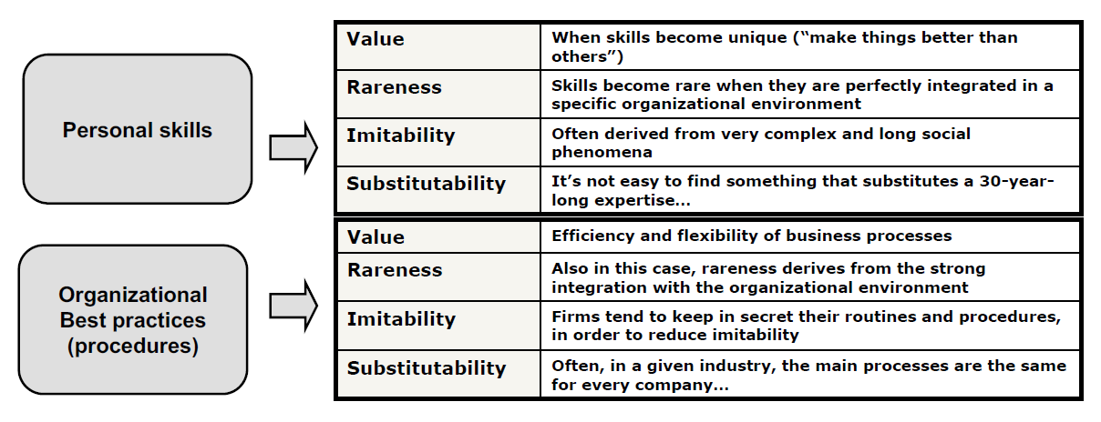

Access to knowledge is one of the barriers to enter in a market sector for newcomers and is used by companies to keep away new potential competitors.

Knowledge Management (KM) is a very complex issue, as it has to do with exploiting information to prove the ability of the company to reach its own objectives so it requires an integrated view on the organization.

* It’s cross-divisional, enterprise-wide
* It’s primarily a management issue
  + Identify relevant forms of knowledge
    - Identify and cultivate virtuous cycles (and not vicious cycles of knowledge)
  + Create social incentives for sharing knowledge
  + Enable the knowledge sharing environment
* It’s boosted by IT tools: Knowledge Management Systems (KMS)
* Costs / Benefits are not easy to be evaluated

There should be, inside a company, virtuous cycles that allow to use information to create new useful knowledge that allows the company to grow.

Managing knowledge can be seen from different perspectives and theoretical strategies: technocratic, economic and behavioral. They are not mutually exclusive and are typically used in combination with each other’s and all of them three have to be applied to make sure that knowledge management is effectively performed in companies. So, each KM initiative may be classified as a combination of strategies:

* TECHNOCRATIC: Focus on application of knowledge and knowledge processes that can strongly benefit from the adoption of Information Technology (e.g., capturing knowledge, identify the sources of knowledge)
* ECONOMIC: KM to create value and cash flow from the possession of highly specific and hardly imitable knowledge
* BEHAVIORAL: KM to create the social incentives to create and share knowledge

According to the **technocratic** strategy, so focusing on technology, the typical problem is how to capture information in order to create knowledge and how to make it available. For example, a shared formalizing technique in a risk assessment company is a way to guarantee that knowledge is captured and made available to all. Another example is the project documentation sharing during a project work. With a strong reliance on the adoption of information and management technology, the objective is to capture knowledge and make it available to other people in the firm. The CSFs for this strategy are: connecting people, deliver incentives for providing content to systems and the content validation (cultivate good content and discard useless contributions).

The KM **economic** strategy focuses on protecting and exploiting the knowledge assets of the firm to generate cash flow and revenue streams. Knowledge is seen as an asset and managed as so. Examples are: patents, copyrights, non-disclosure agreements, intellectual property management, trade secrets. Organizations do not protect all the knowledge they possess, but they generally do a ranking and extract the key knowledge and protect it. The CSF for this strategy are: creating specialized teams/division for managing knowledge assets and identifying the relevant knowledge that may generate revenue.

From the **behavioral** point of view, the key word is communities of practice. Companies try to put together people who have to solve the same kind of problems, and Communities of Practice (CoP) are, in fact, loosely knit teams of people that work on common issues and problems. Tools (organizational and IT-based) are given to CoP in order to support knowledge sharing and transfer. Large corporations create strong links between people with the same qualification within the organization (e.g., lawyers, sw developers, HR managers of different divisions). The CSFs are to identify relevant CoPs and connecting people.

According to the behavioral strategy a key point is creating a knowledge sharing culture, and there is a lot that companies can do to facilitate it. The design itself of the company’s space and the structures are exploited in order to create the antecedents of knowledge sharing. Examples are shared spaces such as water coolers, coffee makers, vending machines, and open office spaces in order to remove the barriers among individuals. CSFs are to design useful knowledge spaces and encourage and legitimize people in sharing knowledge. People should know rules about what kind of knowledge can be shared and need to be incentivized to share as much as possible, so also the rules should be as less strict as possible.

## Knowledge Management Systems

Knowledge Management Systems (KMS) are defined as “…a class of information systems applied to manage organizational knowledge…, that is, IT-based systems to support and enhance the organizational processes of knowledge creation, storage/retrieval, transfer, and application”. This definition is very vast, and every organizational IT-based system may adhere to it.

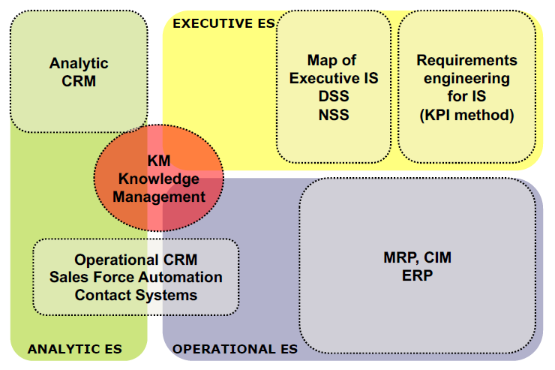

The chart shows the modules of a company information system from a knowledge management perspective.

Any module of an ERP can be part of the KMS of an organization.

The success of knowledge management initiatives can be assessed from different perspectives:

* Project-oriented evaluation: companies launch knowledge management projects and this is evaluated:
  + the resources that are dedicated to the project and their growth (people, money, …)
  + the reach of the initiative (number of offices, divisions, …)
  + the survival over time of the project

Also surveys on people help the project evaluation with feedback

* KMS-oriented evaluation (IT-intensive KM): to assess the quality of technology and the usage
  + Usage of KMS (number of accesses, retrieved documents, KB extension, …)
  + Reach of the electronic community (e.g., number of people)
* Efficiency and financial evaluation
  + Reduced cycle time, number of claims, …
  + Improved customer satisfaction, satisfied phone calls, …
  + Evidence of financial benefits

There shouldn’t be focus on just one way of assessment, but a balanced set of indicators should be built. Generally, a correlation can be found between indicators of the first two classes, while financial indicators often remain uncorrelated with the others.

Success is something that needs to be well measured, as KM projects have a high failure rate. The reasons why they fail are more than one:

* Complex inter-organizational processes: Governance problems (this is the most frequent issue), so the project hasn’t been managed properly.
  + Who is going to be accounted for costs of the KM initiative?
  + 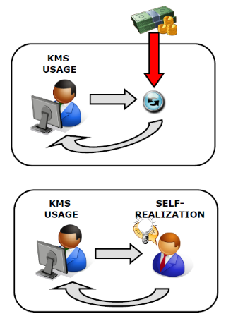How to assess the benefits of the KM initiative?
  + Who is going to be accounted for the benefits?
* Tendency to overestimate the power of IT tools for KM
* …
* KMS often remain unused by intended users

The issue with usage is the balance between External and Internal motivation. The incentives for KMSs usage can be:

* External (extrinsic): prizes, monetary rewards, increased visibility, …
* Internal (intrinsic): make system usage personally meaningful and support self-realization of users

Typically, external incentives are good to start gathering knowledge, they increase the number of contributors. However, they also decrease the quality of contributions, which is undesirable. To keep quality high, the incentive schema needs to be continuously adapted (Incentive alignment).

## Case study: Law Firm

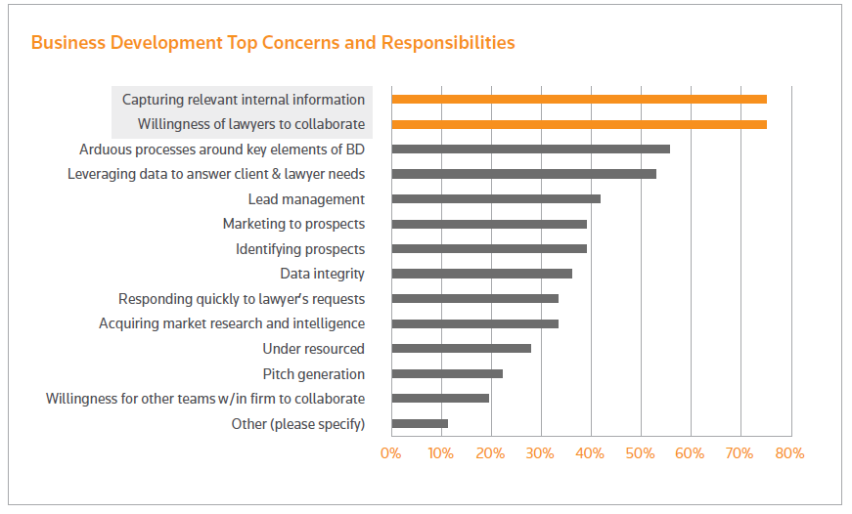Knowledge Management (KM) systems continue to play an evolving role as law firms look for the best cost-efficient and cost-effective ways to capture and share their lawyers’ accumulated knowledge. Lawyers rely on accessing prior work product – including deals, templates, precedent documents, legal know-how, and associate training – while constantly considering and evaluating changes in law and practice. All of this is accomplished while they are seeking efficiency to serve their clients’ best interests.

Legal strategic technology company *Intapp* surveyed 400 law firms in 2017 and examined their top concerns and responsibilities. One of the biggest business development concerns for 75 per cent of participants was data capture and the willingness of lawyers to collaborate with each other.

Only 58 per cent of the surveyed firms had centralized processes to collect, store, and analyze ongoing data efforts. Collect information requires a big effort, just like analyzing the data.

A successful knowledge management system reduces the amount of time required to draft updated agreements and documents by modifying them to reflect current law and practice. The best KM systems reduce reliance on memory when working on multistep transactions. But few large firms have mapped the documents to the process – that’s where the efficiency of using *Thomson Reuters Practical Law Canada* resources comes into play.

Most large firms have a KM system, including a collection of prior work undertaken by the firm and an occasional collection of marquee documents, but unfortunately, these are not always maintained or used. Practical Law, on the other hand, presents access to organized and maintained marquee documents. Practical Law keeps all documents current, helps associates get up to speed, and also integrates into a firm’s existing KM platform or knowledge-sharing mosaic. Practical Law provides analytical resources, not just more unannotated precedents. And lawyers appreciate the fact that less of their own time and effort is spent on generating and maintaining KM resources. A KM system can be elevated with resources not replicated, such as Practical Law, and insight into existing precedents can be leveraged with the depth of annotations.

Practical Law’s competitive advantage allows firms to deliver a broad range of legal services to clients more efficiently and with greater cost certainty. It reduces non-billable time by minimizing the length of time it takes to get up to speed on unfamiliar legal issues. Instead of drafting a document from scratch, Practical Law resources can be modified for specific purposes, reducing the amount of time needed to draft agreements and documents. Adding Practical Law’s strategic insights of annotations in your documents will better advance your clients’ interests.

Practical Law can be implemented if a firm has no KM system in place and, if a system already exists, Practical Law can easily complement it. In fact, in most cases, it is used in conjunction with a firm’s existing KM system and works to build its level of insight and proprietary knowledge. The benefits of using Practical Law with an existing system include an immediate increase in the size and breadth of the firm’s KM resources.

O’Melveny’s internally developed KM system, OMMLit, equips lawyers with a central database that researches hundreds of common litigation tasks. It provides information and tips on how to deal with tasks based on the firm’s records.

# 10. Projects management

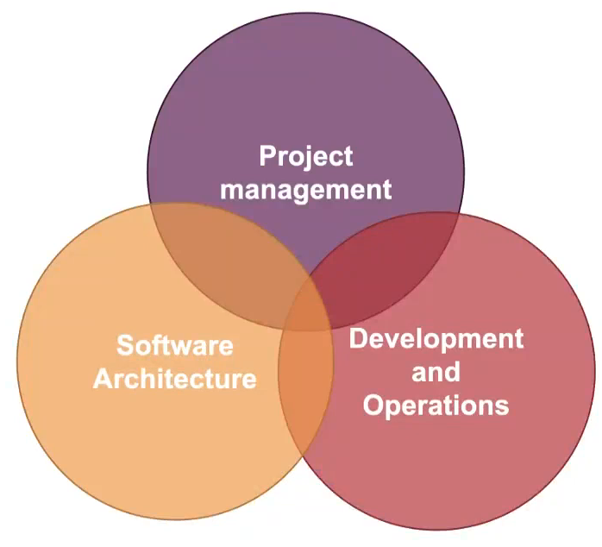

Three are the main topics that an enterprise should consider if wants to be competitive:

* Project management: how to organize projects and people working at them (till agile approach)
* Software Architecture: how to design information systems to better support enterprise processes (till micro-services)
* Development and operations: how to design the software lifecycle management process to be effective and fast (till *devops*)

More competitive organizations on the market are shifting from a machine focused model to a more organic one. People in typical organizations follow very precise processes, guided by software and by machines, and this is very efficient. However, nowadays the business and the changes are too fast, companies have less time to study the market and make strategies and all the necessary in order for their products to enter the market. With an “organical” approach a company can be more productive in less time. The process is not anymore the center of how a company is organized, but the human part is, which is more easily adaptive.

The classical principles of enterprise organization are:

* 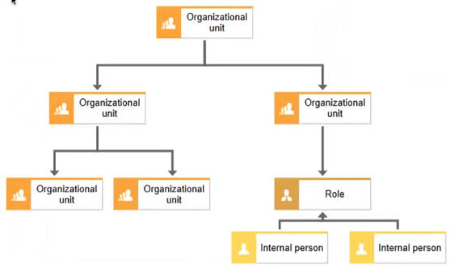Clearly define tasks and roles, adopt delegation as a principle (hierarchy)
* Search for continuous process innovation, implement efficient and standardized processes.
* Define performance and control indicators.
* Establish and share objectives, from general to operational, from systemic to individual.
* Measure and incentivize based on objectives.
* Implement communication, coordination and reporting systems, develop information systems.
* Properly manage priorities and workloads.
* Pursue continuous improvement.

In traditional project management, there are clearly distinguished sequential phases and everything is statically defined when the project is started (what resources, also human, what time, what budget). In particular, IT projects are traditionally based on the **waterfall** model. A lot of organizations still use this kind of approach.

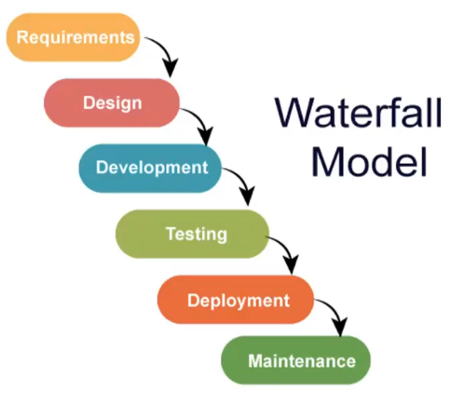Starting from the collection of requirements, the product is designed in all its aspects and then the development starts. After development comes the testing part, and if it is successful the deployment happens. After deployment the maintenance process begins.

There are sequential steps, one activity after the other. The waterfall approach focuses only on the solution and final product to deliver, and each step is finalized at reaching it. The functionalities need to be well understood in advance, because the design happens altogether in advance and is not meant to be repeated anymore, and this is very difficult. During the implementation phase, the context might change or the design might prove itself to be not as good as expected. The analysis must have a very high granularity because there will be no further time for analysis during the implementation phase. Also, with the waterfall approach, there is at the beginning a unique and contractually binding estimation of costs. So, there might be problems with budget related to initial expectations. The idea needs to be continuously adapted with the evolution of the project. Also the client might change its mind and change its requests, so the requirements might change after the design phase and this needs to be handled. After the development, the application goes into production and here there might be coordination issues between departments.

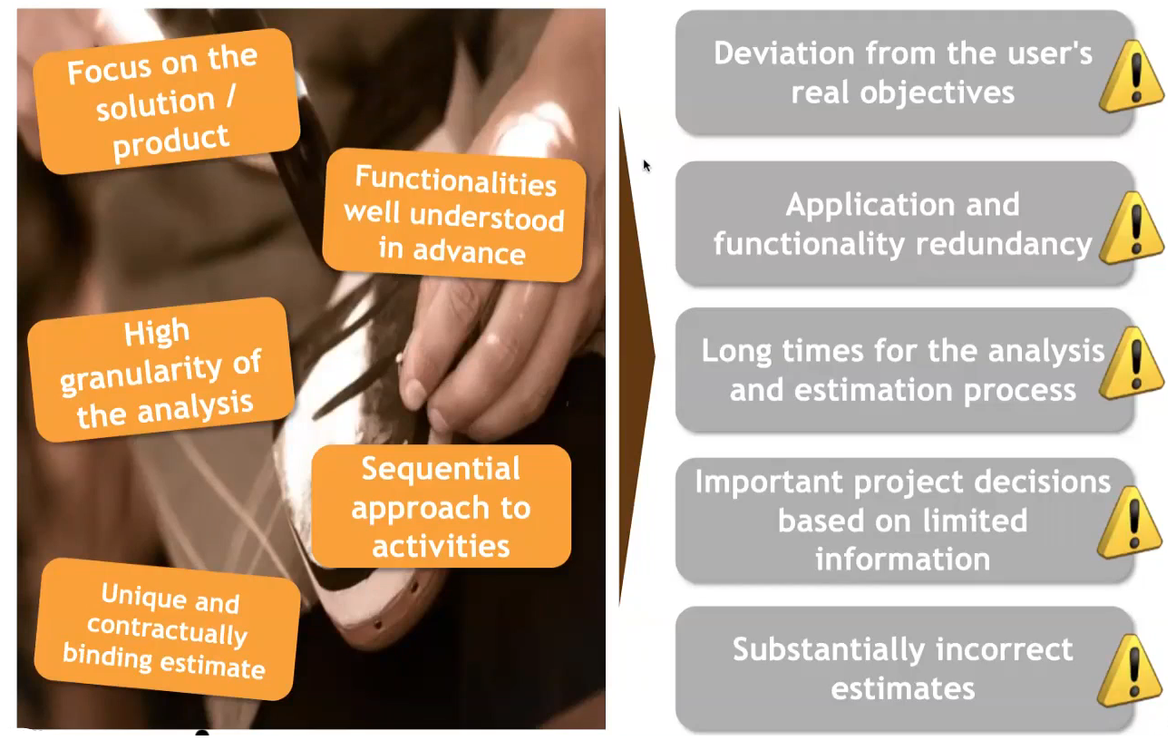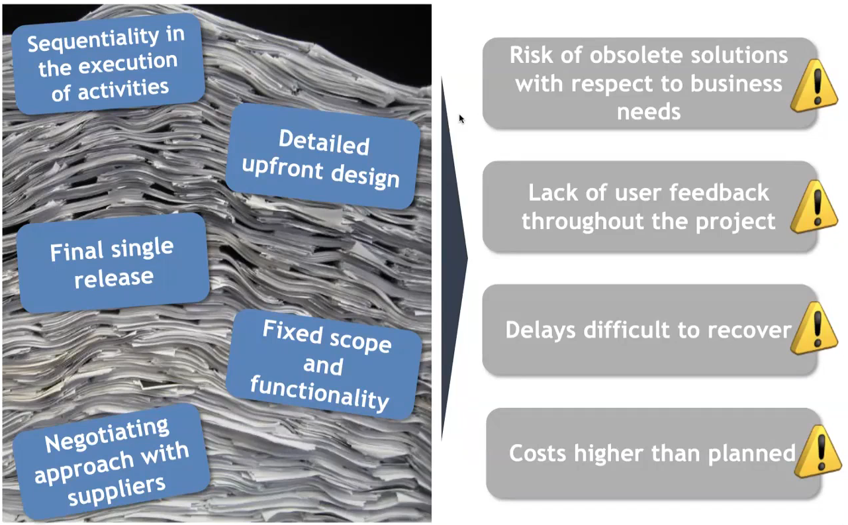

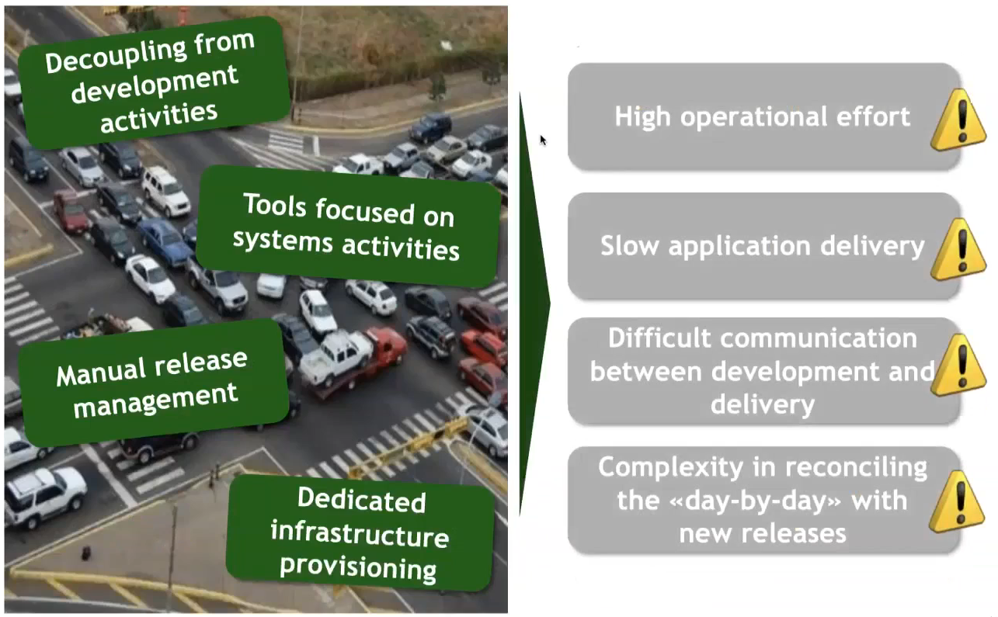

For little projects, waterfall will work fine, but for bigger projects with bigger teams this approach tends to fail and lead to many issues.

The time to market is the length of time it takes from a product being conceived until its being available for sale. It’s good to reduce it, as being late erodes the addressable market into which producers have to sell their product. It also becomes even more strategic to anticipate competitors. Agile methodologies are also needed to adapt quickly to the market.

If the waterfall approach is adopted, predicting the future would be needed to be more competitive. It cannot be done more than to some extent, so an agile approach proves itself to be better. An **agile** approach allows to be more aligned with the context than a waterfall approach that goas its own way with respect to the context evolution.

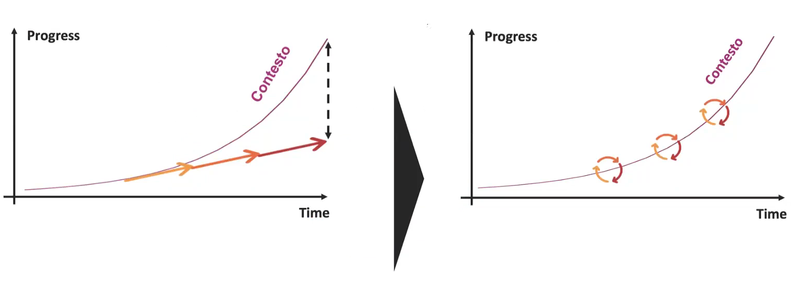

The possibility to adapt in an agile approach is given by the iterations that happen in every phase of the project.

An iterative model starts from planning, but not the whole planning is done at the beginning, then requirements are collected and analysed, and some general design is made, but not the design of all the product. For every functionality the activities are realized by cutting in pieces the domain and doing separate design, development, and testing. Also, the deployment is done in pieces. Feedback can be received from the users and the product can be changed dynamically.

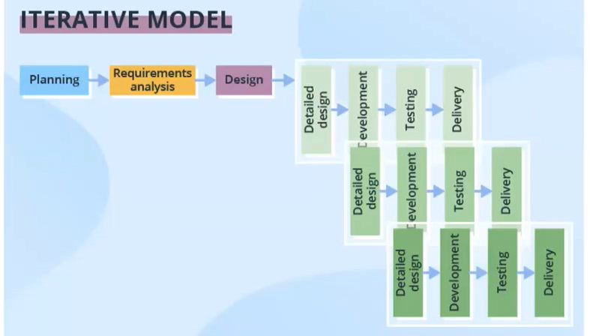

The key word for an agile approach is adaptation to the circumstances: this happens via continuous analysis and redesign and the way costs are handles can benefit from this, as costs are dynamically allocated to needs. The iterative discovering of needs leads to improvement in the successive design and there are continuous refinements.

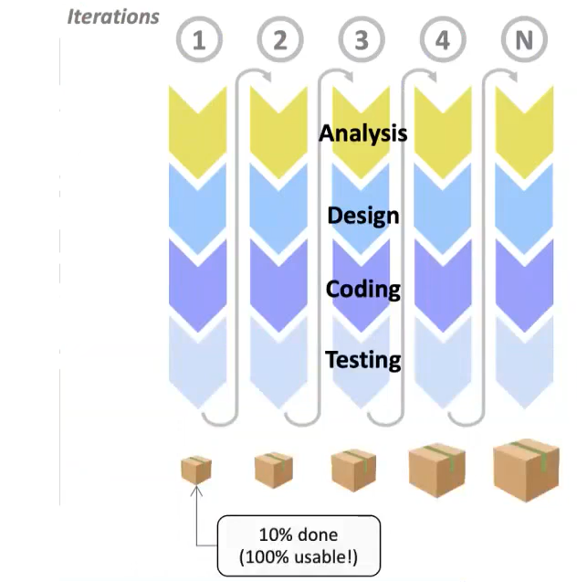This agile approach is not adopted by everyone, but on the contrary, there is resistance towards it from some companies. The approach was invented by developers who used the LIM methodologies invented by Toyota and applied a version of them to IT projects, later than that also the SCRAM methodology was born.

With the different iterations, different and going forward bigger versions of the final product are created. Every version is usable, so subject to analysis.

Inside every iteration, there is still a sequential flow.

Only at the end of the project, with agile approach, you will know how much the project will cost. However, the estimation of costs is generated by a progressive refinement based on the trend of previous iterations and on the needs for the project.

Furthermore, an agile project is more transparent than a waterfall one, because each step is visible. So the project owner can see and make requests and those can be taken in account without twisting the project structure.

It’s easier to adapt top changes and to events that are coming from outside, so there is a controlled management of the variation of needs.

After every iteration there is a review, so there is a constant search for user feedback as a learning opportunity for value generation. If something is done wrong, it’s better to discover it right away instead of discovering it at the final stages of the project.

Sometimes even some developers might reject an agile approach.

The agile method is an evolving concept: from agile software development to agile project management, to business agility. While agile project management makes the step from the single software development to a whole project done in an agile way, the business agility refers to the capability of the entire company to act in an agile way: even decision making is performed via successive iterations composed of phases of building decisions and analysing them.

In traditional project management, scope is fixed while time and budget are only estimated and is considered that they will change. With an agile project management, it’s the exact contrary: time and budget are fixed but the scopes are estimated and they are the ones to adapt.

The agile approach comes from the Agile Manifesto, created by some developers, assessing that:

* Individuals and interactions (teamwork) is more important than processes and tools, which are still decisive
* Working software is more important than comprehensive documentation, which is still valuable
* Customer collaboration is more important than contract negotiation
* Being able to respond to change is more useful than following a plan

While there is a value in the items that are considered less important, the items that are more important are valued more.



# 10. SCRUM

The word scrum comes from rugby: it is a method of restarting play in rugby football that involves players packing closely together with their heads down and attempting to gain possession of the ball.

**Scrum** is an agile framework for developing, delivering, and sustaining products in a complex environment, with an initial emphasis on software development, although it has been used in other fields including research, sales, marketing and advanced technologies.

The key points of scrum are the 3 roles that people can have, the 5 events that can happen and 3 kinds of artifacts.

## Roles

The 3 kind of roles are:

* Product owner
* Scrum master
* Developers

**PRODUCT OWNER:**

The Product Owner's primary responsibility is to maximize the value of the product resulting from the Scrum Team's work. Representing the product's stakeholders and the voice of the customer, he is responsible for delivering good business results.

It defines the vision of what needs to be accomplished.

It is responsible for the effective management of the product backlog, including: create and communicate elements of the product backlog, sort the items in the product backlog by their value, make sure the product backlog is transparent, visible and clear.

The above actions can be carried out in person or delegated, but the PO is accountable. As with the scrum approach actions are divided in iterations, the fault for a failure goes to the PO who did not notice something was not working.

The product owner:

* Defines the Product Vision
* Collects the requirements
* Gathers requirements
* Hypothesizes the product release plan
* Transforms the requirements in Features and User Stories
* Checks the Product Backlog
* Collaborates and answers product-related questions

**DEVELOPERS**

The development team consists of 3-9 people and is cross-functional. It has all the necessary skills to create a "Potentially shippable Product Increment". It is composed by all the people doing something to achieve some goals and produce some artefacts, who plays a role in the development and support of the system or product.

No role or title is recognized within the development team, but the team is self-organized for the work and is “empowered” to find the best solutions. If there is a bad solution, the team is accountable.

**SCRUM MASTER:**

The scrum master is a facilitator, helps all roles and functions to collaborate effectively, but is also a teacher / coach, as he "trains" the Team and the Product Owner, helping them to understand and follow Scrum values, practices and rules. He "protects" the team and educates people outside the team about the practices the team is adopting, he collaborates with the Organization to create the best working environment for the team to perform.

He has the task to remove impediments to the ability of the team to deliver the product goals and deliverables, he ensures that the Scrum framework is followed by coaching the team in Scrum theory and concepts, often facilitating key sessions, and encourages the team to grow and to improve.

## Events

The events are 5 and are part of the workflow:

* Backlog refinement
* Sprint planning
* Daily scrum
* Sprint review
* Sprint retrospective

A **sprint** (also known as iteration or time box) is the basic unit of development in scrum. It consists in from 1 to 4 consecutive weeks (usually a duration of 2 weeks is selected) during which the team develops the Product Backlog Items (PBI) chosen during the Sprint Planning to reach the Sprint Goal.

Once the Sprint duration has been established, it is a good idea not to change it without a good reason. There needs to be no interruptions between sprints.

Changes to the Sprint Backlog during the Sprint should be avoided, unless the changes make it easier to achieve the goal, with the same product value.

Each sprint starts with a sprint planning event and ends with a sprint review and a sprint retrospective.

Scrum emphasizes valuable, actionable output at the end of the sprint that just was completed. In the case of software, this likely includes that products are fully integrated, tested and documented, and potentially releasable.

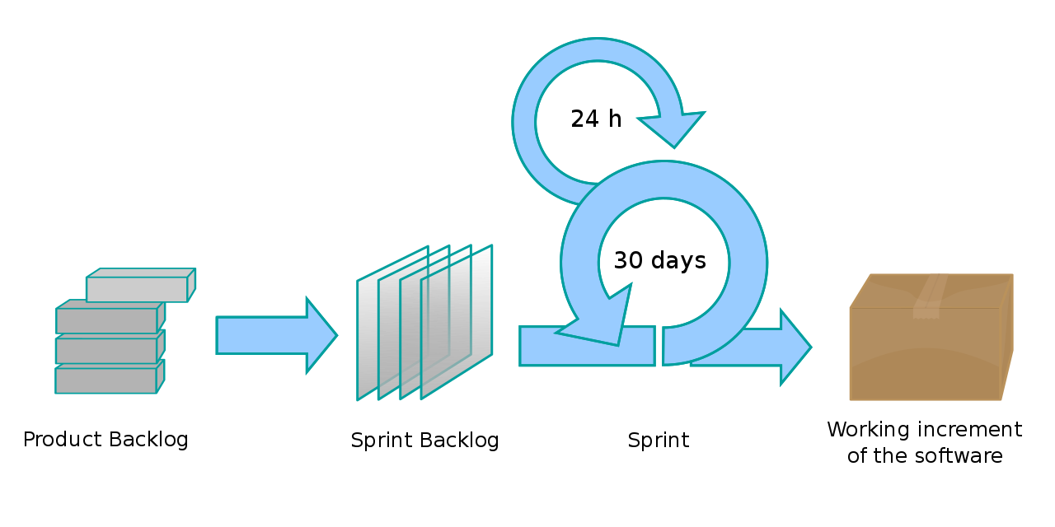

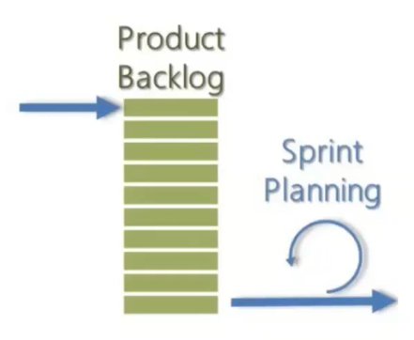**SPRINT PLANNING**

Event during which the Scrum Team sets a (high level) goal for the Sprint and plans how to achieve it. A simple meeting with the objective of selecting some items from the top of the product backlog, putting them inside the sprint backlog, in order for them to be worked on inside the next sprint.

Sprint planning happens at the beginning of each sprint and is time-boxed (4-8 hours). The entire Scrum Team participates in the Sprint planning meeting, which is divided into two parts: the first discusses which PBIs to put in the Sprint Backlog, the second discusses how to implement the chosen PBIs.

HOW

Input: Sprint Backlog (Backlog Items), Capacity of the team

output: Sprint Backlog (Tasks)

Rules: the team reflects on how to transform backlog items into potentially shippable product increment, the team identifies the tasks, the product owner must be available to provide information on the stories

WHAT

Input: product backlog, capacity of the team, team velocity

output: Sprint Backlog (Backlog Items)

Rules: the product owner explains the goal of the Sprint, only the team decides how many stories to "draw" from the product backlog

So, to summarize: st the beginning of a sprint, the scrum team holds a sprint planning event to:

* Agree on the sprint goal, a short description of what they forecast to deliver by sprint end, based on the priorities set by the product owner
* Select product backlog items that contribute towards this goal
* Form a sprint backlog by mutually discussing and agreeing on which items are intended to be done during that sprint

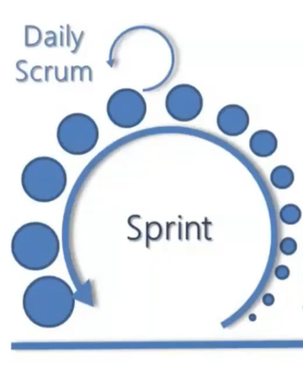**DAILY SCRUM**

Each day during a sprint, the developers hold a daily scrum with specific guidelines, to which all developers come prepared. During the daily meeting (maximum duration of 15 minutes) the team organizes the day to advance towards the achievement of the sprint goal, communicates any impediments and aligns itself on the progress.

There are several patterns that can be used to structure the discussion during the daily. The Team can choose the most suitable structure, as long as the focus is on the advancement of the sprint and produces a feasible work plan.

Everyone needs to be able to talk in the timespan dedicated to the meeting, and tell what he has done, what he is doing, whether he is having impediments.

No detailed discussions should happen during the daily scrum. Once over, individual members can discuss issues in detail, often known as a 'breakout session' or an 'after party'.

**SPRINT REVIEW**

During the sprint review, which happens at the end of a sprint, he project is evaluated against the sprint goal defined during sprint planning. The completed items are presented to the PO that can accept or reject them asking for fixes and adjustments.

The entire Scrum Team and the Key Stakeholders are present (in some contexts also colleagues from other departments, managers and customers). The Scrum Team conducts the review, showing to stakeholders what was accomplished in the sprint, and the Product Owner accepts or rejects the various deliverables.

The Product Backlog is adapted based on the emerging feedback.

The recommended duration is 1 hour for each week of the Sprint as maximum.

**SPRINT RETROSPECTIVE**

At regular intervals, the development team thinks about how to be more effective and hones their behaviour accordingly. The only goal is to grow and improve the team work and not trying to find the culprit. During each Retrospective, the team, reflecting on the Sprint that has just ended, plans actions to increase the quality of the product, improving work processes.

The Scrum Team, the Scrum Master, participates in the Retrospective. Even if the presence of the PO is not mandatory, it is still strongly recommended.

**BACKLOG REFINEMENT**

Although not originally a core scrum practice, backlog refinement (formerly called grooming) was added to the Scrum Guide and adopted as a way of managing the quality of product backlog items entering a sprint. It is the ongoing process of reviewing and amending/updating/re-ordering product backlog items in the light of new information.

The Team collaborates with the Product Owner analysing and estimating the stories to prepare the features to be worked on in subsequent sprints.

All team members must be involved during the backlog refinement, so the entire team analyses, breaks down and estimates User Stories. The goal is to make the stories "ready" following the order of priority.

The backlog refinement meeting usually lasts one hour a week and is scheduled mid-sprint.

The refinement backlog can also involve business contacts, becoming an opportunity to collect and deepen feedback. From the direct confrontation with the business, the following may emerge: new requests, priority changes, task to remove from the scope.

## Artefacts

The 3 artefacts are:

* Product backlog
* Sprint backlog
* Working software

**PRODUCT BACKLOG**

The Product Backlog is a list of items sorted on the basis of business value. These items in the Product Backlog include features that go into realizing the Product Vision.

The product backlog is a breakdown of work to be done and contains an ordered list of product requirements that the team maintains for a product. Common formats for backlog items include user stories and use cases.

A *user story* is an informal, natural language description of features of a software system, written from the perspective of an end user or user of a system.

The highest, most valuable elements in the backlog must be described in detail, so that the team can estimate and test them, and have a size that can be realized in the Sprint.

The list of stories evolves, changes and is updated continuously.

**SPRINT BACKLOG**

The sprint backlog is the subset of items from the product backlog intended for developers to address in the upcoming sprint. The Team typically relies on the historical production capacity of previous Sprints to decide how many stories to put into scope.

Usually, each story is broken down into tasks by the team, which are identified following a detailed and shared technical analysis of the main technical aspects. This promotes self-organization and a sense of belonging to the team.

**POTENTIALLY SHIPPABLE PRODUCT INCREMENT** (working software)

The increment is the potentially releasable output of the sprint that meets the sprint goal. It is formed from all the completed sprint backlog items, integrated with the work of all previous sprints.

The increment must be complete, according to the scrum team's definition of done (DoD), fully functioning, and in a usable condition regardless of whether the product owner decides to actually deploy and use it. The concept of "Done" is determined by the conditions identified by the Product Owner and the Team.

Being "potentially deliverable" does not mean that the results will actually be delivered to customers, but that the quality is so high that it can be done at any time.

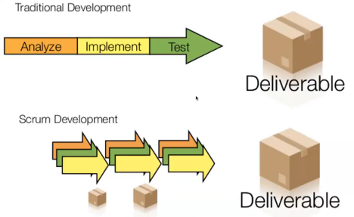

# 11. Big Data Analytics

## Artificial Intelligence

**Artificial intelligence** (AI, also machine intelligence, MI) is intelligence demonstrated by machines, in contrast to the natural intelligence (NI) displayed by humans and other animals, which is called *natural intelligence*.

**Machine learning** (ML) is a subset of artificial intelligence in the field of computer science that often uses statistical techniques to give computers the ability to "learn" (i.e., progressively improve performance on a specific task) with data, without being explicitly programmed. Machines are not provided a definition of the rules of the problem they need to solve, but just a big amount of data and from them they learn to solve the problem.

The traditional problems (or goals) of AI research include reasoning, knowledge representation, planning, learning, natural language processing (NLP), perception and the ability to move and manipulate objects, robotics and sensors.

Capabilities generally classified as AI include successfully understanding human speech, competing at the highest level in strategic game systems (such as chess and Go), autonomous cars, intelligent routing in content delivery network and military simulations, and many more applications.

In Machine Learning, algorithms are typically divided into two main classes:

* **Unsupervised learning**: learning how to solve a problem from data without a need for «ground truth», e.g. clustering or pattern recognition.
* **Supervised learning**: learning from data with «ground truth», e.g. predictive analytics. These algorithms need to be told if they are doing right or wrong.

There are also other classes of Machine Learning algorithms, like Semi-Supervised ones.

«Ground truth» is data on the «true» behavior or status of a system, typically obtained from direct measurement of real-world data. It’s a set of problem instances with the correct solution. Ground truth is a big limitation for Machine Learning applications, because it might not be available.

An example in which collecting the ground truth is expensive and manual but is done anyway because the application has the economics to justify the collection of the ground truth: Earth observation for crop classification (agriculture).

Satellites provide images of the earth, divided in pixels (e.g. 30mx30m pixel size), represented as reflectance values. Given the color of a pixel, the problem might be to identify the kind of crop that is cultivated in that pixel.

* *Unsupervised approach*: from reflectance values, it is possible to identify larger areas (e.g. fields) with clustering techniques. Larger areas are then labelled based on the reflectance footprint of different types of crop.
* *Supervised approach*: from a classification of pixels (ground truth) it is possible to predict the crop for next year by training a random forest on reflectance values of previous time period (e.g. last year’s satellite observations with corresponding ground truth).

The levels of precision reachable with a supervised approach are generally higher than what is obtainable with an unsupervised approach.

**Deep learning** is a sub-class of machine learning algorithms that:

* Use a cascade of multiple layers of nonlinear processing units for feature extraction and transformation. Each successive layer uses the output from the previous layer as input. The first input is the description of the problem and the last output is the solution.
* Learn in supervised (e.g., classification) and/or unsupervised (e.g., pattern analysis) manners.
* Learn from multiple levels of representations that correspond to different levels of abstraction, e.g. the levels form a hierarchy of concepts.

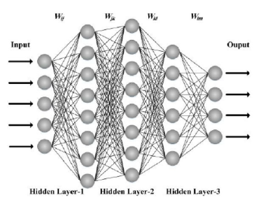A Multi-layer neural network is built by Deep Learning. In it, each layer performs a different transformation.

For example, a neural network for image recognition might have a first layer to segment the image in pixels, a second to aggregate them in areas to obtain a simplified image recognition problem, and a third to train a (single= network to recognize the image.

Nodes represent non-linear functions that have parameters. The training algorithms associates the best possible parameters to each node in order to obtain the best output with the minimal error thanks to the right combination of parameters. Neural networks are well known to require several input data, so ground truth.

**Natural-language processing** (NLP) is an area of computer science and artificial intelligence concerned with the interactions between computers and human (natural) languages, in particular how to program computers to process and analyze large amounts of natural language data. Challenges in natural-language processing frequently involve speech recognition, natural language understanding, and natural language generation.

NLP has received attention over the years in different fields, starting from the 90’s when the objective was document management, so their classification and retrieval and topic extraction. In 2000 the aim shifted to document and web search, then in 2005 to speech to text technologies, followed by social media analytics web reputation, sentiment analysis in 2010, while in 2015 the interest was in chat bots.

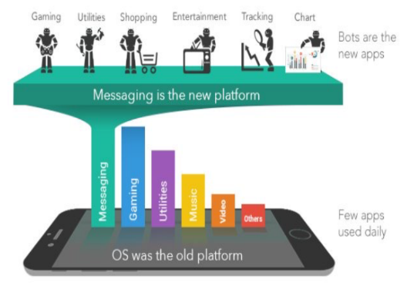An experience with a (chat)BOT should consist in a dialogue in which the user speaks and then receives relevant answers. Generally, a BOT works «for us», just like any other algorithm. The difference between a BOT and an algorithm is that a BOT does what we (humans) would do. For example, if we ask for the square root of a number, the BOT opens the calculator, digits the number, presses the square root button and then reads the result. The interaction with the user is the best state-of-the-art interaction, initially based on text chats, now more often based on speech recognition.

A BOT is more than a mobile app; it is a new paradigm to integrate mobile apps. The current trend is to develop a mobile app equipped with APIs for BOTs. Users are reached on the apps that they use most frequently, typically messaging apps such as Messenger or Telegram.

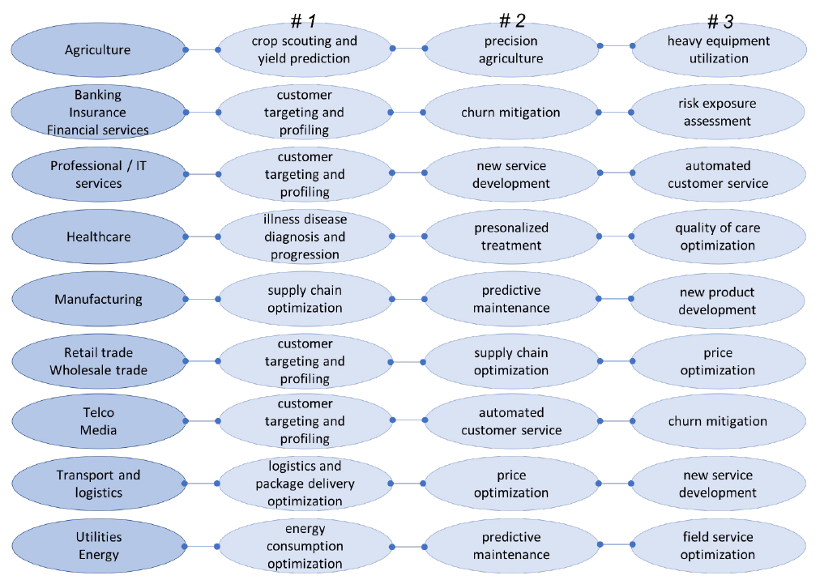The following chart shows what is a Machine learning (AI) application priority for each industry listed.

The most recurring applications are predictive maintenance in manufacturing and targeting in services.

It’s crucial to associate the right KPIs with Machine Learning, because it automates decision making, as every application embeds decisions to be taken. While a human being is flexible enough to look at the outcome of decisions and improve future choices, a machine is not and so needs and indicator like a KPI to optimize as an objective. The following table shows some of the Machine learning (AI) business KPIs:

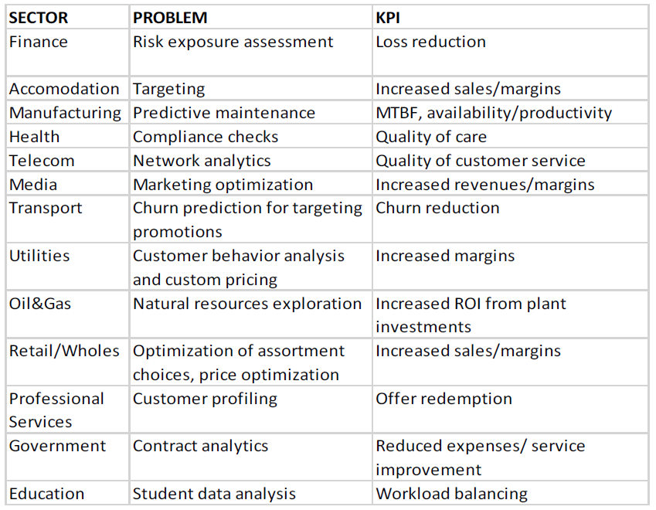

It’s important to make sure to explore the type of decisions that the owner wants the machine to make, and in some cases train more algorithms depending on the KPI to optimize and use the right one according to the current objective.

AI should be related to business KPIs, because with AI we embed (or support) «decisions» inside software, and decisions should be driven by business KPIs. AI should be trained in order to implement a process of continuous learning from the environment in order to adapt to the market. Might be necessary to develop more Machine Learning algorithms and integrate them into a single overall AI application that provides people the right support to make decisions manually and the ability to start and stop different algorithms depending on the context, and run the correct ones with the parameters that they need.

Algorithms have to reach certain KPIs but also KPIS need to be measured on a constant basis to continuously asses the effectiveness of the algorithm. This is because the benefits of AI/machine learning use cases are rarely quantified but they need to be. There’s a lack of business benchmarking initiatives.

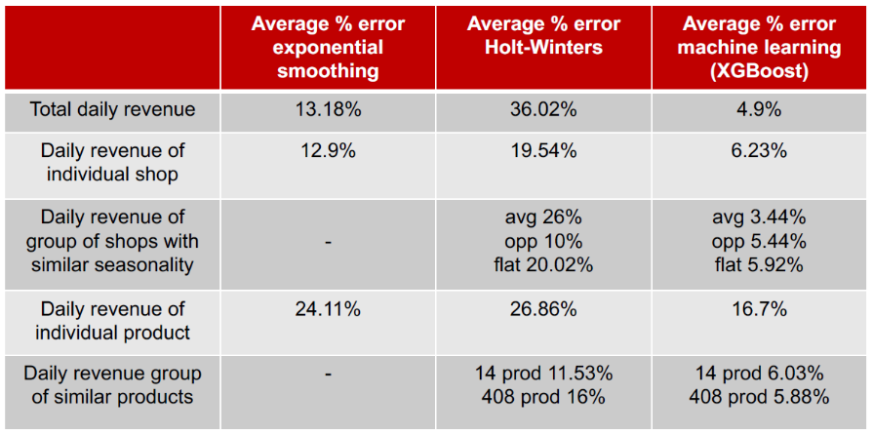An example about retail industry: predicting revenues; the level of precision is of interest. Error tend to decrease as the predictions become more general while rises for specific predictions.

Machine Learning algorithms have different performances and the one algorithm with the best precision regarding the problem faced and the available data must be chosen. Also Machine Learning Models need to be compared. The threshold between an acceptable result with an acceptable error and an unacceptable error for a solution depends on the application.

Machine learning’s benefits can be observed in different contexts and industries. However, managers are (still) sceptical for a variety of reasons. First, AI and machine learning are (and are perceived as) complex and are associated with the concept of «big data» which adds to their complexity. Also, there is no off-the-shelf technical solution and technology is special-purpose and expensive. AI and machine learning are seen as a threat by decision makers (in fact, it may replace some of them).

## How big is Big Data?

Big data is a broad term for data sets so large or complex that traditional data processing applications are inadequate.

Around 2002, the spread of global connectivity is responsible for two main trends: the step increase in the shared amount of information that is produced, and the replacement of analog supports with digital ones.

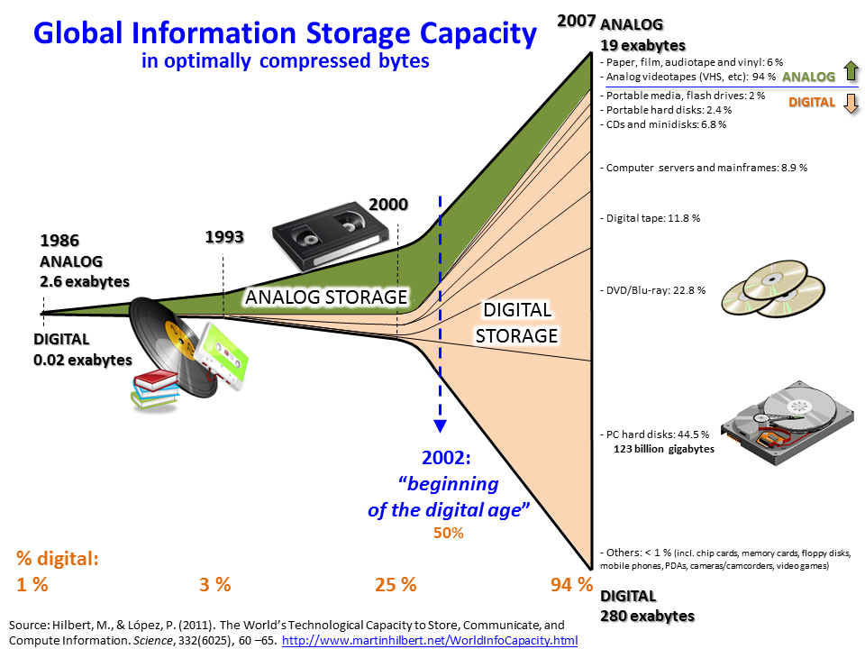

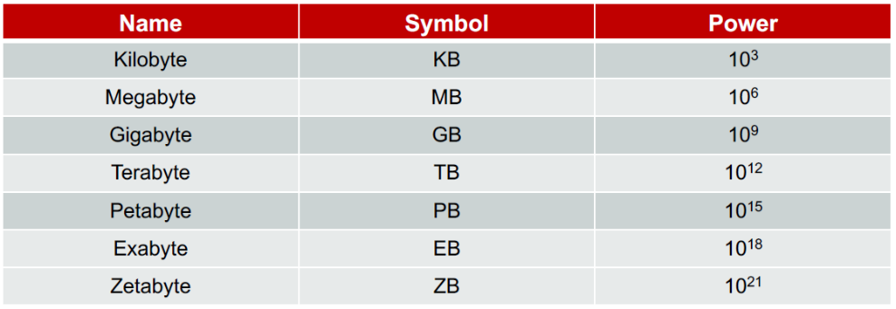

Erik Schmidt (Executive Chairman Google): «From the dawn of civilization until 2003, humankind generated 5 Exabytes of data. Now, we are producing 5 exabytes every two days, and the pace is accelerating. » and global IP traffic is forecasted to reach 3 ZB/year, roughly 4 EB/day by 2021.

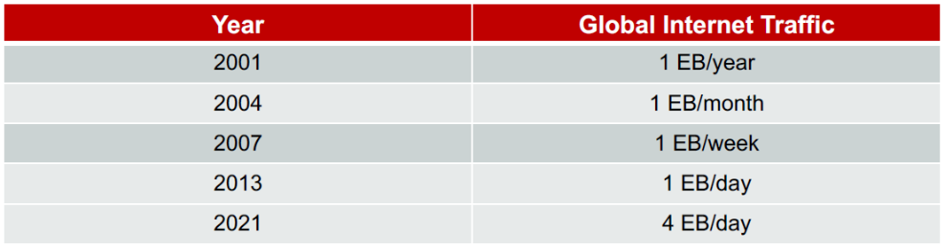  
**Big data** is «a collection of data from traditional and digital sources inside and outside a company that represents a source for ongoing discovery and analysis. ». In a certain sense, Big Data are a unified source of data that can give business benefits to a company when analysed.

Big data is any amount of data that raises technical scalability challenges for a given company due to the increasing growth rate of data and a need for continuous analysis. Even data in the order of Gigabytes can be to some extent considered Big Data for the technical challenge they pose to analyse. Terabytes are definitely Big Data.

Big Data can be classified in types:

* Conversation text data: Twitter, Facebook, …
* Photo and video Image data: Youtube, …
* Audio files: recordings from call centers, …
* Sensor data: geo seismic data, satellite data, …
* The Internet of Things data: smart devices, smart phones, …
* Web customer data: Web logs, …
* Traditional customer data: receipts, loyalty programs, traffic data of telephone/Internet operators, …

Conversation text data reach the size of 25 TB/year, and the volume of data on a specific data usually is small if the brand is local and larger if the brand is global. Semantic engines can process roughly 1 MB of text in 1 day with 1 core. Images generate about 150 PB/year, Audio data from recordings and call centers generate 0,5TB/year, while only YouTube generates 1EB/year of video data.

Sensor data can be of different type: a sensor can record text, photos, video, or audio. It represents a «stream» of data, that is a time series of data points, and their value is in their timeline. Along a timeline, sensor data can easily reach the PB size.

IoT data are also huge, producing 10 PB/year in text data only, but it also includes photos, audio and video. This data is usually transferred to a single location to be processed and then only a summary of it is saved, but transferring streaming data from IoT devices to a single location for processing is challenging both from a technology and economic perspective.

Web Customer data typically grows to several GB/day. For large organizations with extremely active web sites, generating a few TBs of data in a year is common. It’s not unusual that companies store data for some time and then implement a log file rotation daily, weekly, or monthly. Even TB/year is an order of greatness that makes company follow data life cycles so to optimize the process.

Traditional customer data size ranges between 0,5 and 10 TB/year (compressed) depending on the type and size of the business. These data sets include both catalogue and transaction information, which is the largest inside a company. Some industries, like banks, need to keep transactional data for a long time (for banks it is 10 years).

Complex processing operations have to be performed on these data, including customer segmentation and predictive analytics. While these data sets can still be managed with traditional relational technologies, queries can be very slow and non-relational approaches can be advantageous. Open source and free statistical tools may have a very low performance unless data are aggregated, or short time periods are analysed.

## Challenges of Big Data projects

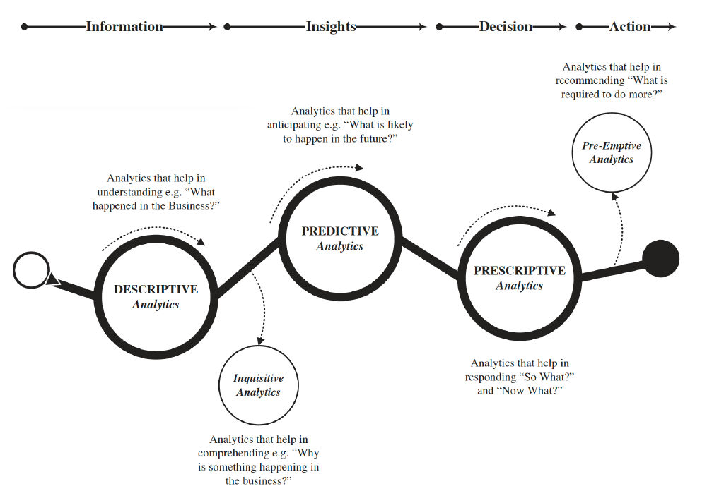

There is a distinction between three different kinds of analytics:

1. Descriptive analytics
2. Predictive analytics
3. Prescriptive analytics

Every kind of analytics requires different types of technologies. However, the three analytics can be seen together as a path of evolution, from descriptive to prescriptive, that companies go through as they learn how to handle big data. Each step does not eliminate the step before.

**Descriptive analytics** are about taking the data and calculating some summary indicators based on those data; they represent the traditional business intelligence. When companies are ready, they implement **predictive analytics**, in order to use data to improve the decision cycle, so that decisions are made based on predictions to support them. One example is prediction on the demand curve. Linear modelling is utilized as the most common approach, but in recent times companies have started to use different algorithms, also based on Machine Learning. Managers learn that this support to decisions, if well implemented, is often more effective than their intuition and experience as managers. The last step is moving to **prescriptive analytics**, which involved automating decisions to some extent. There is of course a resistance towards the automation of decisions. However, this approach is usually oriented to only less critical decisions.

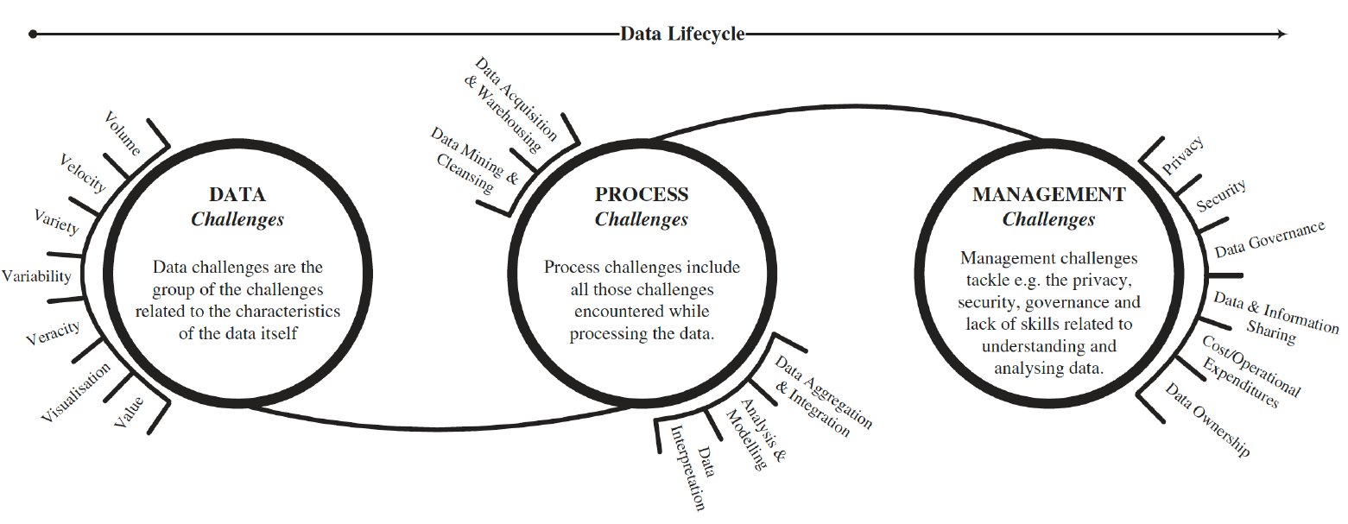This evolutionary process inside a company is challenging, and there is a distinction between types of challenges:

* Data challenges: adding the data, interpreting the data and then preparing them for the analytics
* Process challenges: enacting change in an organization to make best use of the analytics
* Management challenges: about how to manage the whole process and make sure it is effective

The main issues with data projects:

* Getting the technical skills needed to manage the new technologies for big data, otherwise they are going to be ineffective. A solution for a company not having the right technology can be to use cloud computing, which will provide a ready platform, but the costs are usually very high. (management challenge)
* Getting the data, which are very often stored in multiple databases, not integrated, not ready for analysis (e.g. not structured, not real time) (data challenge)
* Getting the analytical skills to explore data and gather new and useful insights (management challenge)
* Achieving business involvement (management and process challenge)

Then, the dimension of data represents a technical challenge for companies. Once, data were “small” and it was easy to run analytics. Companies could process easy analytics with Excel but could also write scripts for few complex analytics always with excel.

Moving to a database, like MySQL, the overall space for data grows, but there are requirements about the technology. The issue with MySQL is the end-to-end system that stores the data and provides the real-time analytics, starting with complex ETL (extraction, transformation and loading). So, using a modern file system and OS, it is very likely that a MySQL database will perform very badly long before reaching theoretical limits, as the useful size of your database is practically limited by the amount of RAM MySQL can use to cache information. According to a rule of thumb, the maximum size of your database should be about 10 times the amount of caching memory (so for 1TB of data 100GB of RAM would be needed). To cope with Big Data, the best option is to run MySQL on a group of computers. The estimated limit of MySQL Cluster is 2 PB. However, setting up a cluster is expensive (hardware costs, need for large bandwidth network, configuration, technical support).

Shifting to other DB systems, also Oracle has issues. The maximum size of the Oracle database is 8 EB, which could accommodate any type of data and is well beyond the typical multi-media big data requirements, and Oracle can integrate large files without migrating them into relational tables. It is also integrated with R, enabling easy access to (open source) analytics and responding to end-to-end knowledge discovery requirements. However, it has the limitations of an SQL database, so it has low performance compared to other technologies.

For analytics purposes, data can be de-normalized, so the table structure can be abandoned in favour of less and bigger tables, with duplicate data, in a NoSQL database. Hadoop is a Framework that allows for the distributed processing of large data sets (terabytes or even petabytes) across clusters of computers. The theoretical storage limit with Hadoop is estimated to be around 120 PB. For analytics, the paradigm is write-once-read-many, so they have very high read performance but very low write performance. Also, Hadoop is optimized for sequential reads, for example needed to calculate the mean value of a huge column, but has bad random read performance.

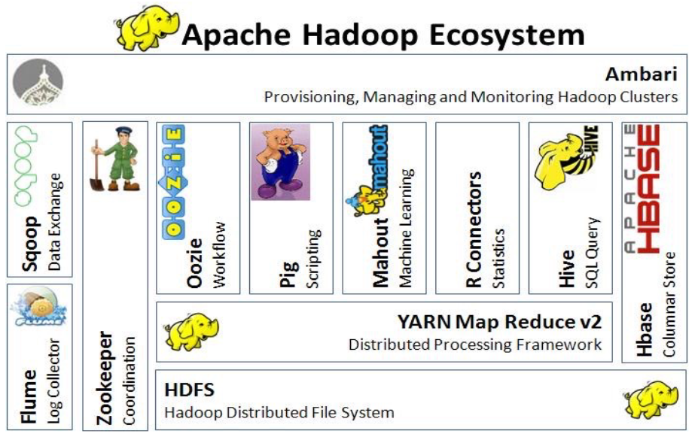Hadoop has two main components:

* Hadoop Distributed File System (HDFS): a distributed, scalable and portable filesystem
* MapReduce: a distributed, fault-tolerant resource manager and scheduler for processing large data sets. MapReduce is a paradigm to query large tables with a Map() and a Reduce() steps.

Hadoop is not just a DB, but it is an ecosystem with many components.

It has many commercial distributions, like Cloudera, MapR, Pivotal, typically with their own ecosystem.

A lot of companies have adopted Hadoop but many are reconsidering it, because doing everything with it in a single DB is not possible due to its bad writing performances.

Another challenge is getting the data. Companies may or may not have integrated data supporting their requirements for machine learning and advanced analytics.

There is also an issue of **Data Lifecycle Management**. At some point, data become obsolete and they have to be deleted. The cleaning of data is more difficult in analytics systems. Data should be complete with respect to the data analytics requirements: this requires knowledge of organizational processes and practices. They should also be integrated: with big data, working on samples that are not statistically significant is a tangible risk. As a consequence, there is an objective difficulty in enforcing consistent quality as the data scales along any and all of the **three Vs** (volume, velocity, and variability). The paradigm should be: data quick to generate, quick to evaporate, as data need to be deleted/cleaned frequently. Then, another difficulty comes from the fact that data are heterogeneous: data have different formats and sources. Integration may be coped with at different levels of abstraction (physical, logical, or only conceptual).

One other challenge, representing an organizational issue, is getting the right skills. The main organizational issue with big data is human resource. Talent management is critical to have good data scientists who can extract value from data. Along with the data scientists, a new generation of computer scientists are designing techniques for processing very large data sets. There are tools that automate analytics, removing the need for coding, but the data need to be put in those tools first by people who can do it.

Leadership is another issue, since companies need clear vision and goals to enable coherent and target-oriented data analyses. Company culture should become data driven. This requires to move away from acting on instinct and HiPPO decisions (decisions based on the highest-paid person’s opinion).

The last important challenge is an organizational issue that is achieving business involvement. In fact, even with the right skills and a strong leadership, building a data-oriented company culture can be a challenge. On one hand, culture can be changed when data are available. On the other hand, making the data available requires a considerable degree of business involvement and commitment. Evangelization and use cases are key to obtain the initial commitment to embark in a big data project.

## Solutions for Big Data projects

According to Gartner the so-called “Megavendors” in the Big Data field are IBM, Microsoft, Oracle and SAP. But there are many other vendors that provide a variety of solutions. The big vendors have a strong market position but tend to be the less innovative, as they show the lowest market growth rate, while data discovery leaders show the highest market growth rate. Of the 43 vendors listed, only 2 smaller vendors operate with a cloud-based approach and only 7 tools provide streaming BI functionalities.

Reporting continues to be the most widely used BI capability, but vendors that give access to a broader range of users to more difficult types of analysis have the highest customer satisfaction and deliver the strongest business benefits.

Data discovery vendors lead versus other vendor types in three key measures: aggregate product score, ease of use, and the complexity of analysis conducted by users. They also deliver the highest business benefits. This likely explains their market momentum. They are better at providing the most innovative and enhanced capabilities to work on innovation and push companies towards more advanced applications of Big Data and analytics.

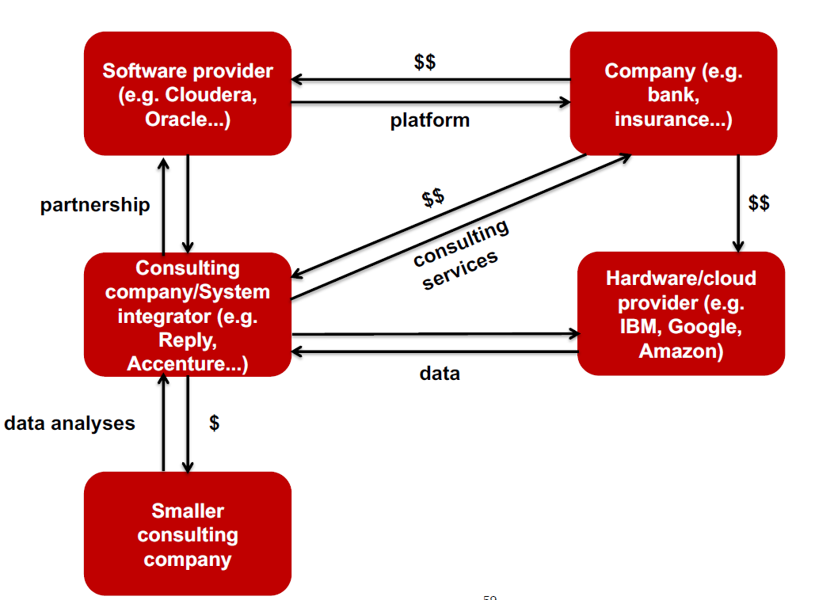To summarize, Megavendors are better at managing big quantities of data but their ability of extracting knowledge from data seems to be less compared to other vendors.

The knowledge extraction process is complex and long, and on the market there is a long value chain.

Companies might purchase a database license and then hire a consulting company or a system integrator to build a data lake storing data for analytics in that database. After that, they go a third type of provider to purchase the processing capacity to install the bought solution. The data extraction can be performed by the system integrator alone or in collaboration with consulting companies.

Consulting companies have a relevant role in Big Data and analytics.

According to Gartner there are over 40 global competitors in consulting services, and a large number of local, smaller, yet growing and profitable consulting companies.

Smaller consulting companies have a variety of roles:

* they gather data from external sources: for example, they develop crawlers or crawl/classify/score manually to fill in a DB for Web reputation analyses
* they perform small and relatively simple system integration projects
* they develop complex analytics ad hoc (for example, they develop customers’ segmentation or sales prediction models tailored to their customers’ sales data)
* they provide industry dependent knowledge (for example, they are specialized in mass retailing and provide marketing insights based on their customers’ sales data)
* they are partners of larger technology providers and perform software customization, analytics, and reporting on behalf of the larger provider

Small consulting companies are often dependent on a global corporation technology provider; this takes away some objectivity from their consulting activities, as they are tied to a specific provider. However, open source technologies are growing, granting big data capabilities to smaller consulting companies, without the intermediation of large technology vendors.

Success stories from companies applying innovative approaches to BI are increasing in number and are no longer limited to smaller organizations. Companies are under pressure and have an increasing need for extracting value from data to improve their competitiveness in the short term, as opposed to starting long and risky projects involving major organizational changes.

There are two types of innovation:

1. «**Quick fix**» innovation: companies look for insights that can provide business value quickly without any major organizational change or integration with operations. Most recent and available data are often used to make one or more pilots and show the tangible benefits of data oriented decision making approach, that is based on advanced data analytics and not just reporting.
2. «**Data-driven business process reengineering**»: companies embark in long-term organizational change to transform into a data-driven organizations basing decisions on evidence. This happens when companies are ready for this change, so probably after the “quick fix” approach has been enacted.

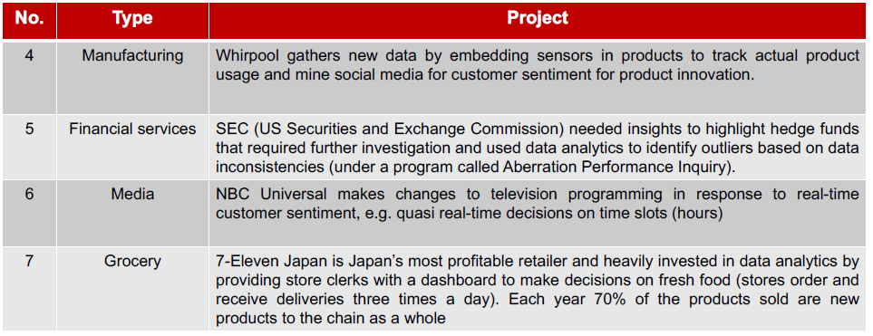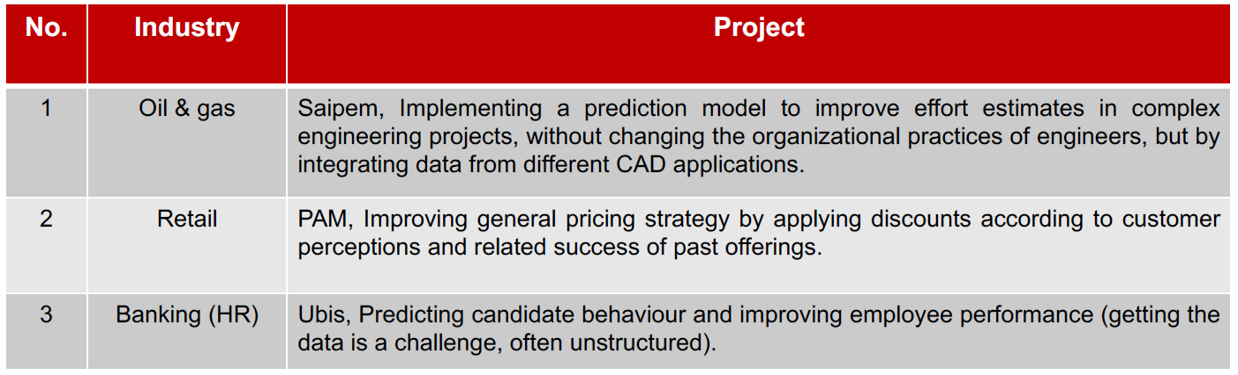Here are some examples of quick fix innovation:

Due to the complexity of big-data related choices and analysis activities, the recent trend is the one of insourcing, hiring people with technical background and run analytics in-house. The goals are the following:

* Work with IT to identify the technical solution that best fits organizational requirements: this may also involve insourcing and consolidation of data centers
* Identify the competences needed to set up an internal group that:
  + performs the analyses of data and works with reference people from multiple organizational functions to tie the analytics to the business needs (requirements management)
  + works with management consultants to use specific analytics to facilitate organizational change (risk and change management)
  + possibly coordinates with smaller consulting companies to integrate ad hoc services with mainstream business needs (contract management)

Insourcing and consolidation of Data Centers bring many savings:

|  |  |
| --- | --- |
| Savings from consolidation:   * economies of scale on technical staff * standardization of technology platform and economies of scale on structure costs and various overheads * discounts on larger contracts | Savings from insourcing:   * better control of all resources * improved access to qualified human resources * lower response times to organizational needs |

Overall savings can be easily greater than 50% and in the billion $ range for large corporations.

The most common approach is to:

“Buy” the infrastructure, since:

* It significantly reduces the time required to complete a big data project
* The loss of technical competences is limited

“Make” data management and analyses, since:

* Data analyses are recognized to be strategic
* Analytics are not a commodity yet and the tailor-made approach often provides an edge

There are many benefits from running the analytics internally. Consultants often tend to standardize their reports and provide analytics according to a template: running the analytics in house allows for greater customization and flexibility. Also, the level of trust in external information can be low, especially if analyses are performed by the same companies providing the «solutions» to the issues identified: for example, Web reputation analyses are very often performed by the same agencies in charge of the company’s Web presence. Moreover, real-time business intelligence may require a tighter relationship with the business in order for knowledge discovered from the analyses to be quickly translated into action.

The typical data science “group” is usually composed by three profiles: the data scientist, the computer scientist, the data manager.

The data manager manages data and data related platforms, but is not good at developing software and using code or machine learning and algorithms. The computer scientist has this knowledge but has limited business knowledge. He has expertise in the design of highly efficient algorithmic software. The data scientist has the business knowledge, so is much better at interpreting results. He has expertise in statistical modelling and analysis, as well as business knowledge.

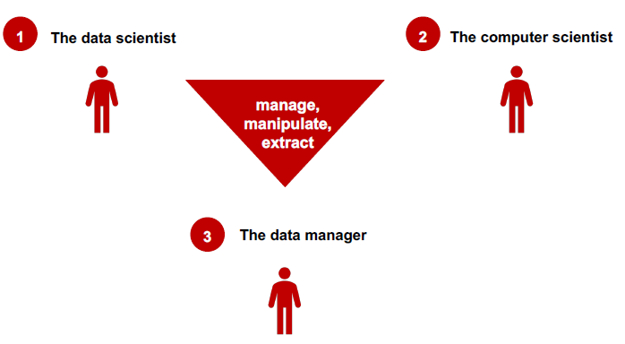There is a shortage in the field of technical skills, as it is difficult to find and retain human resources with the right requisites. Also, continuous and fast innovation makes technology more and more complex and difficult to manage. A solution, which can be often inevitable, is outsourcing.

Looking at how companies have operated with outsourcing over the years:

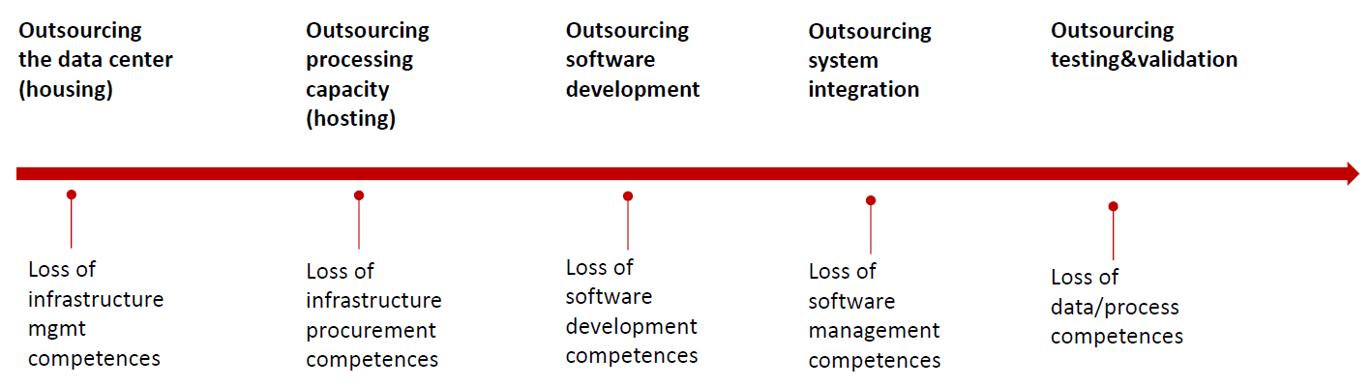

The last step of outsourcing testing and validation is crucial. If a company loses data and process competences cannot know anymore whether a supplier is selling them something that works and provides correct results or not.

In this perspective, cloud computing could be a threat, as it provides everything but consulting. The two main competitors are Google PAS and Amazon AWS, the address every need: computing capacity, storage and database, networking, Big Data, data transfer, API platform and ecosystem, internet of things, cloud AI, management tools, developer tools, and many more. Cloud PAS becomes a super convenient one-stop shopping for both hardware and software, with a consequent conflict of interest. In addition to a loss of competences, it represents an oligopoly (2 players is almost a monopoly), which in the long run typically causes lower quality and higher costs. Diversification (as opposed to a one-stop shopping) is the only way to mitigate risks.

In managing data project companies should follow 4 main steps.

The first step is to **define the use cases**, analyze the returns for each of them and start from the better ones. For the selected use cases, companies have to pick the key stakeholders, analyze the kind of data in possession that can be of interest, the kind of data that is not in possession but is needed, evaluate the flexibility of current IT services on data, think of the possible insights that would be enabled by more integrated and more readily available data. Once selected the potential use cases, one or two out of them with clear KPIs should be taken to provide a proof of concept. The stakeholders often raise a number of requirements in addition to analytics, such as greater flexibility in managing data and lower lead time from data creation to data analysis and action.

The second step is the **determine the project team** so to cover properly all the roles and responsibilities to be successful. First, identify the project “sponsor” to remove obstacles, find the budget, provide organizational support, and champion the cause. Then, establish the project manager and the team and define the roles and responsibilities of each team member. Understand the team’s availability and resource constraints for the project.

The third step is to **Plan the project**, specifying expected outcomes in measurable business terms, determining any other quantifiable business requirement and defining what a successful Big Data implementation would look like.

As last step, **define the technical requirements**: inventory all tools used today, sketch the current architecture, identify the data sources, define the data schema, design the infrastructure, identify the suppliers.

## Case study of Big Data projects: targeting

Targeting is a broader term including recommendations but not limited to it, and is used in retail. Functionalities provided by targeting are: online recommendation engine, assortment optimization engine (personalized shelf for customers), personalized online search engine with custom order of results, personalized shopping list based on customer’s preferences, couponing engine with personalized pricing, personalized communication engine (mailing, flier, pop-ups, …), in-store proximity recommendation engine, online and in-store instant promotion engine (with personalized pricing), real-time access to big data.

Recommendation strategy should depend on the strategy of the company and not be the exact same one that has success for another company. For example, non-personalized recommendations may work in an online shop for the mass market but might lead to sell cheap products to customers that are willing to pay for more expensive ones in another context. Current targeting starts from the idea of showing personalized content, assuming that this is in and of itself good, but it isn’t always the case. We start from the idea that targeting should be based on business objectives and use personalization in different ways to reach business objectives.

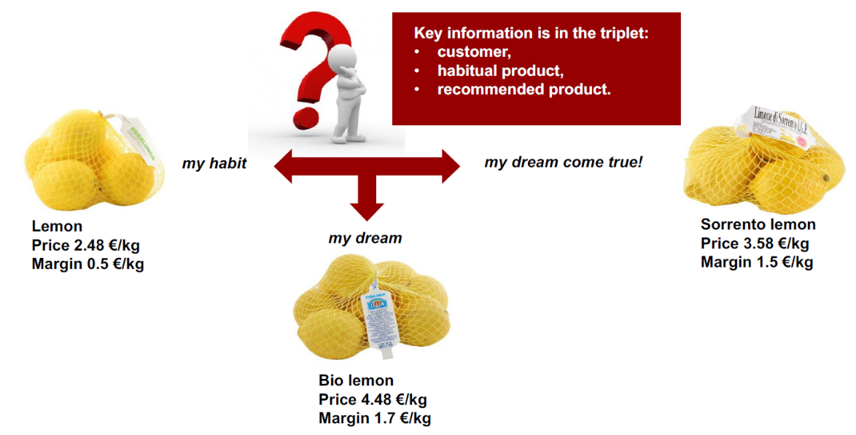

For example, upsell should look at the habit of the customer and make offers that may bring a higher margin to the seller and accommodate the customer desires. It’s possible to make more money, selling a more expensive product with a discount.

The key idea is to look at the data and make fine grained recommendations to clients.

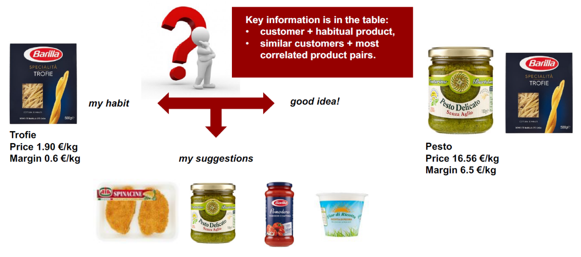Similar is the example of cross-selling. If a customer buys mass market pasta, he probably needs mass market condiments. But if he buys more expensive pasta, then the recommendation should be of condiments that have similar characteristics.

This drives revenues and profits, providing measurable results.

The system can learn how each individual customer reacts to targeting by answering questions, such as:

* Which items are most suitable for upselling?
* Which item pairs are most suitable for crosselling?
* What are the price elasticity limits for different items in upselling?
* What are the price elasticity limits for different item pairs in crosselling?
* Which is the comfort zone of each customer? To what extent should recommendations show habitual products?
* To what extent can we show interesting promotions without exceeding budget limits?

Some proximity services can be based on simple localization based on smartphone/mobile app (or smart device owned by the store). They can provide instant recommendations, promos, memos, ads and recipes and more.

Personalization also helps enabling a variety of options regarding coupons: they can be generated batch and sent via email before a customer’s next shopping experience, customers could choose to which item to apply a coupon within a set of preselected items or they can be automatically applied and notified to customers, or customers are shown instant coupons based on cart content, or products can be bundled on coupons, etc.

It’s to be noted that in some way also customers have some benefits from personalization. So companies are also making customers happy, which is always an objective of any company. These benefits may be:

* Personalization of recommendations: items that are selected for recommendation have a strong connection with customers’ habits.
* Product discovery mechanism: items that are selected for recommendation span across the entire product catalog.
* Serendipity: recommended items are often discounted or have a price that is lower than the habitual product’s price (although they have a greater margin) or are involved in loyalty initiatives

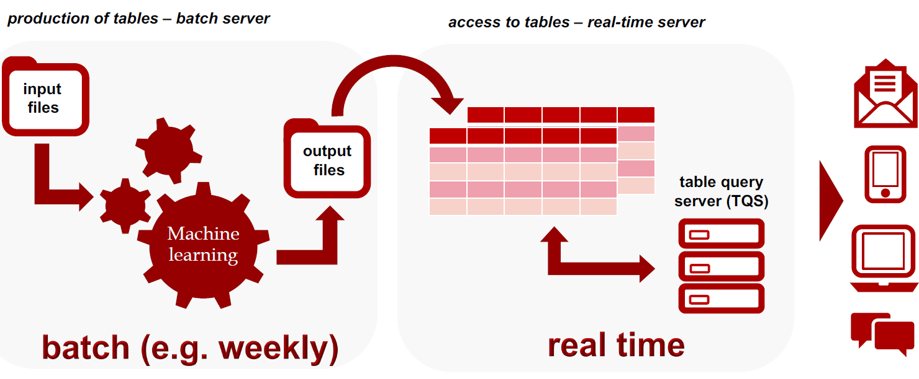

Typically, the systems that are highly personalized are also computation intensive, so what companies do is to produce large recommendation tables periodically in a batch way, then provide real-time access.

The batch component can be deployed on premises or in cloud, while the real-time component should be deployed on premises to minimize latency.

**Conclusions on Big Data and Analytics**

* Big data is getting bigger: need for scalable and inexpensive solutions
* Start with basic analytics looking for quick fixes
* Experiment with advanced analytics looking for quick fixes
* Start on a longer term change program when big data projects have reached consensus with many stakeholders (can be facilitated by change management specialized consulting companies)

# 12. The widening digital divide

The digital agenda has long been recognized as critical for the success of a company, successfully executing digital transformation has become a matter of either prospering or struggling to survive as an organization. The COVID-19 pandemic accelerated what was an already occurring event, an era defining shift from an industrial economy to an information-centric one. Companies that had already made meaningful investments in digital technologies such as cloud, automation, and artificial intelligence, are poised to accelerate those investments in the coming year. In contrast, companies that were in the early exploratory phases or had not yet started, are less likely to invest in the near term following what will inevitably be not only the trend but needed to be competitive.

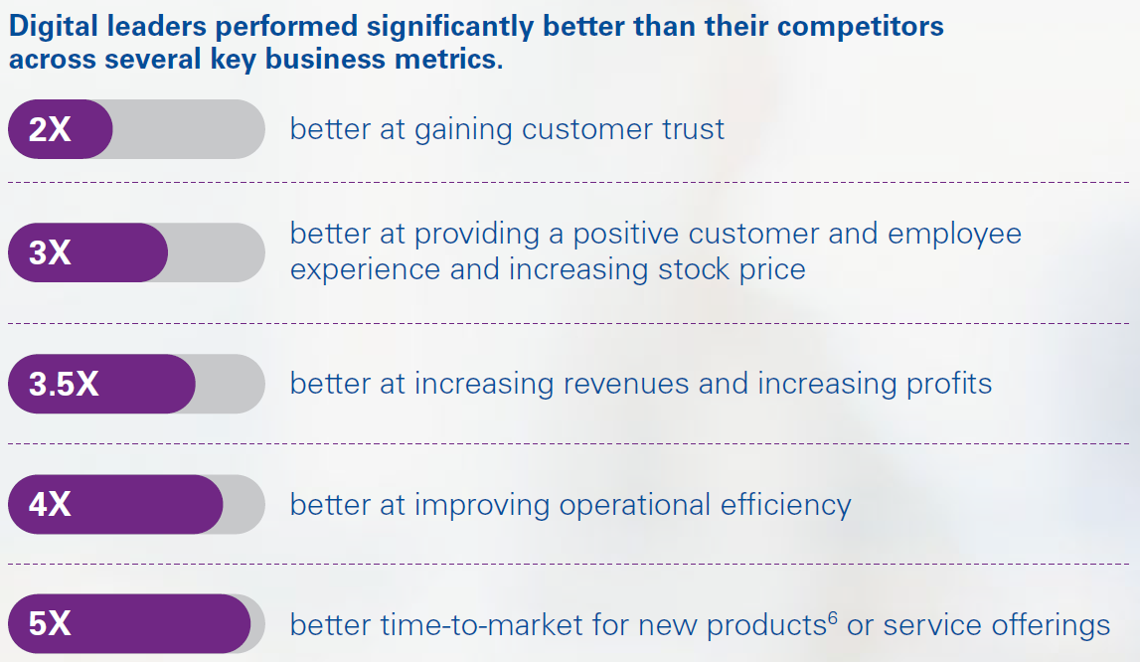For some companies, the danger is that the gap will soon become simply too wide to bridge—and the difference in experience doing business with, or working for, a digital leader compared to another organization will become almost painfully apparent. In some sectors, the digital leaders are setting up a winner-takes-all market.

Digital leadership comes for an organization if it spaces its digital innovation across the key attributes:

* Dynamic investment: adjust funding policies to account for new ways of working and show the financial connection between it spend and business value.
* Costumer trust: build technical trust with an IT function that serves and protects customers and manages technology risk.
* Data as an asset: unlock the value of information with a data-capable workforce that uses new tools and data sources to create business insights.
* Adaptive workforce: develop an it workforce strategy that matches evolving technology skills with organizational growth, while accommodating changing employee expectations and ways of working.
* Modern delivery: leverage modern delivery techniques, like product management, Scaled Agile, and DevSecOps, to accelerate design and delivery of key products.

Surviving and thriving in the new reality requires businesses to continuously and safely deliver the products, services, and experiences at the speed that customers expect. The **market speed operating model** is portfolio driven, meaning the entire operating model should be designed around the specific value streams of the business.

The market speed operating model is formed by three principles:

1. Everything must be seen through the lens of a value stream and specific business outcomes linked to end-to-end technology portfolios
2. Pivoting from siloed architectural and design governance to full-stack architecture based on a modern tech stack, hyper- automation, and open-source standards is important if you are to quickly and safely deliver against business needs while remaining aligned
3. Sequencing, scaling, and aligning changes to the operating model through investments targeted at specific business outcomes is the way to follow so to not create complexity and lose momentum

The IT function can’t proceed at a single pace anymore— it’s got to be omni-speed, capable of truly responding to the demands of both the market and employees. Siloed, monolithic structures must be reimagined from islands of projects and activities to full-stack architectures and customer experience teams.

However, for most companies, it is not economically viable (or necessary) to run the entire enterprise portfolio at light speed. Knowing how to optimally achieve the desired outcome is more important than forcing it into a homogenous digital model.

## Adaptive workforce

An **adaptive workforce** is ‘an ecosystem’ capable of both shifting to meet the changing dynamics of market demands, and of evolving their skillsets to meet the requirements of continuously emerging technologies. Organizations should develop an IT workforce and sourcing strategy based upon transparency into evolving market conditions, and leverage data-led scenarios that enable technology skills to be matched with priority growth areas, while accommodating changing employee expectations and ways of working.

Digital leaders are managing this new reality in several ways. Firstly, they shape the ecosystem to be future ready by adopting an approach known as “atomizing”, with which the job is not assigned to a person, but the tasks are disaggregated and organized based only on the outcome. Disaggregating the work also helps businesses decide which tasks are better done through automation and augmentation and which tasks should remain human-centric. To create a forecast, manual data gathering and tracking can be replaced by robotic process automation (RPA), while the creative problem-solving aspects of forecasting can be faced with Machine Learning (ML). Harnessing RPA and ML helps increase the focus on value-additive work and achieve better results while enabling staff to push the boundaries of their capabilities.

The second way companies are innovating with adaptive workforce is by revisiting ways of working, incentives, and Learning. In particular, within the IT function, there is a focus on ensuring the workforce is both technically capable and has the right blend of business acumen. Also, a leadership culture that emphasizes values, collaboration, and empathy is followed. Strong culture can attract talent even more than better remuneration. There needs to be an intuitive talent path through which team members can develop their careers, with a strong culture of development, training, and upskilling.

Building an adaptive and highly flexible team—including embedding intelligent automation, and augmenting with machine learning and AI in the right places—is a key focus for any CIO if technology is to truly support the business, not only shifting with required demands, but also anticipating transformational change and meeting it with a workforce that is engaged and empowered to deliver.

With a shift from a people-based business to a technology and insights-based model, it became clear that the technology workforce, both internally and externally, required a major upgrade. The organization began by linking their commercial products and services strategy to their technology roadmap. A transformation program office (TMO) and product management function can be established to aim investments towards the areas needing strategic IT innovation. The innovation happens targeting roles and skills of both internal and external technologist, so to support specific product types, and unified tool sets are implemented to enable agile and more automated working environments, along with a governance model that needs to ensure flexibility and quick response to risks and opportunities.

## Modern delivery

Modern delivery is a model that helps CIOs and the entire technology organization more rapidly deliver value, reduce failed deployments, and create a culture of continuous improvement while helping the business win in the market. In fact, frequent deployments, shift-left approaches, and automated operations are all IT efficiencies, but these directly translate into business achievements. These modern delivery methods help achieve organizational goals more effectively.

Leaders in modern delivery deploy code much more frequently, massively shorten delivery cycles, and recover from incidents significantly faster. These attributes encourage creativity, experimentation, and innovation, helping the business adapt to the market and outpace competitors. Digital leaders that have adopted modern delivery typically realize progressive improvements to product and application delivery efficiency, code quality, and operational support over three to four years, and while increasing employee motivation and commitment.

## Data as an asset

With data sitting at the core of the modern enterprise, utilizing it has become critically important. The ability to separate insights from the noise and unlock value and performance improvement is a distinguishing feature of a digital leader.

While in many organizations the view of the value of data has exponentially increased in recent years, the approach to managing it has not. Frequently, data is still seen as a ‘by-product’ of business processes and as a management and technology problem rather than something be owned by the business. Seeing the full value of data requires a fundamental shift in the way organizations approach and understand it.

Unlocking data requires both a data-capable workforce across the entire organization and the architecture and frameworks to enable this workforce with the data they need, in a high-quality and readily usable format, enabled by new tools and data sources to create business insights.

According to KPMG, there are three principles about data to follow:

* Develop a modern data architecture built upon cloud, leveraging multiple data sources
* Scaled solutions in analytics, automation, and integration
* Helps ensure clear data accountabilities and establish strong data fluency among employees

A company, in order to follow these principles, should design its data architecture so to fit the purpose of the business value stream. The workforce needs to have the right culture about data in order for a correct design to properly work, and the governance should be aligned with these policies in favor of data exploiting.

## Customer trust

Customer are becoming more informed and more demanding, so achieving their loyalty can be difficult. Nowadays, consumers and businesses increasingly expect the organizations they do business with to protect their interests, or they will leave and turn to competitors. Trust has become the currency that all brands trade upon, while providing a customer-centric experience. By always acting in the best interest of the customer, digital leaders help ensure trust is embedded as a concept from product ideation through delivery.

Therefore, at a strategic level, investing in customer trust is a clear executive priority. IT organizations with centralized governance need to allow sufficient discretion and flexibility to individual teams to create solutions to accommodate customers’ standards of quality. In parallel, insights should be collected through automation, collecting data and monitoring emerging risks as they arise.

The trust focus should extend across the third-party ecosystem, utilizing proven industry leaders wherever possible, establishing clear policies and a program to continuously evaluate providers, and using multiple measures of quality, bias detection, and explainability to help ensure models and data from across the ecosystem can be relied upon.

Front-running organizations are also embracing Trust by Design through DevSecOps, which has emerged as the leading practice to help build and maintain trusted technology. It enables the continuous focus and integration for security across the technology value chain and effectively helps shift-left risk and security processes and capabilities.

## Dynamic investment

In a market speed operating model, businesses can rapidly pivot, seize new opportunities, quickly exit poorly performing investments, and de-risk large initiatives, and so the IT organization must run at speed. Dynamic investment enables an organization to continuously adapt to change, constantly adjusting direction so that investments are consistently aligned with customers, markets, and the changing types of technology.

Arguably, the most fundamental aspect is replacing the annual budgeting cycle with a much more dynamic process. The goal is to shift from long-range annual budgeting towards funding initiatives on a rolling basis so that investment can adjust to operational, business, or technology conditions. What is important is not when the budget review happen, but that they follow an iterative and dynamic concept, that also facilitates decision making.

Digital leaders apply other key dynamic investment principles such as taking a product-centric approach to IT investment, leaner business cases, nimbler governance, more dynamic capitalization policies, and the use of predictive analytics to support decision- making, to accelerate and unlock value faster and propel organizations toward their most strategic goals.

# 13. Micro-services

## Web application and architectures

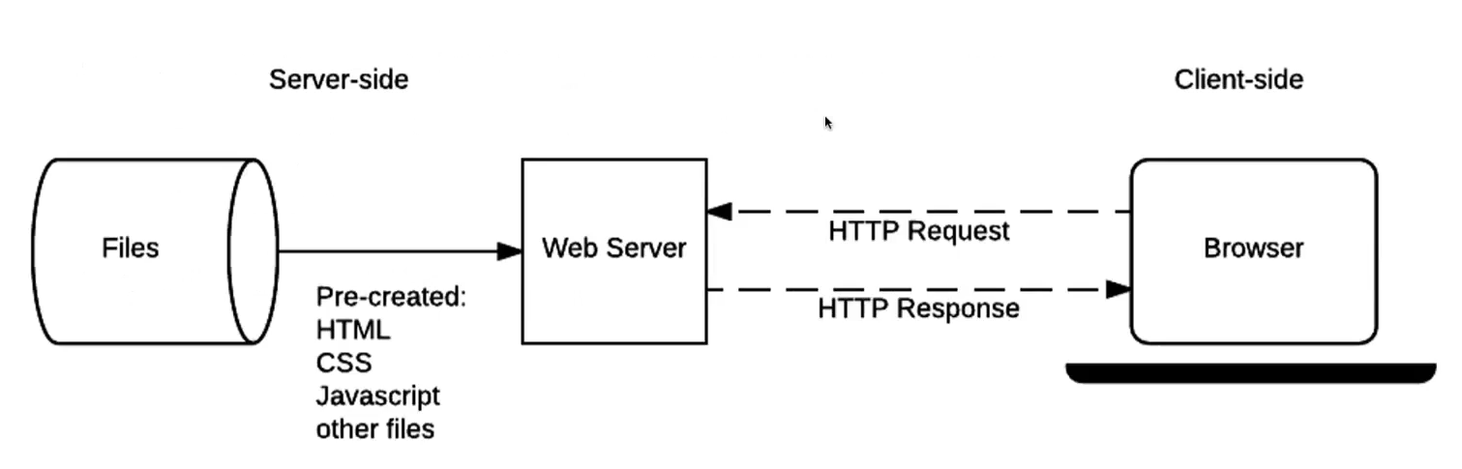

In a simple architecture based on HTTP and a web server, a request is sent from the browser to the server on a specific port and the server, who listens for requests, performs what is asked accessing to some files and builds and sends a response to the client browser that shows it. Resources are static and the interaction is limited.

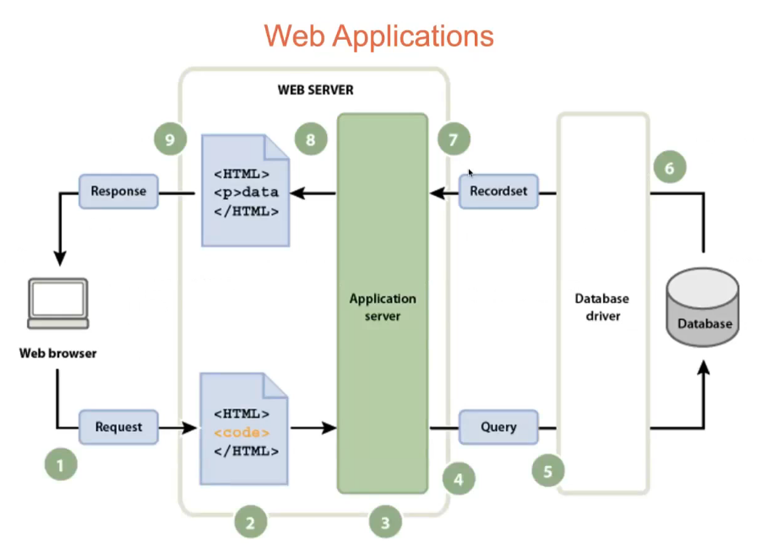The evolution of this architecture is **Web applications**. The input from user is considered and instead of reading static resources from a file system, it considers a business logic and makes some queries to interact with a Data Base. Also, some presentation business logic is executed to convert the data from the application logic into a response.

These applications contain executable code (usually JavaScript) to run on the browser. Instead of reloading the whole content every time, like with the old web server architecture, the page is dynamically changed. User experience is very similar to a desktop application.

The Database is considered as a detached system from the server-side part.

The application logic inside the application server is usually very complex and needs to be managed. The best way is to create more components with different responsibilities inside the business logic layer. The usual design pattern is the **Model-View-Controller** (MVC) design pattern. It also facilitates the cooperation of people in developing it, and it is possible to say that the architectural style follows in some way the organization style.

The business logic is inside the service and the service itself can be organized in more components, usually called *business delegates*, so to organize better and distribute the complexity.

The concept is to divide the related program logic into three interconnected elements. This is done to separate internal representations of information from the ways information is presented to and accepted from the user.

Some web MVC frameworks take a thin client approach that places almost the entire model, view and controller logic on the server. In this approach, the client sends either hyperlink requests or form submissions to the controller and then receives a complete and updated web page (or other document) from the view; the model exists entirely on the server.

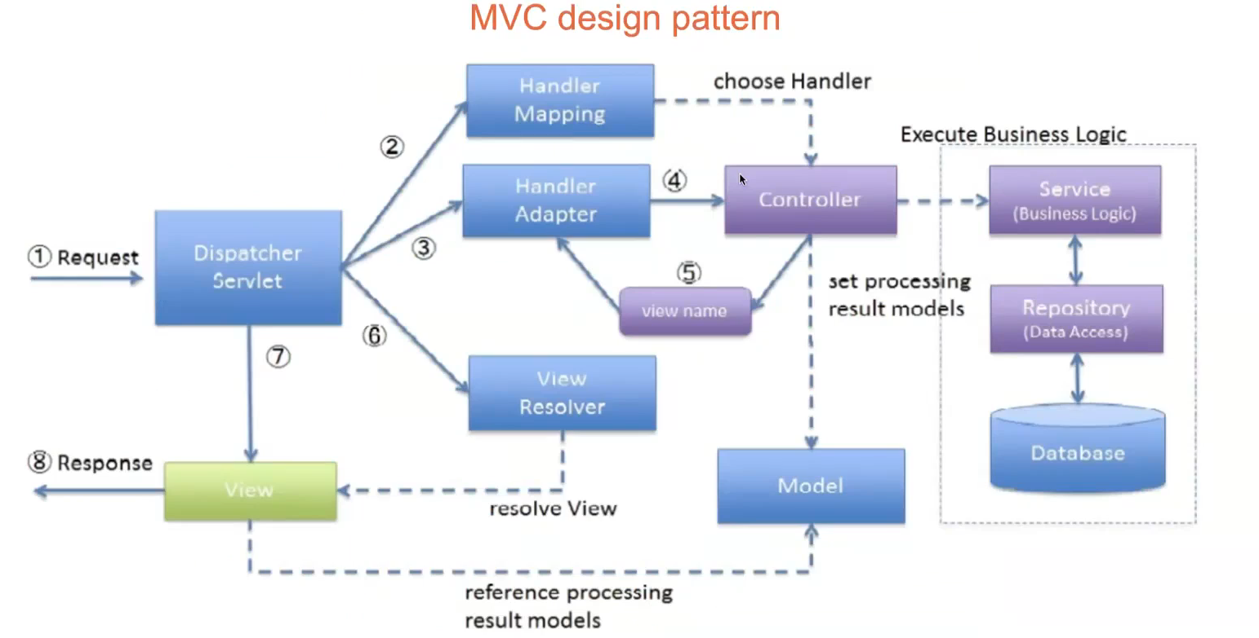

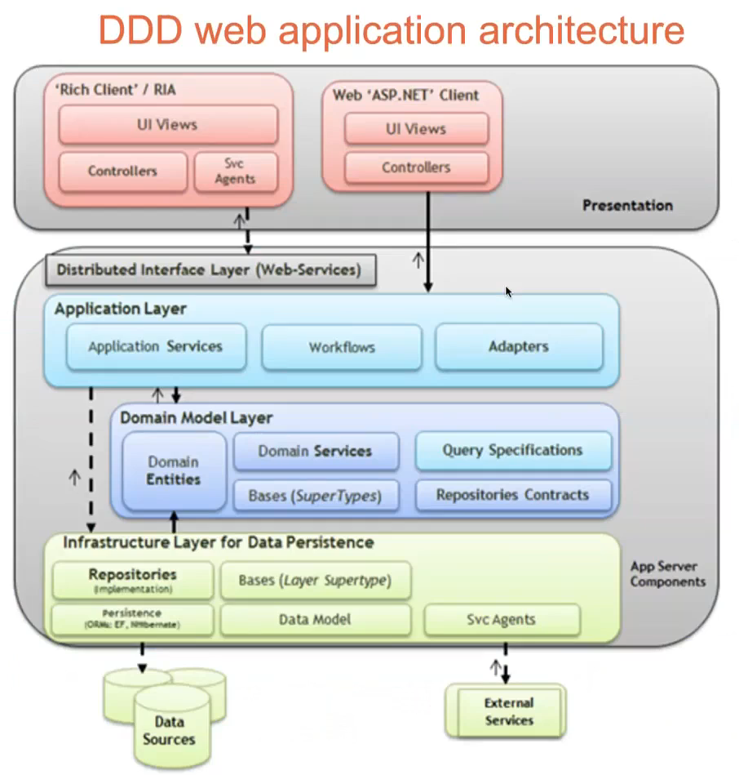Another step forward the actual modern structure of a business information system is the **Domain-Driven Design** (DDD) architecture. It is a software design approach that focuses on modelling software to match a domain according to input from that domain's experts. In terms of object-oriented programming it means that the structure and language of software code (class names, class methods, class variables) should match the business domain. DDD connects the implementation to an evolving model.

The goals of this approach are:

* place the project's primary focus on the core domain and domain logic
* basing complex designs on a model of the domain
* initiating a creative collaboration between technical and domain experts to iteratively refine a conceptual model that addresses particular domain problems.

However, DDD is recommended only for complex domains where the model provides clear benefits in formulating a common understanding of the domain. The main disadvantage of this model is that it requires that everything is inside a single executable object and runs inside it. These objects are called *Application servers* and they constitute a monolithic architecture. There will be more instances of these objects but from the logical perspective the only component running inside the server is of this kind.

Having a single executable macro-component that contains all the application logic can be problematic. It is typically composed of modules that try to encapsulate the application logics, and create two orthogonal dimensions:

* Architectural level
* Business functionality

The architectural level dimension usually consists of three levels (layers):

* Presentation layer
* Business logic layer
* Data access layer (persistence with database and other data sources)

Every component can be put inside one of these layers. In the data access layer there can be components that access to other systems, so there is not only interaction with the data base and its persistence.

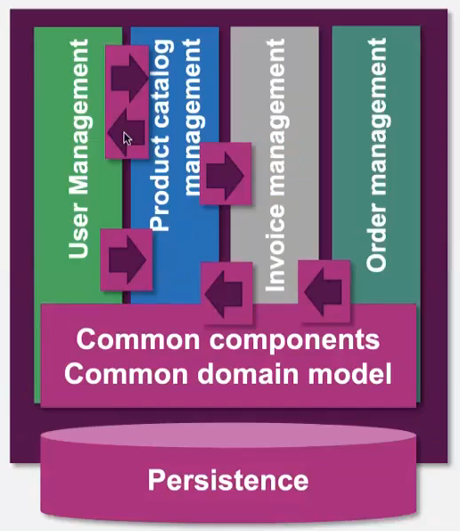Regarding business functionalities, the size of the application functionality includes, for example: user management, product catalog management, invoice management, order management, and so one. The functionalities are highly coupled to each other.

Every component tries to implement the single responsibility principle. There is a common domain model, and every vertical component is using the same model. So, if there is a change, all the components are affected.

Criticisms of domain-driven design argue that developers must typically implement a great deal of isolation and encapsulation to maintain the model as a pure and helpful construct.

The complexity is very high to manage.

Regardless, there are some cases in which the monolithic architecture is still utilized. Its strengths are:

* High initial productivity
* Ease of development
* Easy build & deployment
* Unique technology stack

So, it is a very efficient short-term solution, for example, to beat on time the competitors. However, the technical debt of this solution is very high. **Technical debt** is a term used in software development process describing trade-off between choosing a quicker short-term solution that results in long-term consequences. Like financial debt, technical debt accumulates interest in the form of the extra effort to overcome problems that appear in the future. There are different forms of technical debts, regarding:

* Requirements: the gap between the captured product requirements and what was actually implemented
* Versioning: problems that arise with not using a clear versioning system or having a disorganized repository
* Build: problems with the building process that make it complex or difficult
* Test: any shortcuts taking in testing or a lack of tests
* Defect: any bugs or failures found in the software
* Design: technical shortcuts taken during the design stage
* Architectural: decisions made that compromise quality and maintainability
* Documentation: refers to documents on the project that are out-of-date, incomplete or a code base that lacks comments
* Code: refers to poorly written code that doesn’t follow best coding practices
* Infrastructure: using tools, technologies or configuration that are not optimal for the software solution

Technical debt is a vicious cycle.

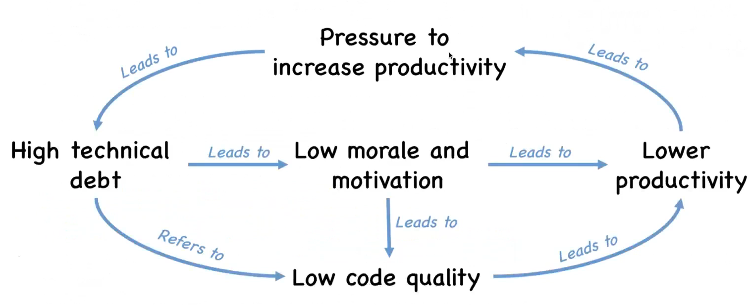

Agile approaches try to defeat this occurrences, for example through strict iterations.

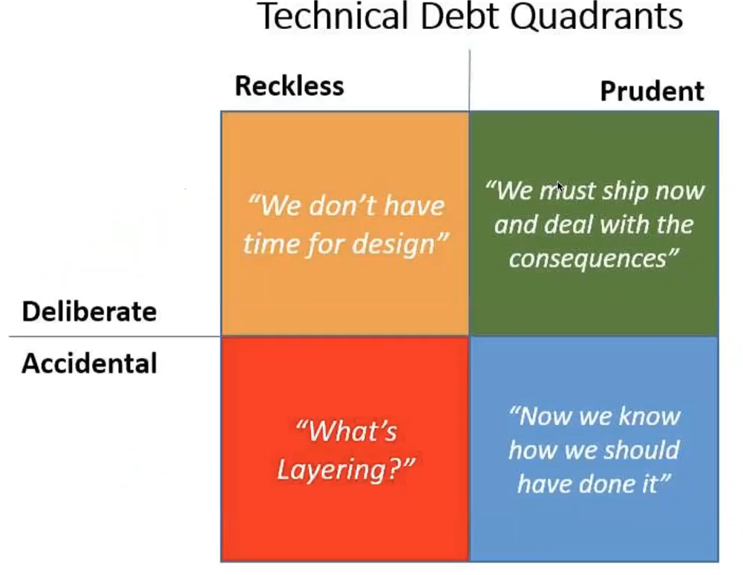There are different kinds of technical debts. They might even be due also to a good team and style of working (left quadrants).

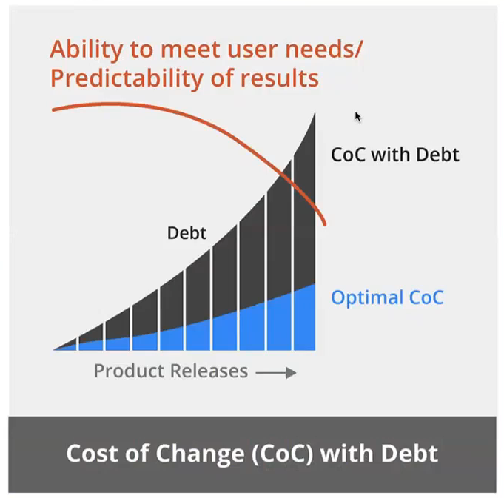More experience can help, but it is not enough if the approach is wrong.

The main weaknesses of the monolithic architecture are the following:

* Development
  + Slow evolution
  + Difficult maintenance
  + Team scalability
* Performance
  + Load scalability
* Unique technology stack
  + Generation scalability
  + Heterogeneous scalability
* “Big ball of mud”
  + Easy to accumulate high technical debt
  + Functional scalability

## Verso un'architettura basata su microservices - Il Blog di Andrea MerlinMicro-services paradigm

With the Micro-services paradigm, the application is developed as a suite of small executable units (micro-services) that publish business oriented API, so exposes business logic using an Application Programming Interface. The goal is for every service to do one single thing in the best way.

Each micro-service manages a consistent subset of functionalities (processes and entities) belonging to the global application domain. So, each micro-service manages a “bounded context”: a piece of the global domain that is sufficiently atomic and independent from the rest of the application domain.

# 14. Intelligent Automation

**Intelligent automation** represents all the technologies that enable the transformation and automation of business processes by leveraging any combination of software robotics, cloud, artificial intelligence and smart machines. It is comprised of basic Robotics Process Automation (RPA), enhanced RPA, cognitive automation and is enabled by rules- based macros, artificial intelligence and natural-language processing. At its most basic level, robots automate the steps in a process instead of having people move transactions from one step to the next. At its most complex level, cognitive systems draw on historical data to handle exception processing, make judgments to resolve customer issues and complement knowledge workers to provide new insights.

Some definitions for the technologies included in intelligent automation:

* **Artificial intelligence** (AI): Artificial intelligence is the capability of a machine to imitate intelligent human behaviour.
* **Machine learning** (ML): Machine learning is an application of artificial intelligence that enables systems to automatically learn and improve from experience without being explicitly programmed. Machine learning focuses on the development of computer programs that can access data and use it to learn for themselves.
* **Cognitive computing** (CC): Cognitive computing is the simulation of human thought processes in a computerized model. Cognitive computing involves self-learning systems that use data mining, pattern recognition and natural language processing to mimic the way the human brain works.
* **Robotic process automation** (RPA): Robotic process automation enables organizations to configure computer software or a ‘bot’ to capture and interpret existing applications for processing a transaction, manipulating data, triggering responses and communicating with other digital systems.

Intelligent automation (IA) and data and analytics (D&A) are at the top of every organization’s strategic and tactical agenda, as they could both improve operational efficiency and effectiveness and provide the basis for a broad range of new or enhanced products and services, including the ones tied to improve customer service quality.

Organizations must press ahead with their IA efforts and also pay keen attention to how to address not only the technological challenges they will face, but also those more operational and cultural in nature. It takes a corporate culture that is ready and capable of embracing fundamental changes in how it operates. It requires tangible and active top-level executive commitment and strategic leadership. It takes an understanding of the impact of IA on the workforce and the change management capabilities to address it. And it requires practical knowledge of the various IA technologies, judicious use of third-party expertise and, finally, a recognition of the amount of time, money and resources it will take to exploit IA’s potential.

Five key findings about AI:

* The end goal is not just better management of costs. It’s also about improving customer engagement, getting more insights from data and boosting growth. While cost savings will remain a ’must have‘, it is certainly not the only goal of IA efforts.
* Most IA initiatives are not yet up to scale or operate on an end-to-end process level, but expectations run high for returns on investment. More than half of those surveyed believe they can scale up their IA initiatives within 12 months. The short history of IA efforts, however, leads us to believe these projections are optimistic.
* While there is investment in IA broadly, only 10 percent of respondents are integrating solutions across its various dimensions: automation, artificial intelligence and smart analytics. While initial fragmentation of efforts is not to be unexpected, organizations need to move quickly to understand how, when and where to integrate efforts across technologies to fully optimize their potential.
* Piecemeal or disorganized initiatives remain a stumbling block. Fewer than 10 percent of respondent organizations indicated they approach IA management and implementation from an enterprise-wide perspective. While this is understandable in the early stages of IA adoption, organizations must move to better coordinate and integrate efforts and must better prioritize efforts that should receive maximum funding and support going forward.
* Wide and quick adoption of IA is constrained by lack of a leadership mandate and vision to carry it through and rally employees who face changing roles and skill upgrading, or possibly job loss. Caution or prudence has its place with any new set of technologies but organizations must overcome them as quickly as possible and not let them become institutionalized.

Business leaders need to recognize and pro-actively manage the potential of IA: more than just cost savings or gaining operational efficiencies, IA is about fundamentally changing how an organization operates from the standpoint of internal operations, how it deals with its customers and suppliers and how it delivers its core products and service.

Organizations typically do not have sufficient skills or resources to undertake IA efforts and subsequently manage them. This is especially the case with machine learning and artificial intelligence. Organizations need to be realistic about what resources can be harvested internally and what resources can be leveraged via third-party service providers and vendors.

Speed of execution is critical to achieving a first-mover advantage with AI investments, competitive edge and financial success. Still, there is distinct correlation between IA investments and top financial performance. The reverse is also true: less time and fewer resources equal poorer performance.

Optimistically, a lot of managers believe they can confidently manage ‘sizing up’ IA projects and initiatives. That takes a corporate culture change, and along with that, authority and accountability. Figuring out who will take charge of the agenda in unchartered territory is one large step. Another is dealing with displaced staff and cultivating talent in newer, digital arenas. The foremost issues identified are the need for more in-house talent to support IA advancements and, significantly, more senior management leadership and vision to set the agenda to embrace change.

Understanding why most businesses are going slow with IA can be traced back to three factors: who’s really in charge of leading the initiative, how integrated IA is within the business, and how best practices are picked up and learned. It’s typically information technology that takes charge of getting IA deployed. The issue is that too companies have a combined IT and business approach. This scenario makes for a less than ideal outcome if a limited number of departments actually get involved. Also few have established Centers of Excellence (COE) to learn from successes and centralize best practices.

Intelligent automation’s impact on jobs, both in terms of partial or full elimination of work roles or, on the flip side, empowering workers with new skills and insights, is already a reality in the market. The reality is IA will eliminate white collar jobs, and organizations need to proactively address this reality. Leaders are handling job displacement by retraining tops layoffs by a wide margin. This retraining issue needs to be addressed by organizations’ human resources departments. But what’s also required is that business and executive management work with HR to define the collective workforce of the future and direct retraining and reskilling efforts toward that future.

According to KPMG, these are the factors for success:

* Recognize and embrace exponential change. Enterprises need to have a clear and supported vision for how their business will change through IA. Treating this transformation simply as technology change or a point in time human resources challenge will yield lackluster results. Integrated automation is the effective melding of technology, talent, organizational change and leadership to achieve exponential outcomes.
* Create a clear leadership mandate and vision that perpetually answers the question ’Why IA?’. While projects can be led from the function level up, they have to be complemented by top- down ownership, mandate and vision — truly a programmatic approach to IA.
* Embrace integration. The majority of enterprises are investing in multiple IA technologies, but are using them in a siloed or piecemeal fashion. Deeper results and broader benefits can spring from combining technologies to solve problems or reinvent processes or functions.
* Cultivate an enterprise-wide approach to IA. Use the enterprise lens to break down the silos and elevate the best practices. This is critical for scale and the achievement of objectives.
* Take a multi-faceted approach to IA talent. You will never scale without the necessary talent to execute the strategy and operate the reinvented business with an automation mindset. Enterprises cite reskilling as an easy approach to minimizing layoffs while, at the same time, developing necessary talent.
* Be aggressive and fast. Set clear and strategic goals, look for ways to best achieve them and then execute decisively. Do this fast and expect failure. Take what works and scale. Take what does not and pivot or move on.

At last, there are 10 action points, or steps, most organizations could take to help drive scale in IA:

1. Remember that intelligent automation, while enabled by technology, is a business issue and opportunity. Rethink your core operating models in the context of the advances IA can enable. It is about reinventing the business, not pursuing a series of technology investment projects.
2. Spearhead IA initiatives from a strategic perspective via a top-level champion who understands its value and has not only the vision to direct it enthusiastically and effectively, but also the support to rally the staff around.
3. Ensure coordinated collaboration between business units, executive management and the information technology group. IA is a business enabler but it is powered by IT.
4. Strategize to combine IA technologies that can work together rather than opt for piecemeal tactics to solve problems. Look to reinvent processes or functions. Ensure tight integration with other technology efforts such as cloud, block-chain and advanced data and analytics.
5. View IA from an enterprise level to scale up its usefulness within the business and broaden its scope to various functions. Everyone doing their own thing runs the risk of redundant efforts, diluted ROIs and underachievement of potential benefit. A coordinated enterprise approach will lead to consistent technologies, resources, governance and investment pools — and will elevate the best practices.
6. Ensure adequate capital, resources and time are allocated to retrain, reskill and upgrade staff (a challenging multi-year effort). Be realistic about just how many staff can be retrained.
7. Ensure adequate change management programs are in place to manage the transition from human to digital labor. Understand what new skills are required so as to retrain and reskill based on a defined workforce of the future.
8. Be creative in addressing IA skills shortages (including use of contingent labor and external service providers) to fill in the talent gap while your IA agenda matures and advances.
9. Embrace smart failures. Learn from those market leaders who aren’t afraid to fail, but are masters in failing fast and then succeeding with what works.
10. Learn how to pivot, learn from mistakes and be aggressive.

## Intelligent customer interactions

Every business aims to get customer service right: demonstrate empathy, respond promptly, courteously, and efficiently. The challenge is doing all of this consistently and under different circumstances. Virtual business operations put customer interactions in a spotlight and technology and a new tech-enabled customer service approach can help.

With constant advances in data analytics, artificial intelligence, and robotic process automation, companies can supercharge their customer service capabilities. These advances make customer service faster, more responsive and personal, and more broadly available, no matter where their customers and employees are. They also can automate substantial parts of the process, freeing human agents to spend more time on the highest-value activities.

Firstly, a digital-enabled technology architecture must be in place, so to improve information accuracy and offer many channels to customer and anticipate their needs. Then, customer interaction technologies help the customer service team to respond to negative situations, thanks to cloud solutions which collect data real-time from chats and conversations and determine the core issues.

Customers should have multiple, connected channels. Organizations should anticipate the customers’ channel preferences and provide a services tailored to their history and likings. More organizations are implementing chat-bots, that are usually preferred to guided answer searches.

Analytics are critical to understanding customer expectations. As customer expectations shift, companies must interpret, measure, and act on metrics in different ways. Flexibility is needed and enabled by learning from analytics.

Being trustworthy is even more important today to maintain loyal customer relationships. “To increase trust, business should focus on solutions, not selling. And a strong digital presence doesn’t guarantee trust; to establish a true relationship, digital technology must go beyond simple transactions and actually engage the customer.

In general, customer expectations are growing, but they aren’t unreasonable. Three critical service expectations for customers:

* Customers expect companies to be proactive in helping them, and show integrity and empathy in doing so. They want companies to contact them about problems or potential problems before they happen. This shows companies understand customers’ circumstances and can help build trust and loyalty.
* Customers expect personalized and enabled help. They want to interact with agents who have access to their latest transactions and have the power to resolve their issue, which creates a smooth process and minimizes their time and effort.
* Customers expect seamless integration between self-service and live-service channels. With integration, agents know what customers have been doing, whether in digital or live-assisted channels, and have access to all of their records. This speeds up and simplifies the process to resolve inquiries and can turn poor experiences into great ones.

KPMG believes that organizations that wish to lead in customer service can do so using a three-step process that incorporates these components:

1. Add intelligence to improve customer experiences
2. Deliver a consistent experience across all channels
3. Keep human agents in the loop.

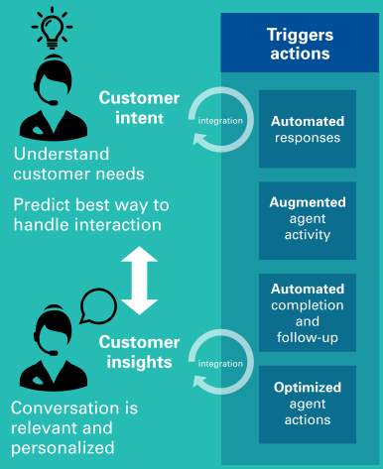The first step to exceeding customer expectations is to anticipate them. The easiest way to do that is by leveraging big data and data analytics, powered by technologies like cloud computing, intelligent automation, machine learning, and other artificial intelligence techniques. These technologies help provide intelligence to help companies better understand customers and also make interactions with them more predictable, precise, and personal. They also make it possible for organizations to deflect a high percentage of customer inquiries to virtual agents, which can anticipate customer sentiment and intent and deliver answers and even the actions customers seek. When inquiries require interaction with a live person, these same technologies can provide human agents with immediate access to similar insights, and suggest the best way to resolve the inquiries. Integrated transactions and data enable technology to gather customer intent and sentiment. This insight triggers actions that can smoothly fulfill customers’ inquiries consistently on any channel.

The second step is about delivering a consistent experience across all channels. This is because customers expect the same experience and level of service independently of the channel they are using to interact with an organization. A critical first step in repairing uneven service experiences is integrating customer data, including transaction data, across all channels. Companies can then combine data and analytics with intelligent automation capabilities and process optimization to enable a better, more consistent customer experience across all channels.

Intelligent automation technologies can augment human agents by quickly synthesizing all the relevant data and suggesting a personalized resolution. For example, a company could use natural language processing and machine learning to supplement what the call center agents hear, and its customer service systems could immediately analyze the customer’s intent and sentiment to suggest a response. The third step recognizes the human value in interactions. Technology is the great enabler of superior customer experiences, relieving human agents of duties that intelligent systems can now handle. Technology also enables agents to respond in a more thorough and personalized fashion in complex or sensitive instances. Keeping human agents involved is critical even as companies move to self-service for simpler transactions. Customers will continue to demand conversations with humans to resolve more complex issues. When customers make contact in those instances, companies will need to quickly identify the issues and respond based on each customer’s intent and sentiment. Machine learning and natural language processing can augment human agents by quickly synthesizing all the relevant data and suggesting a personalized resolution. Once the issue has been resolved, the system can learn from the experience to enhance its ability to serve future customers. This approach has applications for all types of stakeholder interactions, not just external customers, but also employees.

## Scale now – Embedding intelligent automation across the enterprise

Enterprises are keenly aware that they can’t achieve their ambitious goals for intelligent automation (IA) without more scale. Most leaders think they can meet the challenge, but a big perception gap exists between aspiration and reality: Investment, leadership and talent are holding companies back. First, there is high uncertainty about AI financial investments. At the same time, there is small clarity in the agenda to go forward and the cultural change needed is not easy to accomplish.

Companies are embarking on this journey with caution. They’re seeing results in finance and accounting and global business services, but critical areas like customer service, sales and marketing appear to be lagging behind. Too many organizations don’t know what to do next or how to scale.

Scale means deployments are beyond pilot stage and into full production, across multiple end-to-end functions or processes, and they’re fully ramped up and operating. When scaled, these technologies make people more efficient and can lead to the development of new products, solutions, and business models. Maintaining the courage and top-down leadership to charge ahead is essential to achieving IA scale. A need is to realize and prioritize the upskill and reskill in-house IA talent.

Key findings:

* The inability to scale is the largest perceived inhibitor to achieving goals.
* Investment in intelligent automation (IA) technologies is nowadays strong.
* IA solutions are siloed.
* The top strategic goals: driving revenue growth and making better use of data.
* The top operational goals are centered on the customer experience.

Fragmented efforts to scale IA mean little or no return on investment, and competition will let who doesn’t invest behind. Once a foundational investment is made in tools, staffing, process redesign and core infrastructure including cloud, they can be applied across a wide-ranging scope of applications and functions to achieve scale.

Business needs to scale automation technologies across the expanse of the enterprise, balancing priorities and goals around core steps. They have to understand and choose among hundreds of technology options; they need to get data and analytics rolling; and they have to decide the order and priority of automation among all the moving parts of their organizations. However, nothing will advance without two basic realizations:

* The C-suite needs to lead the way and make bold decisions on scaling functions across business units—and organizations must have the right in-house talent to develop and benefit from the transformation.
* Automation is not simply about deployment—it’s about business and operating model transformation built on data, and new technologies supported by people.

Culture for scale is something to be built, and in this scenario top-down leadership and in-house talent are the fuel for transformation and success. Culture is the way you provision talent, the skillsets you cultivate and nurture, and how you deploy this talent around defined goals and tools. A dynamic culture builds its own skills and capabilities from within and deploys the right talent in the right ways around the right technology—and it does so in large part by upskilling or reskilling its workforce. It is essential to build a critical mass of skills, both in business and IT areas.

Many businesses struggling to move beyond experimentation with AI haven’t planned for the people and the change elements these technology disruptions bring. They’re obsessed with the technology itself, and they forget that the only way they will realize benefits is by focusing on the people.

Here are the top five AI jobs that companies need to create or consider if they are to effectively build and scale their capabilities:

* AI architect
* AI Product Manager
* AI Ethicist
* Data Scientist
* Software Engineer

Every business needs to be a tech company in its mindset and actions. In essence, leadership must approach automation boldly and intelligently to redefine core processes and the roles of people in the full range of functions—how they work, what they can do and the intelligent interactions they have with customers.

KPMG recommends the following steps:

1. Redesign your core processes and operating models in terms of the advances automation technologies can provide
2. Gain top-level leadership support from a leader who enables transformation with financial buy-in and the enthusiasm that rallies teams around the cause
3. Build a culture of automation by uniting IT and business teams so you can prioritize and strategize the deployment of technologies across business functions in an inter-disciplinary and whole-brained way
4. Blend and integrate IA technologies as a way to reinvent processes or functions instead of opting for piecemeal tactics to solve problems
5. Govern data to build the business case and machine learning models from accurate, relevant data
6. Commit to change management programs to manage the transition from human to digital labor
7. Hire for the new skills needed to build and manage automation technologies—and be creative in addressing IA skills shortages by leveraging contingent labor, crowdsourcing and external service providers